|  |  |
| --- | --- |
| Logo_FPT_University_doc | **MINISTRY OF EDUCATION AND TRAINING** |

**FPT UNIVERSITY**

**CAPSTONE PROJECT DOCUMENT**

**AGC101**

**FINAL REPORT**

|  |  |
| --- | --- |
| **Tra Da** | |
| **Group Member** | SE03451 – Soulivong Phimmathong |
| SE03271 – Hoang Van Canh |
| SE03030 – Vu Hoang Hieu |
| SE03193 – Nguyen Hoang |
| SE03334 – Nguyen Huu Thao |
| **Supervisor** | Mr. Nguyen Van Sang |
| **Project Code** | AGC101 |

Hanoi, May 2016 – August 2016

Table of Contents

[1 INITIAL IDEA FOR AGC 6](#_Toc459757798)

[1.1 INTRODUCTION 6](#_Toc459757799)

[1.1.1 Purpose 6](#_Toc459757800)

[1.1.2 Acronyms and Definitions 6](#_Toc459757801)

[1.2 ABSTRACT 6](#_Toc459757802)

[1.3 LITERATURE REVIEW 7](#_Toc459757803)

[1.4 PROPOSAL 10](#_Toc459757804)

[1.4.1 The idea 10](#_Toc459757805)

[1.4.2 Objectives 10](#_Toc459757806)

[1.4.3 Brief description about system 11](#_Toc459757807)

[1.4.4 System features 12](#_Toc459757808)

[1.5 BENEFIT FROM PROJECT 13](#_Toc459757809)

[1.5.1 For our group 13](#_Toc459757810)

[1.5.2 For Community 14](#_Toc459757811)

[1.6 CRITICAL ASSUMPTION AND CONSTRAINTS 14](#_Toc459757812)

[1.7 POTENTIAL RISKS 15](#_Toc459757813)

[2 SOFTWARE PROJECT MANAGEMENT DOCUMENTS 17](#_Toc459757814)

[2.1 INTRODUCTION 17](#_Toc459757815)

[2.1.1 Purpose 17](#_Toc459757816)

[2.1.2 Definition and Acronyms 17](#_Toc459757817)

[2.2 PROJECT OVERVIEW 18](#_Toc459757818)

[2.2.1 Project Description 18](#_Toc459757819)

[2.2.2 Scope 18](#_Toc459757820)

[2.2.3 Standard Objectives 18](#_Toc459757821)

[2.2.4 Milestone and Deliverables 19](#_Toc459757822)

[2.3 PROJECT ORGANIZATION 20](#_Toc459757823)

[2.3.1 Software Process Model 20](#_Toc459757824)

[2.3.2 Project lifecycle 22](#_Toc459757825)

[2.3.3 Organizational Chart 23](#_Toc459757826)

[2.3.4 Roles and Responsibilities 24](#_Toc459757827)

[2.4 TOOLS AND INFRASTRUCTURES 25](#_Toc459757828)

[2.4.1 Hardware tool 25](#_Toc459757829)

[2.4.2 Software tool 26](#_Toc459757830)

[2.5 SCHEDULE 27](#_Toc459757831)

[2.5.1 Detailed Schedule 27](#_Toc459757832)

[2.5.2 Meeting Schedule 28](#_Toc459757833)

[2.5.3 Effort Estimation 28](#_Toc459757834)

[2.6 RISK MANAGEMENT 28](#_Toc459757835)

[2.6.1 Risk Register 28](#_Toc459757836)

[2.6.2 Risk probability and impact matrix 29](#_Toc459757837)

[2.7 CODING CONVENTION 29](#_Toc459757838)

[2.7.1 Php naming convention 29](#_Toc459757839)

[2.7.2 File naming convention 29](#_Toc459757840)

[3 REQUIREMENTS SPECIFICATION DOCUMENTS 31](#_Toc459757841)

[3.1 USER REQUIREMENTS SPECIFICATION 31](#_Toc459757842)

[3.1.1 Introduction 31](#_Toc459757843)

[3.1.2 Overall Description 32](#_Toc459757844)

[3.1.3 Functional Requirements 34](#_Toc459757845)

[3.1.4 Non – Functional Requirements 38](#_Toc459757846)

[3.2 SOFTWARE REQUIREMENTS SPECIFICATION 38](#_Toc459757847)

[3.2.1 Introduction 38](#_Toc459757848)

[3.2.2 System Purpose 40](#_Toc459757849)

[3.2.3 Scope 40](#_Toc459757850)

[3.2.4 Overall Description 41](#_Toc459757851)

[3.2.5 Entity Relation Model 46](#_Toc459757852)

[3.2.6 Functional Specification 48](#_Toc459757853)

[3.2.7 Non-functional Specification 92](#_Toc459757854)

[4 SOFTWARE DESIGN DOCUMENTS 95](#_Toc459757855)

[4.1 ARCHITECTURE DESIGN 95](#_Toc459757856)

[4.1.1 Choice of Architecture Design 95](#_Toc459757857)

[4.1.2 Architectural Presentation 97](#_Toc459757858)

[4.1.3 Package Design 97](#_Toc459757859)

[4.2 DETAILED DESIGN 99](#_Toc459757860)

[4.2.1 Class Description 99](#_Toc459757861)

[4.2.2 UC001: Admin Management 109](#_Toc459757862)

[4.2.3 UC002 Customer Management 137](#_Toc459757863)

[4.2.4 UC003 Restaurant Owner Management 152](#_Toc459757864)

[4.2.5 UC004 Guest 173](#_Toc459757865)

[4.3 DATABASE DESIGN 187](#_Toc459757866)

[4.3.1 Database Diagram 187](#_Toc459757867)

[4.3.2 Table Descriptions 187](#_Toc459757868)

[5 SOFTWARE TEST DOCUMENTS 199](#_Toc459757869)

[5.1 INTRODUCTION 199](#_Toc459757870)

[5.1.1 Purposes 199](#_Toc459757871)

[5.1.2 System Overview 199](#_Toc459757872)

[5.2 TEST PLAN 199](#_Toc459757873)

[5.2.1 Scope of Testing 199](#_Toc459757874)

[5.2.2 Requirements for Testing 200](#_Toc459757875)

[5.2.3 Test Strategies 203](#_Toc459757876)

[5.3 TEST CASES 210](#_Toc459757877)

[5.4 CHECKLISTS 210](#_Toc459757878)

[5.4.1 Functionalities checklists 210](#_Toc459757879)

[5.4.2 User interface checklists 210](#_Toc459757880)

[5.5 TEST LOGS 213](#_Toc459757881)

[5.5.1 Defect Logs 213](#_Toc459757882)

[5.5.2 Test Reports 213](#_Toc459757883)

[6 SOFTWARE USER’S MANUALS 217](#_Toc459757884)

[6.1 INSTALLATION GUIDE 217](#_Toc459757885)

[6.1.1 Purposes 217](#_Toc459757886)

[6.1.2 Environments 217](#_Toc459757887)

[6.1.3 Application Installation 217](#_Toc459757888)

[6.2 USER's GUIDE 225](#_Toc459757889)

[6.2.1 Purposes 225](#_Toc459757890)

[6.2.2 Functional Description 225](#_Toc459757891)

[6.2.3 Detailed Guidelines 226](#_Toc459757892)

[6.3 PROJECT RESULT REPORT 259](#_Toc459757893)

[6.3.1 Product Judging 259](#_Toc459757894)

[6.3.2 Project Summary 260](#_Toc459757895)

[6.3.3 Lessons Learnt 261](#_Toc459757896)

[7 REFERENCES 262](#_Toc459757897)

**PART 1  
INTRODUCTION**

# INITIAL IDEA FOR AGC

## INTRODUCTION

### Purpose

This report provides an overview of AGC project – our Capstone Project in FPT University. It includes background information, literature review of existing systems, the initial idea of this project, a brief description about our expected system and some potential risks, critical assumptions, constraints, also some benefits for our group and website users.

### Acronyms and Definitions

|  |  |  |
| --- | --- | --- |
| Acronym & Abbreviation | Definition | Note |
| AGC | Angi.com |  |
| PHP | Hypertext Preprocessor |  |

Table 1: Definitions and Acronyms

## ABSTRACT

The development of technology and the increasing use of the Internet as a primary source of information lead to the introduction website explosively. This increasing on demand for better restaurant services; these changes in the habits of current and potential customers directly result with the need for significant changes in the development of Online marketing plan.

Almost restaurants currently do not have their own websites to be a channel for advertising, introducing and supporting their business. For the rest, the current system cannot afford the demand of customer like searching, comparing, communicating and reviewing the quality of services efficiently and optimally.

So, we have to connect all customers and restaurant owners, create mutual zone to share the market and bring the benefit for all of them. Furthermore, new expected website has to ensure that provides all functions for customers (seek information, compare, review, book table, order food and manage their booking); for restaurant owners (manage their site content, manage food order, customer booking on their restaurant); has friendly interface and easy to use.

## LITERATURE REVIEW

There are many restaurants & food websites, mobile applications, Facebook pages, blogs those introduce about restaurants, suggest users about places to eat, book a table, order food and manage their booking too such as: Lozi.vn, Foody.vn, etc.

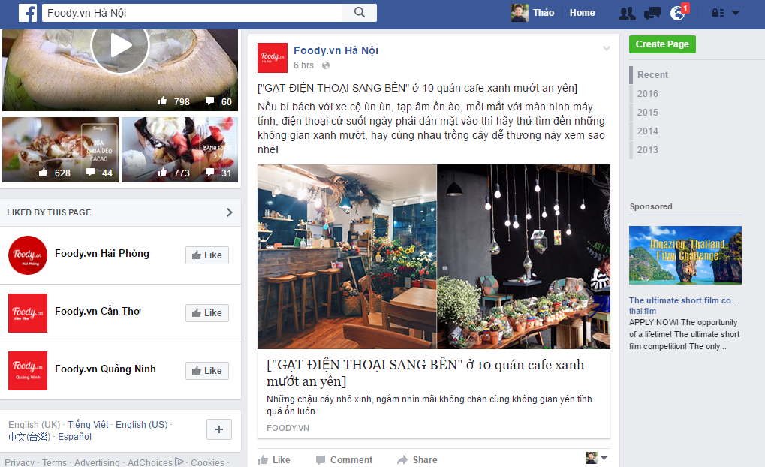

Figure 1 Facebook page

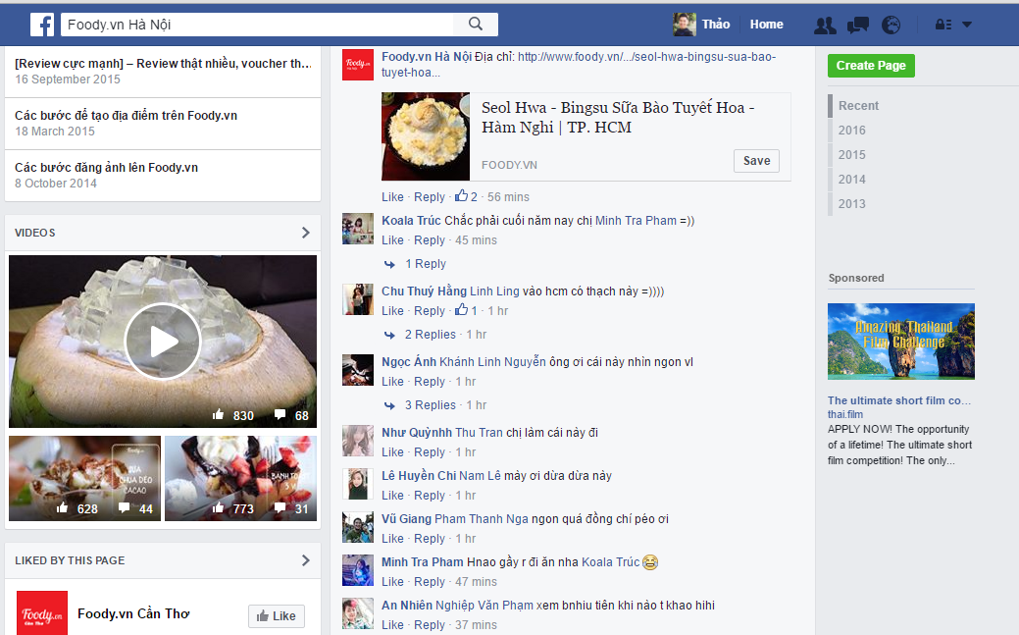

Figure 2 Facebook page

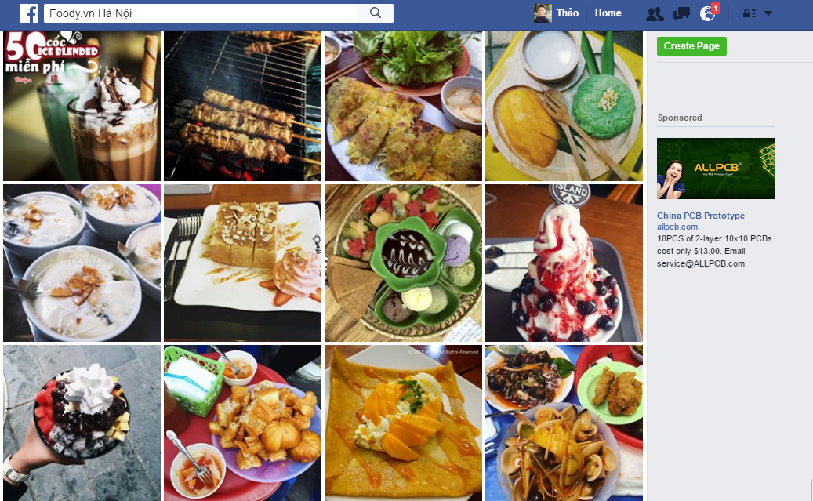

Figure 3 Foody.vn Facebook Page

Facebook Page is one of most online social network which user to share information and interact in a large community. User can add others, view topic and get news from notifications.

Best selling point of Facebook Page is shop owners have a free space to communicate with others and the frequently of using.

However, with the functions provided in Facebook fan page, it only helps user to get news and review subjectively following the direction of admin. To afford demand of customer like: searching, comparing, reviewing & making reservation online efficiently – what social network likes Facebook, Tweeter cannot do, we need a website which supports more tools for these requirements.

**Restaurant & food website such as: Foody.vn & Lozi.vn**

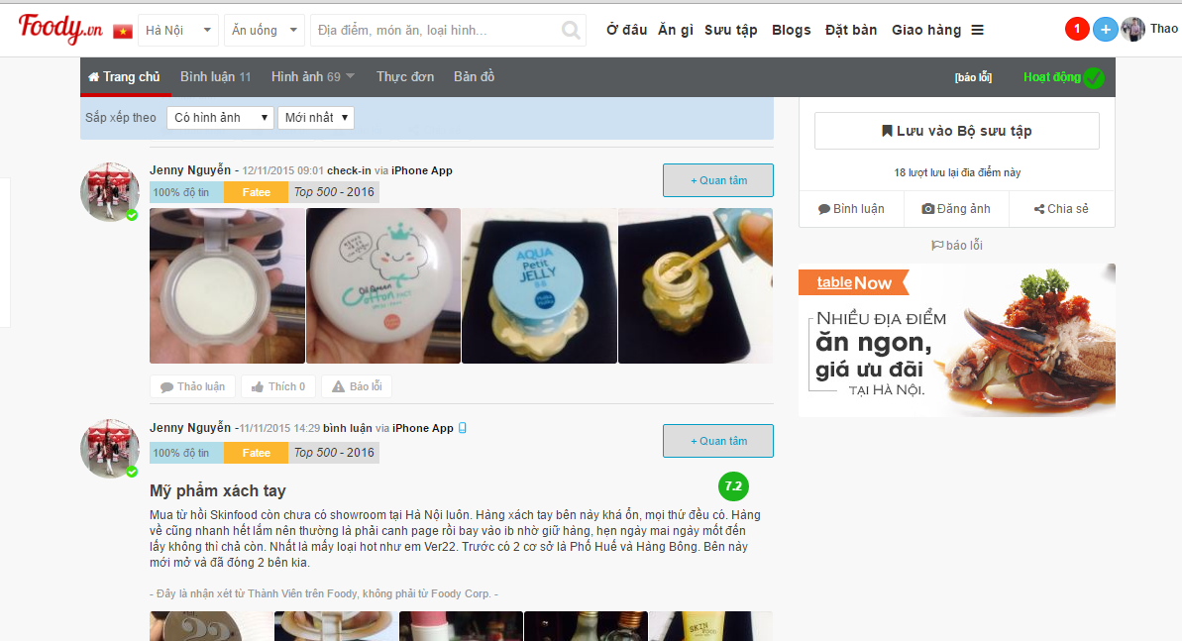

Figure 4 Foody.vn

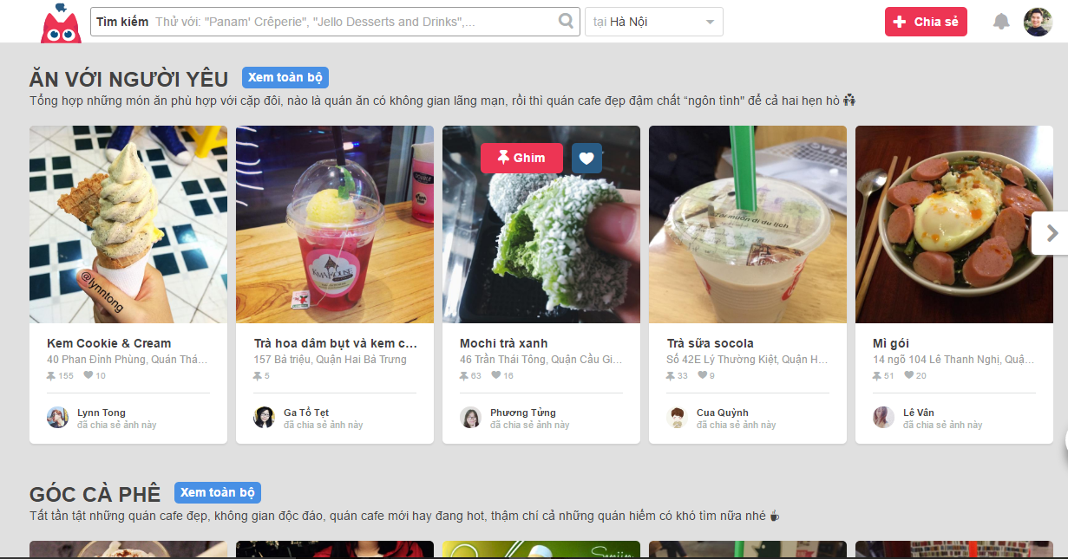

Figure 5 Lozi.vn

Foody.vn & Lozi.vn are two examples of most successful restaurant & food websites in Viet Nam. They provide all information about foods & places for users. User also can create post by upload picture and write review for a place. Easy to use and friendly imagine are the advantages to attract users.

However, those website still have some weakness affect choice of customer, such as: too many advertises; Website interface is hard for user to catch up direct information; the duplicate of information; clone accounts and quality of reviews also.

## PROPOSAL

### The idea

The ideas of creating a web application for introducing about restaurants & booking table online is not new; there are many existing websites now. However, our expected AGC web application includes main functions of current websites, friendly user interface and easy to use.

Figure 6 The idea

### Objectives

This project is a Capstone Project for all team members.

Firstly, we do this project to fulfill the requirements from FPT University studying program. During the time do this, we can learn how to develop a project, how to communicate with other team members, how to control time, how to do teamwork effectively. We also can work with some new technology – PHP, new frameworks: CodeIgniter, MySQL Workbench, etc. Therefore, after finishing this project, we can practice what we have learnt in university and learn so many new things. It is very necessary for our future work after graduated from FPT University.

Secondly, we want to create a web application that helps user find information about restaurants, dining address; the promotions. It provides the users a more effective, easier and simpler way to book table. They can view, edit, and manage their booking too. Specially, this web application allows user to review the restaurant that they used services. So other user can refer to and make thier decision. The other special features of AGC is to enable users to order food on menu before coming so that they can enjoy the best services.

The difference between our system from the current restaurant and food website is that our website content is manage by restaurant owners. They have to pay fee for administrator to have restaurant account. And they can manage (view, update, delete) their site content, manage (view, statistic) customer order/ booking on their restaurant. So, they can develop their business effectively.

### Brief description about system

This web application will includes most restaurants in Hanoi, Vietnam. It will be public for all Internet users to look for information about restaurant and food. However, they need to sign up to use full functions from the system. With friendly and simple interface, customer can easily find information, review restaurants, book table, etc. restaurant owner can manage their site content, manage customer booking on their restaurant. If they have any problem, they can get contact admin directly. This web application uses PHP technology platforms and browsers.

The picture below is the application feature flow:

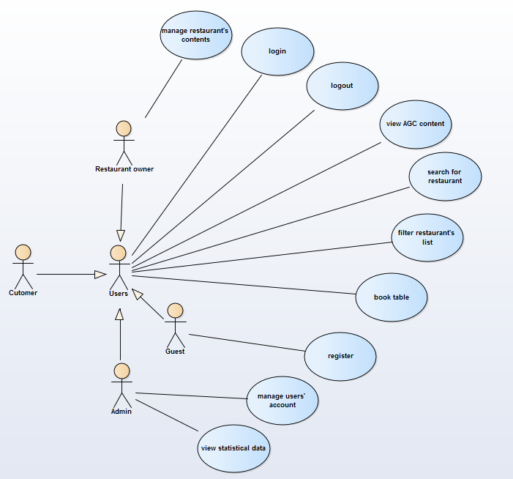

Figure 7 AGC feature flow

### System features

AGC provides huge advantages of helping customers to find their best fits restaurants and menus as well all others basic information needed such as contact information, address, etc.

On the other hand, restaurants owner also have chances to show their products and services on AGC, which will gain their potential customers. Besides, the owners will also able to access some business statistical data such as total amount of booking, etc.

**Our main functions are grouped by users as follow:**

1. **Admin**
   * Control users’ accounts.
   * Add/modify restaurants’ categories.
   * Add/modify news.
   * View statistical information.
   * View Customers and Restaurant owners information
2. **Customers**
   * Access to plenty of restaurant basic information and information of the system as a whole.
   * View specific restaurant information in detail.
   * Reserve tables if needed.
   * Search for interested restaurants or even dishes.
   * View restaurants’ list based on interest, address, restaurant category, etc.
   * Interact with social network
3. **Restaurant owners**

* Create and publish restaurant information on the websites.
* View customers table booking as well as customers’ basic information.
* Update table booking status for customers.
* Interact with social network.

1. **Guests**

* View general information in AGC.
* Register with AGC.

## BENEFIT FROM PROJECT

### For our group

After developing and implementing this project, our group will:

• Have experiences in managing software project: How to make a plan, manage time and risk, etc. These experiences will help us a lot in our future work.

• Know how to communicate with other team members and how to do teamwork  
efficiently.

• Have chance to study new technology: PHP technology and frameworks: Codesigniter, Bootstrap, HTML5, JQuery, etc.

• Complete Capstone Project successfully.

### For Community

Our website will provide channel to help restaurant owners connect with customers effectively. On the other hand, customer can save their time, money and choose the restaurants those meet their need. They also can review and give feedback for restaurant to improve the quality of services.

For restaurant owners, they can have the best marketing engine to develop their business, save a lot of money. Avoid overloading and have best preparation for special demand from customer. Finally, Customer information will give references for them to create the right marketing strategies.

## CRITICAL ASSUMPTION AND CONSTRAINTS

There are some critical assumptions that we realize after analyzing this project. The first assumption is about team members. We assume that all the developers can study new web technology - PHP in a short time. We do not know anything about it before this project, but we have to study hard for not missing any deadline of project plan. Besides, we also assume all our members do not have any health problems, so they are not absent and can do their works. The second one is about devices – laptop. We assume they are always at good condition. There are also some constraints of our project.

Firstly, we are international group so the misunderstanding between team members always happened and need more time to solve.

Secondly, about the time and deadline, we have to finish project on time. It has no extra time for us to complete developing and deliver application to teachers. Besides, the reports need to be submitted before the deadline.

Thirdly, about the quality, the application must be well enough for users to do main functions.

Fourthly, about the business requirements assumption, we assume that restaurants operate well and our system provides almost their needs.

Finally, about the technique, out knowledge in web developing is not the high level. Therefore, with all the expected features that we gave before, we do not know if we can solve all of those or not. However, we will try our best to make our project successfully.

## POTENTIAL RISKS

After analyzing this project, we may face with the following risks:

• Developing a web application by PHP technology is new with us, so it will take time for us to study and may be later we will have some technical problems.

• With the short duration - about 4 months – we will not have enough time to do all  
things and miss the delivery deadline.

• We do not have any experiences in software project management such as time  
management, risk management etc. Therefore, our project plan will be not good and completed. So maybe we will miss the deadline or have some unknown risks.

• It is the first time we manage big project like this, we do not have much experiences in communicating between the team. So maybe in the future, we will have conflict and argument and we will not finish all the works in time.

• About the device, all team members have different laptop with different configuration so we will have some difficulties in installing and testing application.

• Maybe we will lose source code or device during the developed time.

**PART 2  
SOFTWARE PROJECT MANAGEMENT DOCUMENTS**

# SOFTWARE PROJECT MANAGEMENT DOCUMENTS

## INTRODUCTION

### Purpose

### Definition and Acronyms

|  |  |  |
| --- | --- | --- |
| Acronym & Abbreviation | Full form | Definition |
| AGC | AGC | Project name |
| AGC101 | AGC101 | Project code |
| Tra Da | Tra Da | Group name |
| SRS | Software Requirements Specification | A document |
| SPMP | Software Project Management plan | A document |
| SDD | Software Design Description | A document |
| STD | Software Test Documentation | A document |
| SUM | Software User’s Manual | A document |
| IDE | Integrated Environment Development | Software development tool |
| QA | Quality Assurance |  |
| QC | Quality Control |  |

Table 2 Definitions and Acronyms

## PROJECT OVERVIEW

### Project Description

We plan to create a responsive website that assembles restaurants in Hanoi, Vietnam.

All information gathered will be organized neatly and accurately publish to users. On the other hand, restaurant owners will be able to post their menus, services and detailed description of their restaurants on AGC website.

### Scope

**In Scope**

* Gather all types of restaurants in Hanoi, Vietnam in Vietnam
* Customer will be able to perform table booking, interact with social network and view general information in the system
* Restaurant owner will have functionalities to add/update/delete his/her restaurant information as well as updating table booking status
* Admin will be able to control users’ accounts and view numbers of users and restaurants’ account

**Out scope:**

* Choosing menu in a restaurant online
* Developing mobile web based application
* Online payment functionalities

### Standard Objectives

1. Deploy the project before August 27, 2016.
2. Fulfil all requirements specified in SRS.
3. Submit all reports to FPT university capstone stone project committees and academic department.
4. Successfully defense thesis at FPT University.

### Milestone and Deliverables

* **Milestones**

|  |  |  |
| --- | --- | --- |
| **No** | **Milestones** | **Date** |
| **1** | Hold kick – off meeting | 13 Apr 2016 |
| **2** | Completed Report No. 1 Introduction | 25 April 2016 |
| **3** | Created project schedule | 30 Apr 2016 |
| **4** | Completed Report No. 2 SPMP | 5 May 2016 |
| **5** | Competed writing use case | 12 May 2016 |
| **6** | Completed Report No. 3 SRS | 15 May 2016 |
| **7** | Complete Report No. 4 SDD | 5 Jun 2016 |
| **8** | Complete coding and unit test | 3 Aug 2016 |
| **9** | Deliver tested codes (Code demo 1) | 12 Aug 2016 |
| **10** | Completed Report No. 5 STD | 12 Aug 2016 |
| **11** | Completed Report No. 6 SUM | 17 Aug 2016 |
| **12** | Represent capstone project and close the project | 31 Aug 2016 |

Table 3: Milestones

* **Deliverables**

|  |  |  |  |  |
| --- | --- | --- | --- | --- |
| **No** | **Deliverables** | **Format** | **Delivery Date** | **Delivery Method** |
| **Internal deliverables** | | | | |
| **1** | AGC\_WorkSchedule | .mpp | 12 May 2016 | GitHub repository |
| **2** | AGC\_Risk\_Register | .xlsx | 13 May 2016 | GitHub repository |
| **3** | AGC\_Test\_Case | .xlsx | 6 Aug 2016 |  |
| **External deliverables** | | | | |
| **1** | Report No.1 Introduction | .docx | 25 Apr 2016 | GitHub repository |
| **2** | Report No. 2 SPMP | .docx | 5 May 2016 | GitHub repository |
| **3** | Report No. 3 SRS | .docx | 15 May 2016 | GitHub repository |
| **4** | Report No. 4 SDD | .docx | 5 Jun 2016 | GitHub repository |
| **5** | Report No.5 STD | .docx | 12 Aug 2016 | GitHub repository |
| **6** | Report No.6 SUM | .docx | 17 Aug 2016 | GitHub repository |
| **7** | The CD - Source Code Executable Program Package | .rar | 24 Aug 2016 | Hand directly by hand |
| **8** | Final documentation | .docx | 24 Aug 2016 | Hand directly by hand |

Table 4: Deliverables

## PROJECT ORGANIZATION

### Software Process Model

We use Rational Unified Process model to develop AGC website. The Rational Unified Process (RUP) is an [iterative](https://en.wikipedia.org/wiki/Iterative_and_incremental_development) [software development process](https://en.wikipedia.org/wiki/Software_development_process) framework created by the [Rational Software](https://en.wikipedia.org/wiki/Rational_Software) Corporation, a division of [IBM](https://en.wikipedia.org/wiki/IBM) since 2003. RUP is not a single concrete prescriptive process, but rather an adaptable process [framework](https://en.wikipedia.org/wiki/Software_framework), intended to be tailored by the development organizations and software project teams that will select the elements of the process that are appropriate for their needs. RUP is a specific implementation of the [Unified Process](https://en.wikipedia.org/wiki/Unified_Process).

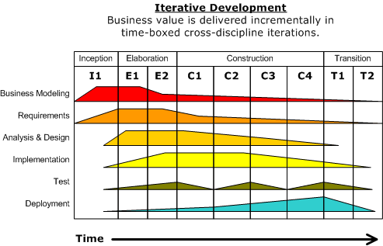

Figure 8 Rational Unified Process Model

#### Inception phase

The primary objective is to scope the system adequately as a basis for validating initial costing and budgets. In this phase the business case which includes business context, success factors (expected revenue, market recognition, etc.), and financial forecast is established. To complement the business case, a basic use case model, project plan, initial risk assessment and project description (the core project requirements, constraints and key features) are generated.

#### Elaboration phase

The primary objective is to mitigate the key risk items identified by analysis up to the end of this phase. The elaboration phase is where the project starts to take shape. In this phase the problem domain analysis is made and the architecture of the project gets its basic form. The key domain analysis for the elaboration is the system architecture.

#### Construction phase

The primary objective is to build the software system. In this phase, the main focus is on the development of components and other features of the system. This is the phase when the bulk of the coding takes place. In larger projects, several construction iterations may be developed in an effort to divide the use cases into manageable segments that produce demonstrable prototypes.

This phase produces the first external release of the software. Its conclusion is marked by the initial operational capability milestone.

#### Transition phase

The primary objective is to 'transit' the system from development into production, making it available to and understood by the end user. The activities of this phase include training the end users and maintainers and beta testing the system to validate it against the end users' expectations. The system also goes through an evaluation phase, any developer which is not producing the required work is replaced or removed. The product is also checked against the quality level set in the Inception phase.

If all objectives are met, the product release milestone is reached and the development cycle is finished.

### Project lifecycle

There are 4 phases in this development:

1. **Inception phase**

This is a first phase of project development. We plan to develop business case, software project management plan and prototype. Define scope, cost and schedule.

1. **Elaboration phase**

During this phase, we further analyze and complete the work in the Inception phase. Identifies users, develop use cases, prototype, and software architecture. After this stage we should have been able to decide whether the project is worth develop or not.

1. **Construction phase**

During this phase, all remaining components and application features are developed and integrated into the product. The main activities will be coding and testing.

1. **Transition phase**

Is the last phase in this software development life cycle, we will have a final check of overall project within Tra Da team and with the advisor to approve. Finally, presentation slide will be created. Then, all documentations and source codes will be submitted to FPT University thesis defense committees.

### Organizational Chart

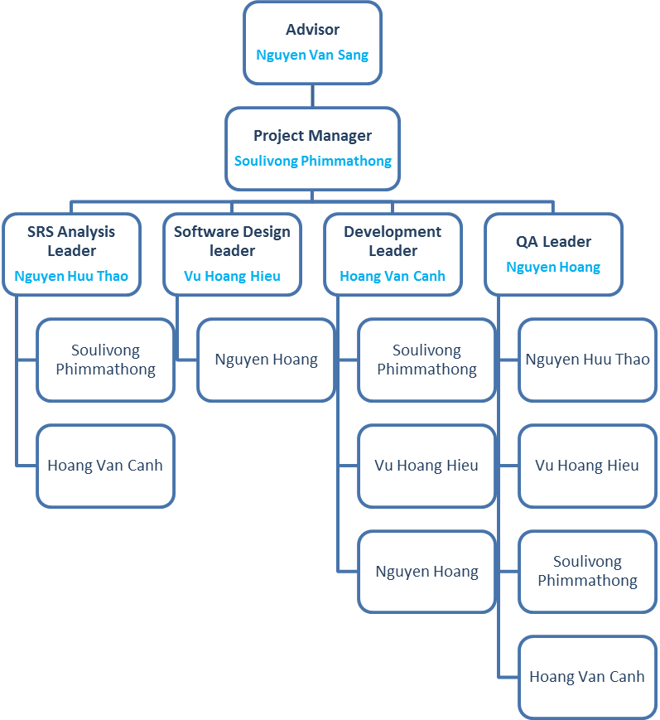

Figure 9 AGC101 Organizational Chart

### Roles and Responsibilities

|  |  |  |
| --- | --- | --- |
| **Full Name** | **Roles** | **Responsibilities** |
| **Nguyen Van Sang** | Team Advisor | * Give team direction. * Give team consultation. * Approve all deliverables. * Approve project success or fail. |
| **Soulivong Phimmathong** | Project Manager | * Oversee overall project. * Encourage and motivate members. * Initialize meeting. * Ensure all tasks will be all schedule * Divide and assign tasks. * Create SPMP. * Control work quality. |
| **SRS Analysis** | | |
| **Nguyen Huu Thao** | SRS Analysis Leader | * Lead collecting and analyzing software requirements. * Complete SRS documentation. |
| **Soulivong Phimmathong** | SRS Analysis member | * Work closely with the SRS analysis leader. |
| **Software Design** | | |
| **Vu Hoang Hieu** | Software design Leader | * Lead and design the look and feel of AGC web application. * Complete SDD documentation. |
| **Nguyen Hoang** | Software design member | * Work closely with the Software design leader. |
| **Development** | | |
| **Hoang Van Canh** | Development Leader | * Lead coding team. * Demonstrate the completed sytem. |
| **Soulivong Phimmathong** | Development member | * Work closely with the Development leader. |
| **Vu Hoang Hieu** | Development member | * Work closely with the Development leader. |
| **Nguyen Hoang** | Development member | * Work closely with the Development leader. |
| **Testing** | | |
| **Nguyen Hoang** | QA Leader | * Lead Testing team. * Complete STD. |
| **Nguyen Huu Thao** | QA member | * Work closely with the testing leader. |
| **Vu Hoang Hieu** | QA member | * Work closely with the testing leader. |
| **Soulivong Phimmathong** | QA member | * Work closely with the testing leader. |
| **Hoang Van Canh** | QA member | * Work closely with the testing leader. |

Table 5: Roles and Responsibilities

## TOOLS AND INFRASTRUCTURES

### Hardware tool

|  |  |  |
| --- | --- | --- |
| **Hardware** | **Purpose** | **Detail** |
| 5 Laptop computers | development tool | With minimum: 4GB RAM, 500GB Hard disk and Intel core i5, 1.80 GHz |
| 2 Android phones | testing tool | Android 5.0 |
| 2 IOS phones | testing tool | IOS 9 |
| 2 iPad | testing toll | Ipad 2 mini and iPad 4 |

Table 6 Hardware tool

### Software tool

|  |  |  |
| --- | --- | --- |
| **Category** | **Software** | **Version** |
| IDE | Netbeans IDE | 8.1 |
| MySQL Workbench | 6.3 CE |
| Operating system | Windows 7, 8.1, 10 | Home, Professional, Education |
| Communication | Facebook |  |
| Email |  |
| Skype |  |
| Documentation | Microsoft Word | 2013 |
| Microsoft Excel | 2013 |
| Microsoft PowerPoint | 2013 |
| Microsoft Project | 2007 |
| Database | MySQL |  |
| Data Repository | Google Drive |  |
| Git Hub and Tortoise Git |  |
| Facebook |  |
| Design | https://www.draw.io/ |  |
| https://pidoco.com/ |  |
| Enterprise Architect | 12.1 |
| Microsoft Visio | 2010 |
| Language | Php | 5.6 |
| Framework | CodeIgniter | 3.0.6 |
| Bootstrap | 3.3.7 |
| Server | XAMPP | 5.6 |
| Apache | 2.4 |

Table 7 Software tools

## SCHEDULE

### Detailed Schedule

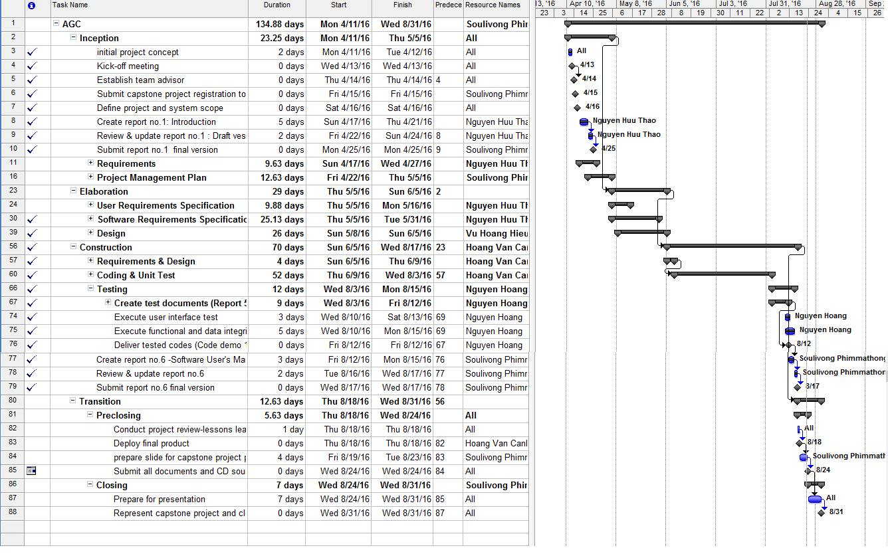

Figure 10: AGC\_Project\_Schedule

See AGC\_WorkSchedule.mpp for details.

### Meeting Schedule

The meeting will normally held twice a week, In order to plan, and accomplish project’s objectives. We have the 2 following kind of meeting

1. **Tra Da with the Advisor:**

The advisor will call for the meeting once in a week on the weekday between 12:20 to 1:00 PM based on day available from 15 April to 12 June 2016. Then, from 13 June to 28 August 2016, the meeting will be hold on every Monday evening from 5:00 PM to 6:00 PM. Agenda includes guiding, reviewing, and giving recommendations from the advisor. Finally, questions from members are asked and answered instantly. The meeting result will be recorded in a note, then this note will be posted on Google Drive group folder.

1. **Team meeting**

This meeting is hold internally within Tra Da members (exclude an advisor). The meeting will be officially hold once a week, PM will create meeting agenda, specifically include reviewing the previous work, plan for incoming tasks and assign members to carry out the tasks. All team meeting result will be posted on Tra Da Facebook group.

Furthermore, we also have many minor meeting via instant messages on Facebook chat group.

### Effort Estimation

|  |  |  |  |
| --- | --- | --- | --- |
| **Task name** | **Worst case(days)** | **Best case(days)** | **Expected case(days)** |
| Inception | 25 | 17 | 24 |
| Elaboration | 40 | 23 | 30 |
| Construction | 80 | 60 | 70 |
| Transition | 25 | 13 | 20 |
| Total | 170 | 113 | 144 |

Table 8 Effort estimation

## RISK MANAGEMENT

### Risk Register

See AGC\_Risk\_Register.xlsx file for detail.

### Risk probability and impact matrix

See AGC\_Risk\_Probablity\_and\_Impact\_Matric.xlsx for detail.

## CODING CONVENTION

### Php naming convention

Use meaningful English noun for variables and English verb for method and follow the following naming convention.

* ClassName – PascalCase
* methodName – camelCase
* propertyName – camelCase
* functionName – camelCase
* $variableName – camelCase

### File naming convention

Specified a meaningful name started each document with “AGC” and use underscores to separate spaces.

Ex: AGC \_Report2\_SPMP.docx

**PART 3   
REQUIREMENTS SPECIFICATION DOCUMENTS**

# REQUIREMENTS SPECIFICATION DOCUMENTS

## USER REQUIREMENTS SPECIFICATION

### Introduction

#### Purposes

This is an SRS for the AGC web application. Document describes general function and non-functional requirements of the system which will be used as input for software design document and will be used as a checklist for software test documentation. Meanwhile users and stakeholders can use it to have an overview of the whole system requirements.

#### Definition and Acronyms

|  |  |
| --- | --- |
| Term | Description |
| Tra Da | group name |
| AGC | Tra Da project name |
| AGC101 | project code |
| SRS | software requirement specification |
| GUI | graphical user interface |
| API | application program interface |
| user | anyone who uses the system |
| admin | A website owner and also a person who is given specific permission for managing and controlling the system. |
| Customer | a user who have registered on the system |
| Restaurant owner | Someone who has a restaurant and wants his restaurant to be a part the application, and he/she is also a customer |
| Guest | anyone who is not a customer |
| Stakeholder | Any person who has interaction with the system |
| index page | home page or main page |

Table 9 Definition and Acronyms

### Overall Description

#### Business Process Overview

AGC is a web application aiming to connect customers and restaurants together. AGC will be available on modern web browers which also compatible on mobile and tablets devices. The site is reliable and convenient which help users to easily access, search for information about the best places to eat, the promotions, the food and the service provided; refer, evaluate the quality of the venue through user reviews and rates features. Besides, AGC provides information of restaurants addresses, food, and table booking service.

#### Product Features

AGC provides huge advantages of helping customers to find their best fits restaurants and menus as well all others basic information needed such as contact information, address, etc.

On the other hand, restaurants owner also have chances to show their products and services on AGC, which will gain their potential customers. Besides, the owners will also able to access some business statistical data such as total amount of booking, etc.

Our main functions are grouped by users as follow:

1. **Admin**
   * Control users’ accounts.
   * Add/modify restaurants’ categories.
   * Add/modify news.
   * View statistical information.
   * View Customers and Restaurant owners information
2. **Customers**
   * Access to plenty of restaurant basic information and information of the system as a whole.
   * View specific restaurant information in detail.
   * Reserve tables if needed.
   * Search for interested restaurants or even dishes.
   * View restaurants’ list based on interest, address, restaurant category, etc.
   * Interact with social network
3. **Restaurant owners**

* Create and publish restaurant information on the websites.
* View customers table booking as well as customers’ basic information.
* Update table booking status for customers.
* Interact with social network.

1. **Guests**

* View general information in AGC.
* Register with AGC.

#### User Characteristic

AGC users are grouped into 4 categories:

1. Admin: is AGC system owner, who have a high knowledge in information technology, specifically internet and web service. In practical admin is a person who have a high understanding of overall system and system in detail. Furthermore admin also have to have ability to make a deal with restaurant owners as clients.
2. Customers: are anyone who have registered on AGC website, but not restaurant owners. They want to know both general and in detail information of what AGC provides, also need a fast service with friendly user interface.
3. Restaurant owners: are anyone who have registered with AGC website as restaurant owner, they want to gain as many customers as possible, also need a clear content manager as well as accurate business statistical data with a cheap prices.
4. Guests: are general users who come to browse on AGC website, they might be interested or not interested in finding restaurants, but if they are interested in the want to have found their desirable one.

### Functional Requirements

#### Activate/deactivate user

**Access right: Admin**

**Description:** when admin have check all requirement of registration he/she will immediately activate that specific user. On the other hand the admin also have right to deactivate accounts those are unvalid.

#### Activate/deactivate restaurant

**Access right: Admin**

**Description:** before any of restaurant information fields to be inserted and display admin will check all requirement and decide whether to activate or not. On the other hand if the restaurant is not valid on the time gone by the admin will also deactivate that account.

#### Rate restaurant

**Access right: Admin**

**Description:**  Admin will give rating to restaurants based on restaurant reputation calculate from amount of likes, shares, comments, and about of table booking.

#### Delete restaurant

**Access right: Admin**

**Description:** if a restaurant have vilolate any rules, those considered to be deleted, admin will use this function to delete or if those account which are no longer exist will be removed as well.

#### Delete user

**Access right: Admin**

**Description:** admin will use this function to remove account that no longer exist or invalid and is condered to be removed.

#### View statistical data

**Access right: Admin**

**Description:** this is the place where admin is able to view amount of restaurants, customers, booking amount and others.

#### Add/delete category

**Access right: Admin**

**Description:** all categories to be used by restaurant will be added by admin.

#### Write/delete/update news

**Access right: Admin**

**Description:** admin will use this function to publish news to users, meanwhile the admin can also edit and delete the news as well.

#### View all users

**Access right: Admin**

**Description:** Admin will be able to view all users’ accounts information.

#### View restaurant information

**Access right: Customer/Restaurant owner**

**Description:** this function allow user to view restaurant information basic information and in detail, which will be display as a list of restaurant or can be displayed as specific restaurant index page.

#### View all restaurants’ categories

**Access right: Admin**

**Description:** Admin will be able to view all categories those have been created in AGC system.

#### View all news

**Access right: Admin**

**Description:** Admin will be able to view all news those have been created in AGC system both news that displaying to users and non-displaying news.

#### View all booking

**Access right: Admin**

**Description:** Admin will be able to view all table booking from all restaurants.

#### View booking detail

**Access right: Admin**

**Description:** Admin will be able to view each table booking detail from all restaurants.

#### Book restaurant

**Access right: Customer/Restaurant owner**

**Description:** this function allow customer as well as restaurant owner as a normal users to make a table reservation from any restaurants.

#### View booking history

**Access right: Customer/Restaurant owner**

**Description:** this function allow users to view their table booking history, by simply click on View booing history tab on profile information page.

#### View account

**Access right: Customer/Restaurant owner**

**Description:** this is a general function allows users to view their profile information

#### Update account

**Access right: Customer/Restaurant owner**

**Description:** this is a function that allow users to update their personnel profile information, it will be displayed in the profile pages.

#### Update password

**Access right: Customer/Restaurant owner**

**Description:** users have ability to change their personnel password, this by access to Change password tab in the account information page.

#### Add/update/delete restaurant information

**Access right: Restaurant owner**

**Description:** this function is strictly used by only restaurant owner, he/she can use this function to add, update, and delete his /her own restaurant information.

#### Add/update/delete restaurant banner

**Access right: Restaurant owner**

**Description:** this function allow user to add banner image to his or her restaurant, the users are able to choose images from their computer devices, and then it will be uploaded to AGC server.

#### Set restaurant profile picture

**Access right: Restaurant owner**

**Description:** user will choose one image from banner images which are added previously to be used as restaurant profile picture.

#### Add/update/delete food information

**Access right: Restaurant owner**

**Description:** this function allows user to add menu/dishes, as well as images, names, description, etc. On the other hand user can also update and deleted as needed.

#### Update booking status

**Access right: Restaurant owner**

**Description:** when customer have fulfilled their table booking or cancelled, or invalid, restaurant will come to manage booking tap and update those status, this status will be display in customers booking history as well.

#### Register

**Access right: Guest**

**Description:** this is a general function that allow none registered users to be able to register their account with AGC.

#### View general information

**Access right: Guest**

**Description:** As a guest, this function allow to none logged in or none account users to view general information from AGC such as home page, about page, user guide page, etc.

#### View restaurant information

**Access right: Guest**

**Description:** this function allow user to view restaurant information in depth by clicking on any restaurant profile pictures or any links provided.

#### Log in/log out

**Access right: Customer/Restaurant owner/Admin**

**Description:** This is a general function allow logged in users to log out by clicking on log out on the top right corner of the header bar, or by clicking on Log out tab in the account page.

#### Search

**Access right: All users**

**Description:** this a functions where users can input keyword on the textbox and click on search button to see restaurants results related to their keyword.

#### Social interaction

**Access right: All users**

**Description:** this function use third party software such as Facebook API to allow users to interact with social network on AGC web pages such as like, share, comment, etc.

### Non – Functional Requirements

* **Availability**: the web application must be available 24/7, even if many users are accessing at the same time.
* **Maintainability**: many functions will be added and upgraded in future versions, therefore the codes must be clear and clean, extendable and reusable.
* **Reliability**: information display in AGC website must be accurate and reliable.
* **Portability**: users must be able to access AGC through any of their modern web browsers and any device and AGC website must display the right screen for the right devices.
* **User interface friendliness**: users must be able to understand general GUI by sense, with giving any directions.

## SOFTWARE REQUIREMENTS SPECIFICATION

### Introduction

#### Purposes

This SRS aims at describing functional and non-functional requirement in details. This document will be used by project team and stakeholders to review and check the progress of the project as well as giving direction to development team to know what to be implemented and also to assure the system will correctly perform its intended functionalities.

#### Definition and Acronyms

This section describes the definitions, terms, and acronyms that are used in software requirements specification.

|  |  |
| --- | --- |
| Items | Description |
| **SRS** | software requirement specification |
| **Tra Da** | group name |
| **AGC** | project name |
| **AGC101** | project code |
| **Admin** | administrator |
| **GUI** | graphical user interface |
| User | anyone who uses the system |
| admin | A website owner and also a person who is given specific permission for managing and controlling the system. |
| Customer | a user who have registered on the system |
| Restaurant owner | Someone who has a restaurant and wants his restaurant to be a part the application |
| Stakeholder | Any person who has interaction with the system |
| **User** | anyone who uses the system |
| **admin** | A website owner and also a person who is given specific permission for managing and controlling the system and also be a customer |
| **Customer** | a user who have registered on the system |
| **Restaurant owner** | Someone who has a restaurant and wants his restaurant to be a part the application, and he/she is also a customer |
| **Guest** | anyone who is not a Customer |
| **Stakeholder** | Any person who has interaction with the system |
| index page | home page or main page |
| http | Hypertext Transfer Protocol |
| CodeIgniter | Php framework |

Table 10 Definition and Acronyms

### System Purpose

The purpose of developing AGC web application is divided into 2 main categories:

1. To provide solution for users who are looking for restaurant information before entering to the physical place.
2. To provide a cheap channel for restaurant owner to publish their products and/or services to gain potential customers.

The users can be any people who just have no idea of what/where to be eating, or can be any people just need more information about restaurants, therefore, AGC come into take place. We aim to connect consumers and providers together. Finally, it will benefits all sides.

### Scope

* The system aim to develop for web platform which can be accessible from all types of devices with responsive GUI.
* All restaurants to be displayed of AGC website will be inside Hanoi, Vietnam only.
* Language to be used is Vietnamese.
* The functions to be developed are based on 4 types of users:
  + Admin
  + Customer
  + Restaurant owner
  + Guest

### Overall Description

#### System overview



AGC Web Application

Admin module

Database server

Guest module

CodeIgniter

Customer module

Restaurant owner module

Http

File server

AGC system comprises of 3 part: Web server, File server, and database server.

Webserver will be used for managing and displaying information about restaurants and the system as a whole. Every function will be kept in its own module. Admin module will be used by admin, Restaurant owner module will be used by restaurant owner, Customer module will be used by customer, and Guest module will be used by guest.

File server will be used for storing and managing image files.

Database server is where contents and information are stored. Web server will communicate with the database to get data, add, delete and update contents on the website.

#### Product Features

AGC system has following group of main functions and supported functions

|  |  |  |  |
| --- | --- | --- | --- |
| Use case No. | Group of function | Function | Description |
| UC001 | Admin management | Activate/deactivate user | allow users who have account to use system or not |
| Activate/deactivate restaurant | allow restaurant information to display on AGC website or not |
| Rate restaurant | increase or decrease restaurant rating |
| Delete restaurant | remove all restaurant data |
| Delete user | delete account registered in AGC system |
| View statistical data | view total number of restaurant, table booking, etc. |
| Add/delete category | add new or delete category to be used by restaurant |
| Write/delete/update news | fully modify and publish news |
| View all users | view users’ accounts |
| View all categories | view restaurant’ categories those available on AGC system |
| View all restaurant | View restaurants’ information to decide whether to activate or deactivate |
| View all news | Views all news those have been written in AGC system |
| View all booking | View all tables booking |
| View detail booking | Views each table booking in detail |
| UC002 | Customer management | login | general function used for login to the system |
| logout | general function used for logout of the system |
| View restaurant information | view index page of the restaurant |
| Book restaurant | book tables in a restaurant |
| View booking history | view all his/her own tables booking details |
| View account | view information related to personnel information |
| Update password | change password |
| UC003 | Restaurant owner management | Add/update/delete restaurant information | fully modify his/her own restaurant information |
| Add/update/delete restaurant banner | fully modify his/her own restaurant banner images |
| Set restaurant profile picture | choose image from banner images to use us restaurant profile picture |
| Add/update/delete food information | fully modify dishes/menu in his/her own restaurant |
| Update booking status | change table booking status for customers |
| UC004 | Guest management | register | become a member or customer of AGG website |
| View general information | view all general information which is not reserved for only specific users |
| View restaurant information | view restaurant information in detail in restaurant index page |
| Search | general function used for search restaurant based on users keyword |
| Like | Like a restaurant using Facebook account |
| Comment | comment a restaurant using Facebook account |
| Share | share a restaurant using Facebook account |
| Note: Admin and Restaurant owners are able to perform all functionalities those customers are able to, Customer can perform all functionalities those Guest is able to except register | | | |

Table 11 AGC product features

#### User Characteristics

There are 4 types of users in AGC system: Admin, Customer, Restaurant owner, and Guest. Each type of users is able to perform only his own functionalities which is clearly described in product features and other parts in this document. The users only need internet connection and a web browsers to access AGC system.

#### User Documentation

In AGC website there will be a user guide tap for users, which will be displayed on the top of the navigation bar. The contents will instruct users to have more understanding about AGC systems. This includes: instruction for restaurant owner to manage contents, Answers to users for those that might have, and many more.

#### Assumption

AGC has made the following assumption in developing this system

* The functionalities provided will be enough for restaurant owners to manage their basic restaurant contents
* Restaurant owner will visit the website daily or hourly to check if there is a table booking
* Users have electronic devices those can connect to the internet.
* General data inserted by users which is cannot be checked by the system will be accurate
* Users will have prior social network account such as Facebook and Email to perform social network interaction functions

### Entity Relation Model

#### Entity-Relationship Diagram

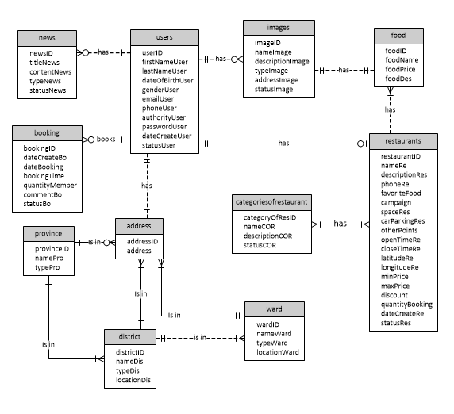

Figure 11 AGC entity relationship diagram

#### Entity Detail

|  |  |  |
| --- | --- | --- |
| Entity name | Description | Occurrence |
| Address | Users’ specific address | Each address is occupied by a user |
| Booking | Making reservation or book tables in restaurants | Each booking is made by a customer |
| News | news that posted in a website | News is information that admin want to send to users |
| Users | All people who visit AGC website | There are admin, customer, restaurant owner and guest as users |
| Images | A general term describes all images | Each image will be added by a user |
| Food | a term describes menu or dishes | Food is a menu in a restaurant |
| Restaurants | A general term describes all restaurants | Each restaurant has one restaurant owner |
| categoriesofrestaurant | Restaurants category | categoriesofrestaurant Is a type of restaurant |
| Ward | A term describes a villages | A ward is an address of users |
| District | A general term describes all districts | A district is an address of users |
| Province | A general term describes all provinces | A province is an address of users |

Table 12: entity data dictionary

### Functional Specification

#### UC001 Admin management

##### Use Case Diagram

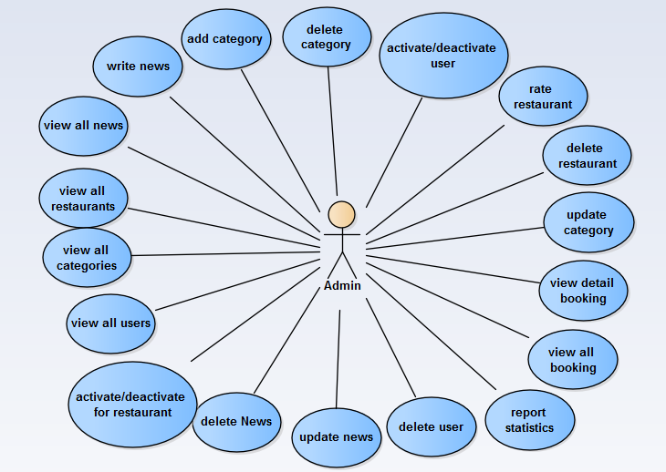

Figure 12 AGC admin management use case diagram

##### Use Case Specification

###### UC001 – 01 Write news

|  |  |  |  |  |
| --- | --- | --- | --- | --- |
| **Use Case ID** | | UC001-01 | **Version** | 1.0 |
| **Use Name** | | Write news | | |
| **Actor** | | Admin | | |
| **Description** | | The function allows admin to create new news in AGC. | | |
| **Precondition** | | After admin login AGC, choose “Quản trị” → “Tin tức” → “Thêm mới” | | |
| **Trigger** | | Click button “Cập nhật” | | |
| **Post-Condition** | | Message "Cập nhật thành công" appear and redirect to list news screen. | | |
| **Main flows** | | | | |
| **Step** | **Actor** | **Action** | | |
| 1 | Admin | User types the URL into internet browser and then enters**.** | | |
| 2 | AGC | The system displays Login screen | | |
| 3 | Admin | Enter the username and password into the login panel. | | |
| 4 | AGC | Display Home screen | | |
| 5 | Admin | Click the “Quản trị” Tab from the menu panel. | | |
| 6 | AGC | Display Admin screen | | |
| 7 | Admin | Click “Tin tức” → “Thêm mới” | | |
| 8 | AGC | Display create news screen | | |
| 9 | Admin | Enter new data for news. | | |
| 10 | Admin | Click button “Cập nhật” | | |
| 11 | AGC | Display success update status | | |
| 12 | AGC | Go to list news screen | | |
| **Alternative flows** | | | | |
| **AT1** | At step 10 in the main flows**,** if admin click button “Quay về” | | | |
| **Step** | **Actor** | **Action** | | |
| 10.1 | Admin | Click button “Quay về” | | |
| 11.1 | AGC | Go to list news screen | | |
| **Alternative flows** | | | | |
| **AT2** | At step 10 in the main flows**,** if admin do not full information | | | |
| **Step** | **Actor** | **Action** | | |
| 11.2 | AGC | Error message appear. | | |
| 12.2 | Admin | Enter full information | | |
| 13.2 | Admin | Click button “Cập nhật” | | |
| 14.2 | AGC | Display success update status | | |
| 15.2 | AGC | Go to list news screen | | |

###### UC001 – 02 Create category

|  |  |  |  |  |  |  |
| --- | --- | --- | --- | --- | --- | --- |
| **Use Case ID** | | | UC001-02 | | **Version** | 1.0 |
| **Use Name** | | | Create category | | | |
| **Actor** | | | Admin | | | |
| **Description** | | | The function allows admin to create new categories in AGC. | | | |
| **Precondition** | | | After admin login AGC, choose “Quản trị” → “Danh mục” → “Thêm mới” | | | |
| **Trigger** | | | Click button “Lưu” | | | |
| **Post-Condition** | | | Redirect to list categories screen | | | |
| **Main flows** | | | | | | |
| **Step** | **Actor** | | **Action** | | | |
| 1 | Admin | | User types the URL into internet browser and then enters**.** | | | |
| 2 | AGC | | The system displays Login screen | | | |
| 3 | Admin | | Enter the username and password into the login panel. | | | |
| 4 | AGC | | Display Home screen | | | |
| 5 | Admin | | Click the “Quản trị” Tab from the menu panel. | | | |
| 6 | AGC | | Display Admin screen | | | |
| 7 | Admin | | Click “Danh mục” → “Thêm mới” | | | |
| 8 | AGC | | Display create category screen | | | |
| 9 | Admin | | Enter new data for category. | | | |
| 10 | Admin | | Click button “Lưu” | | | |
| 11 | AGC | | Go to list categories screen | | | |
| **Alternative flows** | | | | | | |
| **AT1** | | At step 10 in the main flows**,** if admin click button “Quay về” | | | | |
| **Step** | | **Actor** | | **Action** | | |
| 10.1 | | Admin | | Click button “Quay về” | | |
| 11.1 | | AGC | | Go to list category screen | | |
| **Alternative flows** | | | | | | |
| **AT2** | | At step 10 in the main flows**,** if admin do not full information | | | | |
| **Step** | | **Actor** | | **Action** | | |
| 11.2 | | AGC | | Error message appear. | | |
| 12.2 | | Admin | | Enter full information | | |
| 13.2 | | Admin | | Click button “Lưu” | | |
| 14.2 | | AGC | | Display success update status | | |
| 15.2 | | AGC | | Go to list category screen | | |

###### UC001 – 03 Update news

|  |  |  |  |  |  |  |
| --- | --- | --- | --- | --- | --- | --- |
| **Use Case ID** | | | UC001-03 | | **Version** | 1.0 |
| **Use Name** | | | Update News | | | |
| **Actor** | | | Admin | | | |
| **Description** | | | The function allows admin to edit new news in AGC. | | | |
| **Precondition** | | | After admin login AGC, choose “Quản trị” → “Tin tức” → “Xem” | | | |
| **Trigger** | | | Click button “Cập nhật” | | | |
| **Post-Condition** | | | Message "Cập nhật thành công" appear and redirect to list news screen. | | | |
| **Main flows** | | | | | | |
| **Step** | **Actor** | | **Action** | | | |
| 1 | Admin | | User types the URL into internet browser and then enters**.** | | | |
| 2 | AGC | | The system displays Login screen | | | |
| 3 | Admin | | Enter the username and password into the login panel. | | | |
| 4 | AGC | | Display Home screen | | | |
| 5 | Admin | | Click the “Quản trị” Tab from the menu panel. | | | |
| 6 | AGC | | Display Admin screen | | | |
| 7 | Admin | | Click “Tin tức” | | | |
| 8 | AGC | | Display list news screen | | | |
| 9 | Admin | | Click “Xem” to view and edit a news. | | | |
| 10 | AGC | | Display information of news. | | | |
| 11 | Admin | | Edit data in news. | | | |
| 12 | Admin | | Click button “Cập nhật” | | | |
| 13 | AGC | | Display success update status | | | |
| 14 | AGC | | Go to list news screen | | | |
| **Alternative flows** | | | | | | |
| **AT1** | | At step 10 in the main flows**,** if admin click button “Quay về” | | | | |
| **Step** | | **Actor** | | **Action** | | |
| 10.1 | | Admin | | Click button “Quay về” | | |
| 11.1 | | AGC | | Go to list category screen | | |

###### UC001 – 04 Update category

|  |  |  |  |  |  |  |
| --- | --- | --- | --- | --- | --- | --- |
| **Use Case ID** | | | UC001-04 | | **Version** | 1.0 |
| **Use Name** | | | Update category | | | |
| **Actor** | | | Admin | | | |
| **Description** | | | The function allows admin to update category in AGC. | | | |
| **Precondition** | | | After admin login AGC, choose “Quản trị” → “Danh mục” → “Sửa” | | | |
| **Trigger** | | | Click button “Lưu” | | | |
| **Post-Condition** | | | Redirect to list categories screen | | | |
| **Main flows** | | | | | | |
| **Step** | **Actor** | | **Action** | | | |
| 1 | Admin | | User types the URL into internet browser and then enters**.** | | | |
| 2 | AGC | | The system displays Login screen | | | |
| 3 | Admin | | Enter the username and password into the login panel. | | | |
| 4 | AGC | | Display Home screen | | | |
| 5 | Admin | | Click the “Quản trị” Tab from the menu panel. | | | |
| 6 | AGC | | Display Admin screen | | | |
| 7 | Admin | | Click “Danh mục” | | | |
| 8 | AGC | | Display list categories screen | | | |
| 9 | Admin | | Update new data for category. | | | |
| 10 | Admin | | Click button “Lưu” | | | |
| 11 | AGC | | Go to list categories screen | | | |
|  |  | |  | | | |
| **Alternative flows** | | | | | | |
| **AT1** | | At step 10 in the main flows**,** if admin click button “Quay về” | | | | |
| **Step** | | **Actor** | | **Action** | | |
| 10.1 | | Admin | | Click button “Quay về” | | |
| 11.1 | | AGC | | Go to list categories screen | | |

###### UC001 – 05 Delete news

|  |  |  |  |  |  |  |
| --- | --- | --- | --- | --- | --- | --- |
| **Use Case ID** | | | UC001-05 | | **Version** | 1.0 |
| **Use Name** | | | Delete News | | | |
| **Actor** | | | Admin | | | |
| **Description** | | | The function allows admin to delete news in AGC. | | | |
| **Precondition** | | | After admin login AGC, choose “Quản trị” → “Tin tức” | | | |
| **Trigger** | | | Click button “Xóa” | | | |
| **Post-Condition** | | | Refresh list news screen. | | | |
| **Main flows** | | | | | | |
| **Step** | **Actor** | | **Action** | | | |
| 1 | Admin | | User types the URL into internet browser and then enters**.** | | | |
| 2 | AGC | | The system displays Login screen | | | |
| 3 | Admin | | Enter the username and password into the login panel. | | | |
| 4 | AGC | | Display Home screen | | | |
| 5 | Admin | | Click the “Quản trị” Tab from the menu panel. | | | |
| 6 | AGC | | Display Admin screen | | | |
| 7 | Admin | | Click “Tin tức” | | | |
| 8 | AGC | | Display list news screen | | | |
| 9 | Admin | | Click “Xóa” to delete a news. | | | |
| 10 | AGC | | Display dialog with message “Xóa XXX”. | | | |
| 11 | Admin | | Click button “OK”. | | | |
| 12 | AGC | | Refresh list news screen. | | | |
| **Alternative flows** | | | | | | |
| **AT1** | | At step 9 in the main flows**,** if admin click button “Hủy” | | | | |
| **Step** | | **Actor** | | **Action** | | |
| 9.1 | | Admin | | Click button “Hủy” | | |
| 10.1 | | AGC | | Return list news screen | | |

###### UC001 – 06 Delete category

|  |  |  |  |  |  |  |
| --- | --- | --- | --- | --- | --- | --- |
| **Use Case ID** | | | UC001-06 | | **Version** | 1.0 |
| **Use Name** | | | Delete category | | | |
| **Actor** | | | Admin | | | |
| **Description** | | | The function allows admin to delete category in AGC. | | | |
| **Precondition** | | | After admin login AGC, choose “Quản trị” → “Danh mục” | | | |
| **Trigger** | | | Click button “Xóa”. | | | |
| **Post-Condition** | | | Refresh list news screen. | | | |
| **Main flows** | | | | | | |
| **Step** | **Actor** | | **Action** | | | |
| 1 | Admin | | User types the URL into internet browser and then enters**.** | | | |
| 2 | AGC | | The system displays Login screen | | | |
| 3 | Admin | | Enter the username and password into the login panel. | | | |
| 4 | AGC | | Display Home screen | | | |
| 5 | Admin | | Click the “Quản trị” Tab from the menu panel. | | | |
| 6 | AGC | | Display Admin screen | | | |
| 7 | Admin | | Click “Danh mục” | | | |
| 8 | AGC | | Display list categoríe screen | | | |
| 9 | Admin | | Click “Xóa” to delete a category. | | | |
| 10 | AGC | | Display dialog with message “Xóa XXX”. | | | |
| 11 | Admin | | Click button “OK”. | | | |
| 12 | AGC | | Refresh list categories screen. | | | |
| **Alternative flows** | | | | | | |
| **AT1** | | At step 9 in the main flows**,** if admin click button “Hủy” | | | | |
| **Step** | | **Actor** | | **Action** | | |
| 9.1 | | Admin | | Click button “Hủy” | | |
| 10.1 | | AGC | | Return list categories screen | | |

###### UC001 – 07 Activate/deactivate restaurant

|  |  |  |  |  |  |  |
| --- | --- | --- | --- | --- | --- | --- |
| **Use Case ID** | | | UC001-07 | | **Version** | 1.0 |
| **Use Name** | | | Activate/deactivate restaurant | | | |
| **Actor** | | | Admin | | | |
| **Description** | | | The function allows admin to active/deactive for restaurant in AGC. | | | |
| **Precondition** | | | After admin login AGC, choose “Quản trị” → “Nhà hàng” → “Sửa” | | | |
| **Trigger** | | | Click button “Lưu”. | | | |
| **Post-Condition** | | | Message "Cập nhật thành công" appear and redirect to list restaurant screen. | | | |
| **Main flows** | | | | | | |
| **Step** | **Actor** | | **Action** | | | |
| 1 | Admin | | User types the URL into internet browser and then enters**.** | | | |
| 2 | AGC | | The system displays Login screen | | | |
| 3 | Admin | | Enter the username and password into the login panel. | | | |
| 4 | AGC | | Display Home screen | | | |
| 5 | Admin | | Click the “Quản trị” Tab from the menu panel. | | | |
| 6 | AGC | | Display Admin screen | | | |
| 7 | Admin | | Click “Nhà hàng” → “Sửa” | | | |
| 8 | AGC | | Display detail restaurant screen | | | |
| 9 | Admin | | Tick “Kích hoạt” to active/deactive user. | | | |
| 10 | Admin | | Click button “Lưu”. | | | |
| 11 | AGC | | Display success update status | | | |
| 12 | AGC | | Go to list restaurant screen. | | | |
| **Alternative flows** | | | | | | |
| **AT1** | | At step 10 in the main flows**,** if admin click button “Quay về” | | | | |
| **Step** | | **Actor** | | **Action** | | |
| 10.1 | | Admin | | Click button “Quay về” | | |
| 11.1 | | AGC | | Return list restaurant screen. | | |

###### UC001 – 08 Delete restaurant

|  |  |  |  |  |  |  |
| --- | --- | --- | --- | --- | --- | --- |
| **Use Case ID** | | | UC001-08 | | **Version** | 1.0 |
| **Use Name** | | | Delete restaurant | | | |
| **Actor** | | | Admin | | | |
| **Description** | | | The function allows admin to delete restaurant in AGC. | | | |
| **Precondition** | | | After admin login AGC, choose “Quản trị” → “Nhà hàng” | | | |
| **Trigger** | | | Click button “Xóa”. | | | |
| **Post-Condition** | | | Refresh list restaurant screen. | | | |
| **Main flows** | | | | | | |
| **Step** | **Actor** | | **Action** | | | |
| 1 | Admin | | User types the URL into internet browser and then enters**.** | | | |
| 2 | AGC | | The system displays Login screen | | | |
| 3 | Admin | | Enter the username and password into the login panel. | | | |
| 4 | AGC | | Display Home screen | | | |
| 5 | Admin | | Click the “Quản trị” Tab from the menu panel. | | | |
| 6 | AGC | | Display Admin screen | | | |
| 7 | Admin | | Click “Nhà hàng” | | | |
| 8 | AGC | | Display list restaurant screen | | | |
| 9 | Admin | | Click “Xóa” to delete a restaurant. | | | |
| 10 | AGC | | Display dialog with message “Xóa XXX”. | | | |
| 11 | Admin | | Click button “OK”. | | | |
| 12 | AGC | | Refresh list restaurant screen. | | | |
| **Alternative flows** | | | | | | |
| **AT1** | | At step 9 in the main flows**,** if admin click button “Hủy” | | | | |
| **Step** | | **Actor** | | **Action** | | |
| 9.1 | | Admin | | Click button “Hủy” | | |
| 10.1 | | AGC | | Return list restaurant screen | | |

###### UC001 – 09 Rate restaurant

|  |  |  |  |  |  |  |
| --- | --- | --- | --- | --- | --- | --- |
| **Use Case ID** | | | UC001 - 09 | | **Version** | 1.0 |
| **Use Name** | | | Rate restaurant | | | |
| **Actor** | | | Admin | | | |
| **Description** | | | The function allows admin to rate restaurant in AGC. | | | |
| **Precondition** | | | After admin login AGC, choose “Quản trị” → “Nhà hàng” → “Sửa” | | | |
| **Trigger** | | | Click button “Lưu”. | | | |
| **Post-Condition** | | | Message "Cập nhật thành công" appear and redirect to list restaurant screen. | | | |
| **Main flows** | | | | | | |
| **Step** | **Actor** | | **Action** | | | |
| 1 | Admin | | User types the URL into internet browser and then enters**.** | | | |
| 2 | AGC | | The system displays Login screen | | | |
| 3 | Admin | | Enter the username and password into the login panel. | | | |
| 4 | AGC | | Display Home screen | | | |
| 5 | Admin | | Click the “Quản trị” Tab from the menu panel. | | | |
| 6 | AGC | | Display Admin screen | | | |
| 7 | Admin | | Click “Nhà hàng” → “Sửa” | | | |
| 8 | AGC | | Display detail restaurant screen | | | |
| 9 | Admin | | Choose value in “Đánh giá chất lượng” to rate restaurant. | | | |
| 10 | Admin | | Click button “Lưu”. | | | |
| 11 | AGC | | Display success update status | | | |
| 12 | AGC | | Go to list restaurant screen. | | | |
| **Alternative flows** | | | | | | |
| **AT1** | | At step 10 in the main flows**,** if admin click button “Quay về” | | | | |
| **Step** | | **Actor** | | **Action** | | |
| 10.1 | | Admin | | Click button “Quay về” | | |
| 11.1 | | AGC | | Return list restaurant screen. | | |

###### UC001 – 10 Delete user

|  |  |  |  |  |  |  |
| --- | --- | --- | --- | --- | --- | --- |
| **Use Case ID** | | | UC001-10 | | **Version** | 1.0 |
| **Use Name** | | | Delete user | | | |
| **Actor** | | | Admin | | | |
| **Description** | | | The function allows admin to delete user in AGC. | | | |
| **Precondition** | | | After admin login AGC, choose “Quản trị” → “Tài khoản” | | | |
| **Trigger** | | | Click button “Xóa”. | | | |
| **Post-Condition** | | | Refresh list user screen. | | | |
| **Main flows** | | | | | | |
| **Step** | **Actor** | | **Action** | | | |
| 1 | Admin | | User types the URL into internet browser and then enters**.** | | | |
| 2 | AGC | | The system displays Login screen | | | |
| 3 | Admin | | Enter the username and password into the login panel. | | | |
| 4 | AGC | | Display Home screen | | | |
| 5 | Admin | | Click the “Quản trị” Tab from the menu panel. | | | |
| 6 | AGC | | Display Admin screen | | | |
| 7 | Admin | | Click “Tài khoản” | | | |
| 8 | AGC | | Display list user screen | | | |
| 9 | Admin | | Click “Xóa” to delete a user. | | | |
| 10 | AGC | | Display dialog with message “Xóa XXX”. | | | |
| 11 | Admin | | Click button “OK”. | | | |
| 12 | AGC | | Refresh list user screen. | | | |
| **Alternative flows** | | | | | | |
| **AT1** | | At step 9 in the main flows**,** if admin click button “Hủy” | | | | |
| **Step** | | **Actor** | | **Action** | | |
| 9.1 | | Admin | | Click button “Hủy” | | |
| 10.1 | | AGC | | Return list user screen | | |

###### UC001 – 11 Activate/deactivate user

|  |  |  |  |  |  |  |
| --- | --- | --- | --- | --- | --- | --- |
| **Use Case ID** | | | UC001-11 | | **Version** | 1.0 |
| **Use Name** | | | Activate/deactivate user | | | |
| **Actor** | | | Admin | | | |
| **Description** | | | The function allows admin to deactive/active in AGC. | | | |
| **Precondition** | | | After admin login AGC, choose “Quản trị” → “Tài khoản” | | | |
| **Trigger** | | | Click button “Cập nhật”. | | | |
| **Post-Condition** | | | Redirect to list user screen. | | | |
| **Main flows** | | | | | | |
| **Step** | **Actor** | | **Action** | | | |
| 1 | Admin | | User types the URL into internet browser and then enters**.** | | | |
| 2 | AGC | | The system displays Login screen | | | |
| 3 | Admin | | Enter the username and password into the login panel. | | | |
| 4 | AGC | | Display Home screen | | | |
| 5 | Admin | | Click the “Quản trị” Tab from the menu panel. | | | |
| 6 | AGC | | Display Admin screen | | | |
| 7 | Admin | | Click “Tài khoản” → “Sửa” | | | |
| 8 | AGC | | Display detail restaurant screen | | | |
| 9 | Admin | | Tick “Duyệt” to deactive/active user. | | | |
| 10 | Admin | | Click button “Cập nhật”. | | | |
| 11 | AGC | | Display success update status | | | |
| 12 | AGC | | Go to list user screen. | | | |
| **Alternative flows** | | | | | | |
| **AT1** | | At step 10 in the main flows**,** if admin click button “Quay về” | | | | |
| **Step** | | **Actor** | | **Action** | | |
| 10.1 | | Admin | | Click button “Quay về” | | |
| 11.1 | | AGC | | Return list user screen. | | |

###### UC001 – 12 View all news

|  |  |  |  |  |
| --- | --- | --- | --- | --- |
| **Use Case ID** | | UC001-12 | **Version** | 1.0 |
| **Use Name** | | View all news | | |
| **Actor** | | Admin | | |
| **Description** | | The function allows admin to view all news in AGC. | | |
| **Precondition** | | After admin login AGC, choose “Quản trị” → “Tin tức” | | |
| **Trigger** | | Click button “Tất cả” | | |
| **Post-Condition** | | Display list news screen. | | |
| **Main flows** | | | | |
| **Step** | **Actor** | **Action** | | |
| 1 | Admin | User types the URL into internet browser and then enters**.** | | |
| 2 | AGC | The system displays Login screen | | |
| 3 | Admin | Enter the username and password into the login panel. | | |
| 4 | AGC | Display Home screen | | |
| 5 | Admin | Click the “Quản trị” Tab from the menu panel. | | |
| 6 | AGC | Display Admin screen | | |
| 7 | Admin | Click “Tin tức” → “Tất cả” | | |
| 8 | AGC | Display list news screen. | | |

###### UC001 – 13 View all categories

|  |  |  |  |  |
| --- | --- | --- | --- | --- |
| **Use Case ID** | | UC001-13 | **Version** | 1.0 |
| **Use Name** | | View all categories | | |
| **Actor** | | Admin | | |
| **Description** | | The function allows admin to view all categories in AGC. | | |
| **Precondition** | | After admin login AGC, choose “Quản trị” → “Danh mục” | | |
| **Trigger** | | Click button “Tất cả” | | |
| **Post-Condition** | | Display list categories screen. | | |
| **Main flows** | | | | |
| **Step** | **Actor** | **Action** | | |
| 1 | Admin | User types the URL into internet browser and then enters**.** | | |
| 2 | AGC | The system displays Login screen | | |
| 3 | Admin | Enter the username and password into the login panel. | | |
| 4 | AGC | Display Home screen | | |
| 5 | Admin | Click the “Quản trị” Tab from the menu panel. | | |
| 6 | AGC | Display Admin screen | | |
| 7 | Admin | Click “Danh mục” → “Tất cả” | | |
| 8 | AGC | Display list categories screen. | | |

###### UC001 – 14 View all restaurants

|  |  |  |  |  |
| --- | --- | --- | --- | --- |
| **Use Case ID** | | UC001-14 | **Version** | 1.0 |
| **Use Name** | | View all restaurants | | |
| **Actor** | | Admin | | |
| **Description** | | The function allows admin to view all restaurants in AGC. | | |
| **Precondition** | | After admin login AGC, choose “Quản trị” | | |
| **Trigger** | | Click button “Nhà hàng” | | |
| **Post-Condition** | | Display list restaurants screen. | | |
| **Main flows** | | | | |
| **Step** | **Actor** | **Action** | | |
| 1 | Admin | User types the URL into internet browser and then enters**.** | | |
| 2 | AGC | The system displays Login screen | | |
| 3 | Admin | Enter the username and password into the login panel. | | |
| 4 | AGC | Display Home screen | | |
| 5 | Admin | Click the “Quản trị” Tab from the menu panel. | | |
| 6 | AGC | Display Admin screen | | |
| 7 | Admin | Click “Nhà hàng” | | |
| 8 | AGC | Display list restaurants screen. | | |

###### UC001 – 15 View all users

|  |  |  |  |  |
| --- | --- | --- | --- | --- |
| **Use Case ID** | | UC001-15 | **Version** | 1.0 |
| **Use Name** | | View all users | | |
| **Actor** | | Admin | | |
| **Description** | | The function allows admin to view all users in AGC. | | |
| **Precondition** | | After admin login AGC, choose “Quản trị” | | |
| **Trigger** | | Click button “Tài khoản” | | |
| **Post-Condition** | | Display list users screen. | | |
| **Main flows** | | | | |
| **Step** | **Actor** | **Action** | | |
| 1 | Admin | User types the URL into internet browser and then enters**.** | | |
| 2 | AGC | The system displays Login screen | | |
| 3 | Admin | Enter the username and password into the login panel. | | |
| 4 | AGC | Display Home screen | | |
| 5 | Admin | Click the “Quản trị” Tab from the menu panel. | | |
| 6 | AGC | Display Admin screen | | |
| 7 | Admin | Click “Tài khoản” | | |
| 8 | AGC | Display list users screen. | | |

###### UC001 – 16 View all booking

|  |  |  |  |  |
| --- | --- | --- | --- | --- |
| **Use Case ID** | | UC001-16 | **Version** | 1.0 |
| **Use Name** | | View all booking | | |
| **Actor** | | Admin | | |
| **Description** | | The function allows admin to view all booking in AGC. | | |
| **Precondition** | | After admin login AGC, choose “Quản trị” | | |
| **Trigger** | | Click button “Đặt chỗ” | | |
| **Post-Condition** | | Display list booking screen. | | |
| **Main flows** | | | | |
| **Step** | **Actor** | **Action** | | |
| 1 | Admin | User types the URL into internet browser and then enters**.** | | |
| 2 | AGC | The system displays Login screen | | |
| 3 | Admin | Enter the username and password into the login panel. | | |
| 4 | AGC | Display Home screen | | |
| 5 | Admin | Click the “Quản trị” Tab from the menu panel. | | |
| 6 | AGC | Display Admin screen | | |
| 7 | Admin | Click “Đặt chỗ” | | |
| 8 | AGC | Display list booking screen. | | |

###### UC001 – 17 View detail booking

|  |  |  |  |  |
| --- | --- | --- | --- | --- |
| **Use Case ID** | | UC001-17 | **Version** | 1.0 |
| **Use Name** | | View detail booking | | |
| **Actor** | | Admin | | |
| **Description** | | The function allows admin to view detail booking in AGC. | | |
| **Precondition** | | After admin login AGC, choose “Quản trị” → “Đặt chỗ” | | |
| **Trigger** | | Click button “Xem” | | |
| **Post-Condition** | | Display detail booking screen. | | |
| **Main flows** | | | | |
| **Step** | **Actor** | **Action** | | |
| 1 | Admin | User types the URL into internet browser and then enters**.** | | |
| 2 | AGC | The system displays Login screen | | |
| 3 | Admin | Enter the username and password into the login panel. | | |
| 4 | AGC | Display Home screen | | |
| 5 | Admin | Click the “Quản trị” Tab from the menu panel. | | |
| 6 | AGC | Display Admin screen | | |
| 7 | Admin | Click “Đặt chỗ” → “Xem” | | |
| 8 | AGC | Display detail booking screen. | | |

###### UC001 – 18 Report statistics

|  |  |  |  |  |
| --- | --- | --- | --- | --- |
| **Use Case ID** | | UC001-18 | **Version** | 1.0 |
| **Use Name** | | Report statistics | | |
| **Actor** | | Admin | | |
| **Description** | | The function allows admin to report statistics in AGC. | | |
| **Precondition** | | After admin login AGC, choose “Quản trị” | | |
| **Trigger** | | Click button “Báo cáo” | | |
| **Post-Condition** | | Display report statistics screen. | | |
| **Main flows** | | | | |
| **Step** | **Actor** | **Action** | | |
| 1 | Admin | User types the URL into internet browser and then enters**.** | | |
| 2 | AGC | The system displays Login screen | | |
| 3 | Admin | Enter the username and password into the login panel. | | |
| 4 | AGC | Display Home screen | | |
| 5 | Admin | Click the “Quản trị” Tab from the menu panel. | | |
| 6 | AGC | Display Admin screen | | |
| 7 | Admin | Click “Báo cáo” | | |
| 8 | AGC | Display report statistics screen. | | |

#### UC002 Customer management

##### Use Case Diagram

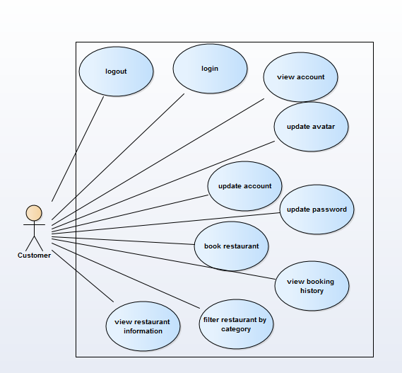

Figure 13 AGC customer use case diagram

##### Use Case Specification

###### UC002 – 01 Login

|  |  |  |  |  |  |  |
| --- | --- | --- | --- | --- | --- | --- |
| **Use Case ID** | | | | UC002 - 01 | **Version** | 1.0 |
| **Use Name** | | | | Login | | |
| **Actor** | | | | Admin or Restaurant owner or Customer | | |
| **Description** | | | | The function allows a user to login in the software when he/she have registered an account and his/her account is still active. | | |
| **Precondition** | | | | Enter <http://angivn.top/> in web browsers and click on login button in the top right of the header bar | | |
| **Trigger** | | | | Logging in dialog is displayed | | |
| **Post-Condition** | | | | User login to his/her account successful | | |
| **Main flows** | | | | | | |
| **Step** | **Actor** | | | **Action** | | |
| 1 | Customer | | | Enter user name & password into User Name & Password fields on the Login screen, then click on Login button. | | |
| 2 | AGC | | | Validate the entered user name & password and then display Home screen | | |
| **Alternative flows** | | | | | | |
| **AT1** | | on step 2 in the main flows**,** if AGC failed to validate user name & password | | | | |
| **Step** | | **Actor** | **Action** | | | |
| 1 | | AGC | Display dialog with message "Tên đăng nhập không đúng" | | | |
| 2 | | Customer | Click “ok” button | | | |
| 3 | | AGC | Return to login dialog | | | |
| **Business Rules:**  - User name is required  - Password is required | | | | | | |

###### UC002 – 02 Logout

|  |  |  |  |  |  |
| --- | --- | --- | --- | --- | --- |
| **Use Case ID** | | | UC002 - 02 | **Version** | 1.0 |
| **Use Name** | | | Logout | | |
| **Actor** | | | Admin or Restaurant owner or Customer | | |
| **Description** | | | The function allows a user to logout of the system | | |
| **Precondition** | | | users have logged in | | |
| **Trigger** | | | log out button is clicked | | |
| **Post-Condition** | | | home page is display with login button in the navigation bar | | |
| **Main flows** | | | | | |
| **Step** | **Actor** | | **Action** | | |
| 1 | Customer | | Click on logout button | | |
| 2 | AGC | | display home page with login button in the navigation bar | | |
| **Alternative flows** | | | | | |
| **AT1** | | N/A | | | |

###### UC002 – 03 View account

|  |  |  |  |  |
| --- | --- | --- | --- | --- |
| **Use Case ID** | | UC002 – 03 | **Version** | 1.0 |
| **Use Name** | | View account | | |
| **Actor** | | Customer | | |
| **Description** | | The function allows a user to view when he/she have registered an account and his/her account is still active. | | |
| **Precondition** | | User login AGC website by registered account | | |
| **Trigger** | | Clicks on Thông tin cá nhân | | |
| **Post-Condition** | | Show information of Customer in Account management screen | | |
| **Main flows** | | | | |
| **Step** | **Actor** | **Action** | | |
| 1 | Customer | Clicks on Thông tin cá nhân in AGC Dashboard | | |
| 2 | AGC | Display View Customer screen with the following fields:  - Left menu: avatar, ID AGC, User name, Account Information, Booking History, Password Change, Logout.  - Tên  - Email  - Ngày sinh  - Giới tính  - Cập nhật button | | |
| 3 | Customer | View all their information. | | |

###### UC002 – 04 Update account

|  |  |  |  |  |
| --- | --- | --- | --- | --- |
| **Use Case ID** | | UC002 - 04 | **Version** | 1.0 |
| **Use Name** | | Update account | | |
| **Actor** | | Customer | | |
| **Description** | | The function allows user to update his/her account information when he/she have registered an account and his/her account is still active. | | |
| **Precondition** | | User is staying in Account management screen | | |
| **Trigger** | | user profile page is displayed | | |
| **Post-Condition** | | Show new information of Customer in Account management screen | | |
| **Main flows** | | | | |
| **Step** | **Actor** | **Action** | | |
| 1 | Customer | Update his/ her account information:  - Tên  - Email  - Ngày sinh  - Giới tính  and clicks on Cập nhật button | | |
| 2 | Customer | New Account information of Customer will be updated into AGC system.  Successful confirmation message “Cập nhật thông tin thành công” will be shown. | | |

###### UC002 – 05 Update password

|  |  |  |  |  |  |  |
| --- | --- | --- | --- | --- | --- | --- |
| **Use Case ID** | | | UC002 – 05 | | **Version** | 1.0 |
| **Use Name** | | | Update password | | | |
| **Actor** | | | Customer | | | |
| **Description** | | | The function allows a user to update his/her new password when he/she have registered an account and his/her account is still active. | | | |
| **Precondition** | | | User is staying in Account management screen and selects Đổi mật khẩu on left menu | | | |
| **Trigger** | | | password page is displayed | | | |
| **Post-Condition** | | | Customer new password will be updated into AGC System and successful confirmation message will be shown | | | |
| **Main flows** | | | | | | |
| **Step** | **Actor** | | **Action** | | | |
| 1 | Customer | | Selects Đổi mật khẩu on left menu from Thông tin cá nhân screen | | | |
| 2 | AGC | | Display Update Password dialog with the following fields:  - Mật khẩu cũ  - Mật khẩu mới  - Gõ lại | | | |
| 3 | AGC Customer | | Enters old password, new password & new password again into three fields on the Change password screen then clicks on Cập nhật button. | | | |
| 4 | AGC | | Validate data and update new password for customer into AGC system.  Successful notification about password update and Login screen will be showed. | | | |
| **Alternative flows** | | | | | | |
| **AT1** | | At step 3 in the main flows**,** if AGC failed to validate password | | | | |
| **Step** | | **Actor** | | **Action** | | |
| 1 | | AGC | | Display dialog with message "Mật khẩu cũ không khớp" | | |
| 2 | | Customer | | Retypes again and clicks on Cập nhật button | | |
| **AT2** | | At step 3 in the main flows**,** if AGC failed to match new password | | | | |
| **Step** | | **Actor** | | **Action** | | |
| 3 | | AGC | | Display dialog with message "Mật khẩu nhập lại khớp" | | |
| 4 | | Customer | | Retypes again and clicks on Cập nhật button | | |

###### UC002 – 06 Book restaurant

|  |  |  |  |  |  |  |
| --- | --- | --- | --- | --- | --- | --- |
| **Use Case ID** | | | | UC002 - 06 | **Version** | 1.0 |
| **Use Name** | | | | Book restaurant | | |
| **Actor** | | | | Customer | | |
| **Description** | | | | Book tables on general restaurants | | |
| **Precondition** | | | | Logged in as customer, in restaurant index page | | |
| **Trigger** | | | | Restaurant index page is displayed | | |
| **Post-Condition** | | | | Restaurant receives booking tables detail | | |
| **Main flows** | | | | | | |
| **Step** | **Actor** | | | **Action** | | |
| 1 | Customer | | | Fill out input fields | | |
| 2 | Customer | | | Click on “lưu” button | | |
| 3 | AGC | | | display message “Cập nhật thông tin thành công” | | |
| **Alternative flows** | | | | | | |
| **AT1** | | on step 3 in the main flows**,** if AGC failed to validate | | | | |
| **Step** | | **Actor** | **Action** | | | |
| 1 | | AGC | display error message | | | |
| **Business rule:**   * (\*) fields cannot be empty * Restaurant owner must input accurate information | | | | | | |

###### UC002 – 07 View booking history

|  |  |  |  |  |
| --- | --- | --- | --- | --- |
| **Use Case ID** | | UC002 - 07 | **Version** | 1.0 |
| **Use Name** | | View booking history | | |
| **Actor** | | Customer | | |
| **Description** | | The function allows users to view their booking history | | |
| **Precondition** | | Logged in as customer, in “lịch sử đặt chỗ” page | | |
| **Trigger** | | Click on “lịch sử đặt chỗ” tab | | |
| **Post-Condition** | |  | | |
| **Main flows** | | | | |
| **Step** | **Actor** | **Action** | | |
| 1 | AGC | Display “lịch sử đặt chỗ” page | | |

###### UC002 – 08 Upload avatar

|  |  |  |  |  |  |
| --- | --- | --- | --- | --- | --- |
| **Use Case ID** | | | UC002-08 | **Version** | 1.0 |
| **Use Name** | | | Update avatar | | |
| **Actor** | | | Admin or Restaurant owner or Customer | | |
| **Description** | | | The function allows a user change his/her avatar | | |
| **Precondition** | | | Logged in system and stay in profile page | | |
| **Trigger** | | | Logged in system and stay in profile page, click ‘chon anh’ | | |
| **Post-Condition** | | | Changed avatar | | |
| **Main flows** | | | | | |
| **Step** | **Actor** | | **Action** | | |
| 1 | Customer | | Click on ‘chon anh’ | | |
| 2 | AGC | | Use CK editor to load upload file-browser UI | | |
| 3 | Customer | | Upload a picture by using CK editor API | | |
| 4 | Customer | | Chose a picture | | |
| 5 | AGC | | Display profile with new avatar with ‘Luu’ button after | | |
| 6 | Customer | | Click ‘save’ | | |
| 7 | AGC | | Change avatar | | |
| **Alternative flows** | | | | | |
| **AT1** | | On step 3 in the main flows**,** if user don’t upload image and chose an image in user’s library, skip step 3 | | | |

#### UC003 Restaurant owner management

##### Use Case Diagram

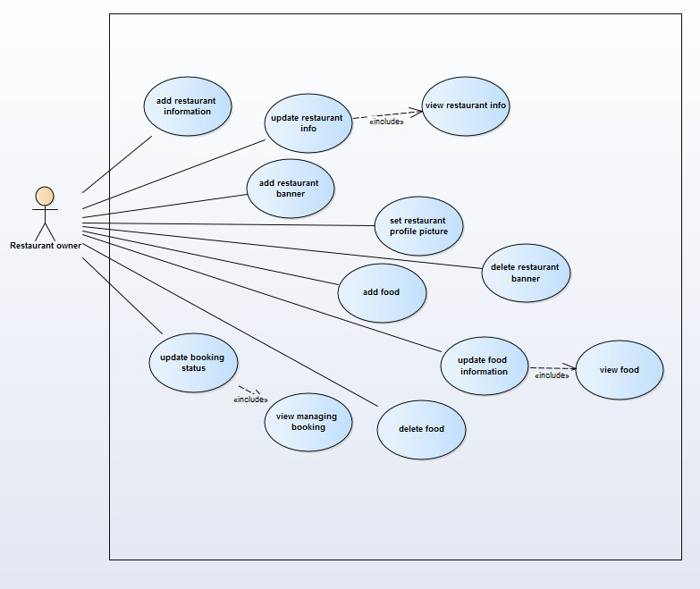

Figure 14 AGC restaurant owner use case diagram

##### Use Case Specification

###### UC003 - 01 Add restaurant information

|  |  |  |  |  |  |  |
| --- | --- | --- | --- | --- | --- | --- |
| **Use Case ID** | | | | UC003 - 01 | **Version** | 1.0 |
| **Use Name** | | | | Add restaurant information | | |
| **Actor** | | | | Restaurant owner | | |
| **Description** | | | | Add new restaurant information | | |
| **Precondition** | | | | Logged in as restaurant owner, view “Thông tin nhà hàng” page | | |
| **Trigger** | | | | Logged in as restaurant owner, view “Thông tin nhà hàng” page , and “Thông tin nhà hang” page is displayed | | |
| **Post-Condition** | | | | New restaurant information will be added | | |
| **Main flows** | | | | | | |
| **Step** | **Actor** | | | **Action** | | |
| 1 | restaurant owner | | | Add new information | | |
| 2 | restaurant owner | | | Click on “lưu” button | | |
| 3 | ACG | | | Validate data and saved to database | | |
| 4 | AGC | | | Display message “Cập nhật thông tin thành công” | | |
| **Alternative flows** | | | | | | |
| **AT1** | | On step 3 in the main flows**,** if AGC failed to validate | | | | |
| **Step** | | **Actor** | **Action** | | | |
| 1 | | AGC | Display error message | | | |
| **Business rule:**   * (\*) Fields cannot be empty * Restaurant owner must input accurate information | | | | | | |

###### UC003 - 02 Update restaurant info

|  |  |  |  |  |  |  |
| --- | --- | --- | --- | --- | --- | --- |
| **Use Case ID** | | | | UC003 - 02 | **Version** | 1.0 |
| **Use Name** | | | | Update restaurant info | | |
| **Actor** | | | | Restaurant owner | | |
| **Description** | | | | Update general information related to restaurant information | | |
| Precondition | | | | Logged in as restaurant owner, added restaurant information, view “Thông tin nhà hàng” page | | |
| **Trigger** | | | | Logged in as restaurant owner, added restaurant information, view “Thông tin nhà hàng” page , and “Thông tin nhà hang” page is displayed | | |
| **Post-Condition** | | | | Restaurant information will be updated | | |
| **Main flows** | | | | | | |
| **Step** | **Actor** | | | **Action** | | |
| 1 | restaurant owner | | | Modify information as need | | |
| 2 | restaurant owner | | | Click on “lưu” button | | |
| 3 | AGC | | | Validate information and save to database | | |
| 4 | AGC | | | Display message “Cập nhật thông tin thành công” | | |
| **Alternative flows** | | | | | | |
| **AT1** | | On step 3 in the main flows**,** if AGC failed to validate | | | | |
| **Step** | | **Actor** | **Action** | | | |
| 1 | | AGC | display error message | | | |
| **Business rule:**   * (\*) Fields cannot be empty * Restaurant owner must input accurate information | | | | | | |

###### UC003 – 03 Add restaurant banner

|  |  |  |  |  |  |
| --- | --- | --- | --- | --- | --- |
| **Use Case ID** | | | UC003 - 03 | **Version** | 1.0 |
| **Use Name** | | | Add restaurant banner | | |
| **Actor** | | | Restaurant owner | | |
| **Description** | | | The function helps restaurant owners to add new banner, only 6 images are allowed | | |
| **Precondition** | | | Logged in as restaurant owner, view “Banner nhà hàng” page | | |
| **Trigger** | | | Logged in as restaurant owner, view “Banner nhà hàng” page , and “Banner nhà hàng” page is displayed | | |
| **Post-Condition** | | | New restaurant banner will be added | | |
| **Main flows** | | | | | |
| **Step** | **Actor** | | **Action** | | |
| 1 | Restaurant owner | | Click on image icon | | |
| 2 | AGC | | Display file choosing dialog | | |
| 3 | Restaurant owner | | Choose an image, and click ok or choose | | |
| 4 | Restaurant owner | | Click on ‘lưu’ button | | |
| **Alternative flows** | | | | | |
| **AT1** | | N/A | | | |
| **Business Rules:**   * Add a proper image height, width, and size | | | | | |

###### UC003 – 04 Set restaurant profile picture

|  |  |  |  |  |  |
| --- | --- | --- | --- | --- | --- |
| **Use Case ID** | | | UC003 - 04 | **Version** | 1.0 |
| **Use Name** | | | Set restaurant profile picture | | |
| **Actor** | | | Restaurant owner | | |
| **Description** | | | This is a profile picture of a restaurant | | |
| **Precondition** | | | Logged in as restaurant owner, view user\_profile page | | |
| **Trigger** | | | Logged in as restaurant owner, view user\_profile page, click on “Chọn ảnh” button | | |
| **Post-Condition** | | | Restaurant profile picture will be set | | |
| **Main flows** | | | | | |
| **Step** | **Actor** | | **Action** | | |
| 1 | Restaurant owner | | Click on “Chọn ảnh” button | | |
| 2 | AGC | | Display file choosing dialog | | |
| 3 | Restaurant owner | | Click on upload button, and choose image file from his/her device then click OK button | | |
| 4 | Restaurant owner | | Move to images folder, then click on Choose button | | |
| 5 | AGC | | Redirect to user\_profile page | | |
| 6 | Restaurant owner | | Click on “Lưu” button | | |
| **Alternative flows** | | | | | |
| **AT1** | | N/A | | | |

###### UC003 – 05 Delete restaurant banner

|  |  |  |  |  |  |  |  |
| --- | --- | --- | --- | --- | --- | --- | --- |
| **Use Case ID** | | | | UC003 - 05 | **Version** | 1.0 | |
| **Use Name** | | | | Delete restaurant banner | | | |
| **Actor** | | | | Restaurant owner | | | |
| **Description** | | | | Delete banner image(s) | | | |
| **Precondition** | | | | Logged in as restaurant owner, added banner, and view “Banner nhà hàng” page | | | |
| **Trigger** | | | | Logged in as restaurant owner, added banner, view “Banner nhà hàng” page , and “Banner nhà hàng” page is displayed | | | |
| **Post-Condition** | | | | Restaurant banner picture will be removed | | | |
| **Main flows** | | | | | | | |
| **Step** | **Actor** | | | **Action** | | | |
| 1 | Restaurant owner | | | Click on “X” sign on the right corner of the picture(s) | | | |
| 2 | AGC | | | Display confirmation dialog | | | |
| 3 | Restaurant owner | | | Click on yes button | | | |
| 4 | AGC | | | Remove banner picture(s) | | | |
| **Alternative flows** | | | | | | | |
| **AT1** | | On step 2 in the main flows**,** if restaurant owner click on No | | | | |
| **Step** | | **Actor** | **Action** | | | |
| 1 | | AGC | Does not make any changes | | | |

###### UC003 – 06 Add food

|  |  |  |  |  |  |  |
| --- | --- | --- | --- | --- | --- | --- |
| **Use Case ID** | | | | UC003 - 06 | **Version** | 1.0 |
| **Use Name** | | | | Add food | | |
| **Actor** | | | | Restaurant owner | | |
| **Description** | | | | The function help owner add new food to his/her restaurant menu | | |
| **Precondition** | | | | Logged in as restaurant owner and view ‘môn ăn’ tab on restaurant info page | | |
| **Trigger** | | | | Logged in as restaurant owner, view ‘món ăn’ tab on restaurant info page, and click ‘Thêm món ăn’ button | | |
| **Post-Condition** | | | | A new food will be added | | |
| **Main flows** | | | | | | |
| **Step** | **Actor** | | | **Action** | | |
| 1 | AGC | | | Display add food dialog | | |
| 2 | Restaurant owner | | | Add correct info to the input fields | | |
| 3 | Restaurant owner | | | Click on cập nhập món ăn button | | |
| 4 | AGC | | | Validate input and add food to database | | |
| **Alternative flows** | | | | | | |
| **AT1** | | At step 3 in the main flows**,** if users click on Đóng button | | | | |
| **Step** | | **Actor** | **Action** | | | |
| 1 | | AGC | Close food dialog | | | |
| **AT2** | | At step 4 in the main flows**,** if the system fail to validate data | | | | |
| **Step** | | **Actor** | **Action** | | | |
| 1 | | AGC | Display error message | | | |
| **Business Rules:**  - ‘Tên’ is required  - ‘Giá’ is required  - if user type un-number character to ‘Giá’ field, add 0 to price in database.  - if user don’t up picture, use default food picture. | | | | | | |

###### UC003 – 07 Update food information

|  |  |  |  |  |  |  |
| --- | --- | --- | --- | --- | --- | --- |
| **Use Case ID** | | | | UC003 - 07 | **Version** | 1.0 |
| **Use Name** | | | | Update food information | | |
| **Actor** | | | | Restaurant owner | | |
| **Description** | | | | Update information for food | | |
| **Precondition** | | | | Logged in as restaurant owner and view ‘món ăn’ tab on restaurant info page | | |
| **Trigger** | | | | Logged in as restaurant owner and in ‘món ăn’ tab on restaurant info page, and click ‘sửa món ăn’ button | | |
| **Post-Condition** | | | | Food information will be updated | | |
| **Main flows** | | | | | | |
| **Step** | **Actor** | | | **Action** | | |
| 1 | AGC | | | Display add food dialog | | |
| 2 | Restaurant owner | | | Modify information as needed | | |
| 3 | Restaurant owner | | | Click on cập nhập món ăn button | | |
| 4 | AGC | | | Validate input and add food to database | | |
| **Alternative flows** | | | | | | |
| **AT1** | | At step 3 in the main flows**,** if users click on Đóng button | | | | |
| **Step** | | **Actor** | **Action** | | | |
| 1 | | AGC | Close food dialog | | | |
| **AT2** | | At step 4 in the main flows**,** if the system fail to validate data | | | | |
| **Step** | | **Actor** | **Action** | | | |
| 1 | | AGC | Display error message | | | |
| **Business Rules:**   * (\*) Fields cannot be empty * Restaurant owner must input accurate information | | | | | | |

###### UC003 – 08 Update booking status

|  |  |  |  |  |
| --- | --- | --- | --- | --- |
| **Use Case ID** | | UC003 - 08 | **Version** | 1.0 |
| **Use Name** | | Update booking status | | |
| **Actor** | | Restaurant owner | | |
| **Description** | | Update booking status for customers | | |
| **Precondition** | | Logged in as restaurant owner and view ‘Quản lý đặt chỗ’ page | | |
| **Trigger** | | Logged in as restaurant owner and in ‘Quản lý đặt chỗ’ page, and view click on book status tap | | |
| **Post-Condition** | | Booking status will be updated | | |
| **Main flows** | | | | |
| **Step** | **Actor** | **Action** | | |
| 1 | Restaurant owner | Change booking status | | |
| 2 | Restaurant owner | Click on “cập nhật” button | | |
| 3 | AGC | Update booking status | | |

#### UC004 Guest management

##### Use Case Diagram

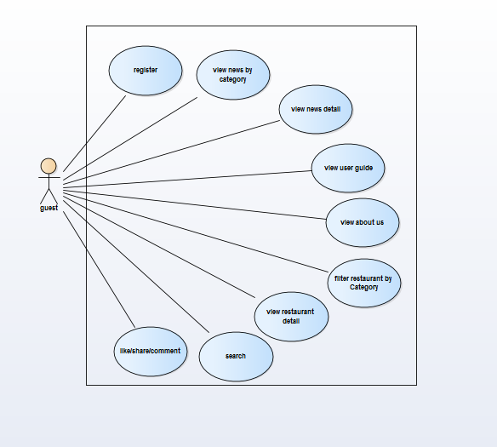

Figure 15 AGC guest use case diagram

##### Use Case Specification

###### UC004 – 01 Register

|  |  |  |  |  |  |  |
| --- | --- | --- | --- | --- | --- | --- |
| **Use Case ID** | | | UC004 - 01 | | **Version** | 1.0 |
| **Use Name** | | | Register | | | |
| **Actor** | | | Guest | | | |
| **Description** | | | The function allows a user to register new account | | | |
| **Precondition** | | | User is staying on Home page | | | |
| **Trigger** | | | Click on register button | | | |
| **Post-Condition** | | | User has an account in AGC | | | |
| **Main flows** | | | | | | |
| **Step** | **Actor** | | **Action** | | | |
| 1 | Guest | | Click on register button in the top right of home page | | | |
| 2 | AGC | | Display register page with the following fields:  - Tên đầy đủ(\*)  - Tên đăng nhập(\*)  - Mật khẩu(\*)  - Mật khẩu(Re) (\*)  - Tỉnh/Thành phố(\*)  - Quận/Huyện  - Xã/Phường  - Địa chỉ  - Ngày sinh  - Giới tính  - Loại | | | |
| 3 | Guest | | Enter information to input form | | | |
| 4 | AGC | | Validate the entered information and then go to success page | | | |
| **Alternative flows** | | | | | | |
| **AT1** | | At step 4 in the main flows**,** if AGC failed to validate | | | | |
| **Step** | | **Actor** | | **Action** | | |
| 1 | | AGC | | Back to register page with all error message | | |
| 2 | | Guest | | Input good information | | |
| 3 | | AGC | | Validate the entered information and then go to success page | | |
| **Business Rules:**   * (\*) field is required * “Mật khẩu” have to match “Mật khẩu(Re)” | | | | | | |

###### UC004 – 02 View news by category

|  |  |  |  |  |
| --- | --- | --- | --- | --- |
| **Use Case ID** | | UC004 - 02 | **Version** | 1.0 |
| **Use Name** | | View news by category | | |
| **Actor** | | Guest | | |
| **Description** | | The function allows a user to find all news base on category | | |
| **Precondition** | | User is staying on Home page | | |
| **Trigger** | | Choose link on new category | | |
| **Post-Condition** | | Stay in news page with chosen category | | |
| **Main flows** | | | | |
| **Step** | **Actor** | **Action** | | |
| 1 | Guest | Click on news button in the top menu | | |
| 2 | AGC | Display drop down dialog with all category: | | |
| 3 | Guest | Click on one of category | | |
| 4 | AGC | Move to News page list all items that match this category | | |
| **Business rule**   * News page has pagination, each “child” page has maximum 20 items(news) * Category items is loaded from database dynamically | | | | |

###### UC004 – 03 View news detail

|  |  |  |  |  |
| --- | --- | --- | --- | --- |
| **Use Case ID** | | UC004 - 03 | **Version** | 1.0 |
| **Use Name** | | View news detail | | |
| **Actor** | | Guest | | |
| **Description** | | The function allows a user read info of a news | | |
| **Precondition** | | User saw news in News page or at the bottom of home page | | |
| **Trigger** | | Click on news tab | | |
| **Post-Condition** | | Stay in new detail page that show all info about this new | | |
| **Main flows** | | | | |
| **Step** | **Actor** | **Action** | | |
| 1 | Guest | Click on news avatar | | |
| 2 | AGC | Move to new detail of this new | | |

###### UC004 – 04 View user guide

|  |  |  |  |  |
| --- | --- | --- | --- | --- |
| **Use Case ID** | | UC004 - 04 | **Version** | 1.0 |
| **Use Name** | | View user guide | | |
| **Actor** | | Guest | | |
| **Description** | | The function allows a user read guide for this website | | |
| **Precondition** | | User is staying in home page | | |
| **Trigger** | | Click on user guide link | | |
| **Post-Condition** | | Move to guide page | | |
| **Main flows** | | | | |
| **Step** | **Actor** | **Action** | | |
| 1 | Guest | Click on “Hướng dẫn” link in the top menu | | |
| 2 | AGC | Move to user guide page | | |

###### UC004 – 05 View about as

|  |  |  |  |  |  |  |
| --- | --- | --- | --- | --- | --- | --- |
| **Use Case ID** | | | UC004 - 05 | | **Version** | 1.0 |
| **Use Name** | | | View about us | | | |
| **Actor** | | | Guest | | | |
| **Description** | | | The function allows a user read more info about website | | | |
| **Precondition** | | | User is staying in home page | | | |
| **Trigger** | | | Click on about us link | | | |
| **Post-Condition** | | | Show info page | | | |
| **Main flows** | | | | | | |
| **Step** | **Actor** | | **Action** | | | |
| 1 | Guest | | Click on “Hướng dẫn” link in the top menu | | | |
| 2 | AGC | | Show drop box has 2 link “Về chúng tôi” and “Đối tác” | | | |
| 3 | Guest | | Click on “Về chúng tôi” | | | |
| 4 | AGC | | Show info in about us page | | | |
| **Alternative flows** | | | | | | |
| **AT1** | | At step 2 in the main flows**,** if user clink on “Đối tác” | | | | |
| **Step** | | **Actor** | | **Action** | | |
| 1 | | AGC | | Move to partner info page | | |

###### UC004 – 06 Filter restaurant by category

|  |  |  |  |  |
| --- | --- | --- | --- | --- |
| **Use Case ID** | | UC004 - 06 | **Version** | 1.0 |
| **Use Name** | | Filter restaurant by category | | |
| **Actor** | | Guest | | |
| **Description** | | The function show all restaurant in a category | | |
| **Precondition** | | User stay in home page of AGC website | | |
| **Trigger** | | Click on a category | | |
| **Post-Condition** | | Show search result page with list of restaurant suitable with category | | |
| **Main flows** | | | | |
| **Step** | **Actor** | **Action** | | |
| 1 | Guest | Point to “Ẩm thực” on the top menu | | |
| 2 | AGC | Drop dialog to show all categories | | |
| 3 | Guest | Click on a category | | |
| 4 | AGC | Move to category page and show restaurant | | |

###### UC004 – 07 View restaurant information

|  |  |  |  |  |
| --- | --- | --- | --- | --- |
| **Use Case ID** | | UC004 - 07 | **Version** | 1.0 |
| **Use Name** | | View restaurant information | | |
| **Actor** | | Guest | | |
| **Description** | | This function help user view detail of a restaurant | | |
| **Precondition** | | Can view, find restaurants (stay in home, search result, category page) | | |
| **Trigger** | | Click on restaurant avatar | | |
| **Post-Condition** | | Show restaurant detail page | | |
| **Main flows** | | | | |
| **Step** | **Actor** | **Action** | | |
| 1 | Guest | Click on a restaurant avatar | | |
| 2 | AGC | Move to restaurant detail page | | |
| 3 | Guest | Click on tab “Bảng giá” under restaurant name | | |
| 4 | AGC | Show tap “Bảng giá” that have more info about menu and price | | |

###### UC004 – 08 View restaurant detail

|  |  |  |  |  |  |  |
| --- | --- | --- | --- | --- | --- | --- |
| **Use Case ID** | | | UC007 - 08 | | **Version** | 1.0 |
| **Use Name** | | | View restaurant detail | | | |
| **Actor** | | | Guest | | | |
| **Description** | | | The function allows a user to login in the software when he/she have registered an account and his/her account is still active. | | | |
| **Precondition** | | | User is staying on Home page | | | |
| **Trigger** | | | Click on login button | | | |
| **Post-Condition** | | | User login to his/her account successful | | | |
| **Main flows** | | | | | | |
| **Step** | **Actor** | | **Action** | | | |
| 1 | Guest | | Click on login button in the top right of home page | | | |
| 2 | AGC | | Display Login dialog with the following fields:  - User Name  - Password  - Login and Close button | | | |
| 3 | Guest | | Enter user name & password into User Name & Password fields on the Login screen, then click on Login button. | | | |
| 4 | AGC | | Validate the entered user name & password and then display Home screen | | | |
| **Alternative flows** | | | | | | |
| **AT1** | | At step 4 in the main flows**,** if AGC failed to validate user name & password | | | | |
| **Step** | | **Actor** | | **Action** | | |
| 4.1 | | AGC | | Display dialog with message "Tên đăng nhập không đúng" | | |
| 4.2 | | Guest | | Click “ok” button | | |
| 4.3 | | AGC | | Return to login dialog | | |

###### UC004 – 09 Search

|  |  |  |  |  |  |  |
| --- | --- | --- | --- | --- | --- | --- |
| **Use Case ID** | | | | UC004 - 09 | **Version** | 1.0 |
| **Use Name** | | | | Search | | |
| **Actor** | | | | Guest | | |
| **Description** | | | | The function allows a user to find restaurant | | |
| **Precondition** | | | | User staying in home pages | | |
| **Trigger** | | | | search icon is clicked | | |
| **Post-Condition** | | | | Show search result page with list of restaurant suitable with keyword | | |
| **Main flows** | | | | | | |
| **Step** | **Actor** | | | **Action** | | |
| 1 | Guest | | | Input keyword to search box | | |
| 2 | Guest | | | Click on search icon next to search box | | |
| 3 | AGC | | | Move to search result page | | |
| 4 | Guest | | | Click on filter link on left navigation | | |
| 5 | AGC | | | Filter result base on user’s choice | | |
|  |  | | |  | | |
| **Alternative flows** | | | | | | |
| **AT1** | | At step 2 in the main flows**,** if user clink on “Đối tác” | | | | |
| **Step** | | **Actor** | **Action** | | | |
| 1 | | AGC | Show all restaurant in result page | | | |
| **Business rule:**   * Result will show restaurants have name or description include keyword * Left navigation will filter result by category and location | | | | | | |

###### UC004 – 10 Like/unlike

|  |  |  |  |  |
| --- | --- | --- | --- | --- |
| **Use Case ID** | | UC004-10 | **Version** | 1.0 |
| **Use Name** | | Like/unlike | | |
| **Actor** | | Guest | | |
| **Description** | | The function allows a user to like a restaurant by using Facebook API. | | |
| **Precondition** | | User is staying on Restaurant Detail page and logged in to his/her Facebook account. | | |
| **Trigger** | | Click on like/unlike icon | | |
| **Post-Condition** | | increase/decrease like on the page | | |
| **Main flows** | | | | |
| **Step** | **Actor** | **Action** | | |
| 1 | Guest | Click on like icon in the bottom of restaurant detail | | |
| 2 | AGC | Using Facebook API to increase/decrease new like to this restaurant detail page and update like number and change ‘Like’ button to like/unlike | | |
|  |  |  | | |

###### UC004 – 11 Comment

|  |  |  |  |  |
| --- | --- | --- | --- | --- |
| **Use Case ID** | | UC004-11 | **Version** | 1.0 |
| **Use Name** | | Comment | | |
| **Actor** | | Guest | | |
| **Description** | | The function allows a user to comment about a restaurant. | | |
| **Precondition** | | User is staying on Restaurant Detail page and logged in to his/her Facebook account. | | |
| **Trigger** | | Click on ‘Post’ icon | | |
| **Post-Condition** | | User add comment to this restaurant. | | |
| **Main flows** | | | | |
| **Step** | **Actor** | **Action** | | |
| 1 | Guest | Click on Comment box of Facebook at the bottom of restaurant Detail | | |
| 2 | AGC | Using Facebook API to enable Post button | | |
| 3 | Guest | Write comment to box and click ‘Post’ button | | |
| 4 | AGC | Using Facebook API to add his/her comment to this restaurant detail page | | |
|  |  |  | | |

###### UC004 – 12 Share

|  |  |  |  |  |
| --- | --- | --- | --- | --- |
| **Use Case ID** | | UC004 - 11 | **Version** | 1.0 |
| **Use Name** | | Share | | |
| **Actor** | | Guest | | |
| **Description** | | The function allows a user to share a restaurant by using Facebook API. | | |
| **Precondition** | | User is staying on Restaurant Detail page and logged in to his/her Facebook account. | | |
| **Trigger** | | Click on ‘Share’ icon | | |
| **Post-Condition** | | User share this restaurant to his/her Facebook page | | |
| **Main flows** | | | | |
| **Step** | **Actor** | **Action** | | |
| 1 | Guest | Click on share icon in the bottom of restaurant detail | | |
| 2 | AGC | Using Facebook API to share this restaurant link to Actor’s Facebook profile | | |

### Non-functional Specification

#### Reliability

* Errors should occurs no more than10 times a year
* The mean time among failures should not more than one month

#### Performance Requirements

##### Availability

The system must be available to the users 24 hours a day, 7 days a week (not consider network failure) and also available for all smart phones, tablets and computers.

##### Response time

The maximum response time for any processes must be no longer than 10 seconds. However, it also depends on the internet bandwidth the network coverage’s condition.

#### User Interface

##### Arrangement

There are 3 main parts in a web page:

* herder/navigation bar: shows main topics tabs
* body: shows main contents
* footer: shows additional information about AGC system

In some pages there might also be a sidebar.

##### Color

Background color is white, red color theme to attract users

##### Text

Vietnamese font format.

#### Design Constraints

* Tra Da team must to follow MVC design pattern in CodeIgniter framework.
* GUI must not confuse users, developing team have to use the most familiar design to users.
* The system should not disclose too much information but rich enough for users need.
* Since the system is a data centric system, database management is crucially important, both primary key and foreign key constraints are carefully identified, as well as Entity, data types, relationship, attributes and null able values.

#### Security Requirements

The system should prevent all SQL injections, and keep users information securely by encrypt password using MD5 technology, and only authorized user can access his/her own private information.

#### Software Requirements

All data is stored on the server, therefore users need to have only electronic devices those have a web browser and internet connection.

**PART 4   
SOFTWARE DESIGN DOCUMENTS**

# SOFTWARE DESIGN DOCUMENTS

## ARCHITECTURE DESIGN

### Choice of Architecture Design

In this project we follow Model View Viewmodel (MVVM) architecture and use CodeIgniter framework to implement the system.

#### Introduction to CodeIgniter

CodeIgniter is an Application Development Framework - a toolkit - for people who build web sites using PHP. Its goal is to enable you to develop projects much faster than you could if you were writing code from scratch, by providing a rich set of libraries for commonly needed tasks, as well as a simple interface and logical structure to access these libraries. CodeIgniter lets you creatively focus on your project by minimizing the amount of code needed for a given task.

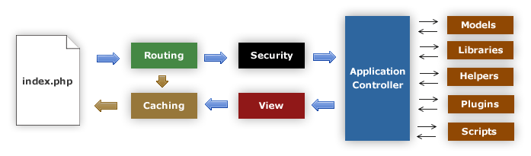

Figure 16 CodeIgniter flow chart

#### Model-View-Controller in CodeIgniter

CodeIgniter is based on the Model-View-Controller development pattern. MVC is a software approach that separates application logic from presentation. In practice, it permits your web pages to contain minimal scripting since the presentation is separate from the PHP scripting.

* The Model represents your data structures. Typically your model classes will contain functions that help you retrieve, insert, and update information in your database.
* The View is the information that is being presented to a user. A View will normally be a web page, but in CodeIgniter, a view can also be a page fragment like a header or footer. It can also be an RSS page, or any other type of “page”.
* The Controller serves as an intermediary between the Model, the View, and any other resources needed to process the HTTP request and generate a web page.

CodeIgniter has a fairly loose approach to MVC since Models are not required. If you don’t need the added separation, or find that maintaining models requires more complexity than you want, you can ignore them and build your application minimally using Controllers and Views. CodeIgniter also enables you to incorporate your own existing scripts, or even develop core libraries for the system, enabling you to work in a way that makes the most sense to you.

### Architectural Presentation

Web browser

AGC

Presentation Layer

(CodeIgniter)

View Model

View

Controller

Data model

(CodeIgniter)

Database

(MySql)

Figure 17 AGC101 System overview

Package Design

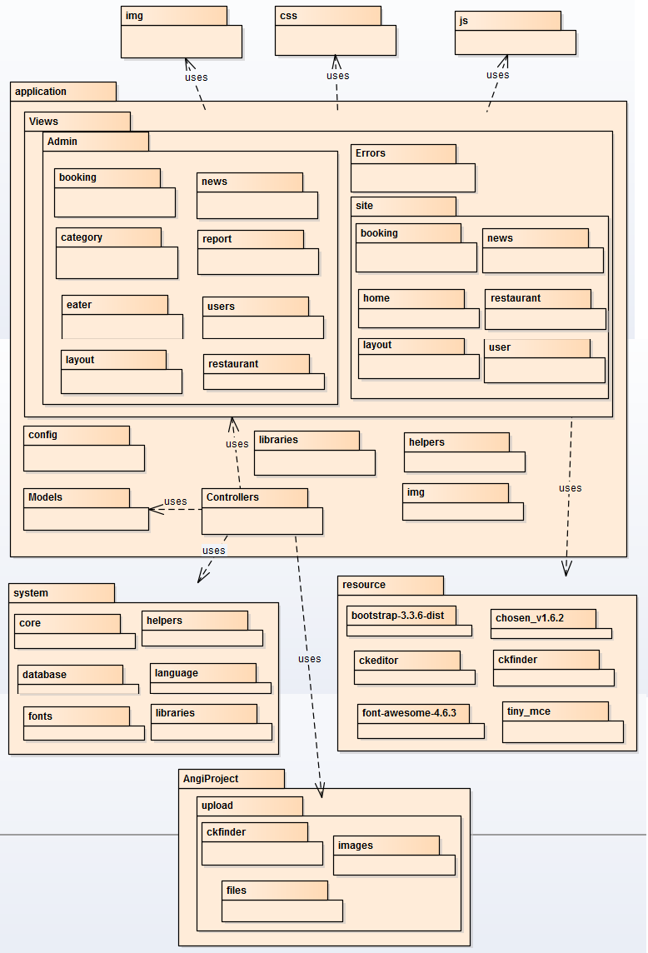

Figure 18 AGC Package Diagram

## DETAILED DESIGN

### Class Description

#### Admin

|  |  |  |  |  |
| --- | --- | --- | --- | --- |
| Class | Admin | | | |
| **Description** | Include all functions and display screen of administrator. | | | |
| **Base Class** | CI\_Controller | | | |
| **Constructor** | \_\_construct | | | |
| **Prototype** | N/A | | | |
| **Source File** | Admin.php | | | |
| **Namespace** | N/A | | | |
| **Attributes** | N/A | | | |
| **Methods** | Name | Input | Output | Description |
| index | N/A | Null | Display main screen of administrator. |
| news | offset | Null | Display list news screen. |
| add\_news | N/A | Null | Display screen to add new news and insert into database |
| edit\_news | newsID | Null | Display screen to update a news and update into database |
| delete\_news | newsID | Null | Delete a news in database |
| restaurant | offset | Null | Display list restaurants screen |
| validateRestaurant | data, error | String | Check input data. |
| edit\_restaurant | restaurantID | Null | Display screen to active and rate a restaurant and update into database |
| delete\_restaurant | restaurantID | Null | Delete a restaurant in database |
| info\_food | foodID | Null | Display informations foods of restaurant |
| returnError | msg | String | Return error message |
| returnSuccess | msg | String | Return success message |
| getDistrictByProvinceId | provinceID | Null | Get information of district by province’s id |
| getWardByDistrictId | districtID | Null | Get information of ward by district’s id |
| eater | level, offset | Null | Display list accounts of eaters and restaurants |
| edit\_eater | eaterID | Null | Display screen to active accounts of eaters or restaurants and update into database |
| delete\_eater | eaterID,level | Null | Delete a account in database |
| categories | N/A | Null | Display list categories screen. |
| add\_category | N/A | Null | Display screen to add a category and insert into database |
| edit\_category | categoryID | Null | Display screen to edit a category and update into database |
| booking | offset | Null | Display list booking of restaurants screen. |
| show\_booking | bookingID | Null | Display detail booking screen. |
| report\_statistics | N/A | Null | Display statistics report of website screen. |
| getConfig | N/A | Array | Paging for website |
| setting | N/A | Null | Setting website |
| check\_id | id,uri | Null | Check account’s id |
| Error | value | String | Display error on screen. |

Table 13: Admin class description

#### Home

|  |  |  |  |  |
| --- | --- | --- | --- | --- |
| Class | Home | | | |
| **Description** | Include all functions and display screen of the homepage. | | | |
| **Base Class** | CI\_Controller | | | |
| **Constructor** | \_\_construct | | | |
| **Prototype** | N/A | | | |
| **Source File** | Home.php | | | |
| **Namespace** | N/A | | | |
| **Attributes** | N/A | | | |
| **Methods** | Name | Input | Output | Description |
| getConfig | N/A | Array | Paging for website |
| index | N/A | Null | Display home screen of website. |
| search | categoryID, districtID, keyword, offset | Null | Display all restaurants by searched keyword. |
| category | categoryID, offset | Null | Display all restaurants by category |
| home\_view\_all | title, type, offset | Null | Display all restaurants sort by rating or discount. |
| news | categoryID, offset | Null | Display all news in website |
| newsDetails | newsID | Null | Display news detail. |
| login | N/A | Null | Display login dialog. |
| logout | N/A | Null | Logout account. |
| signup | N/A | Null | Dislay signup screen and insert account into database. |
| getDistrictByProvinceId | provinceID | Null | Get information of district by province’s id |
| getWardByDistrictId | districtID | Null | Get information of ward by district’s id |
| returnError | msg | Array | Return error message. |
| returnSuccess | msg | Array | Return success message. |
| GetNameOfTypeNews | categoryID | String | Return type of news. |

Table 14: Home class description

#### Restaurant

|  |  |  |  |  |
| --- | --- | --- | --- | --- |
| Class | Restaurant | | | |
| **Description** | Include all functions and display screen of restaurant. | | | |
| **Base Class** | CI\_Controller | | | |
| **Constructor** | \_\_construct | | | |
| **Prototype** | N/A | | | |
| **Source File** | Restaurant.php | | | |
| **Namespace** | N/A | | | |
| **Attributes** | N/A | | | |
| **Methods** | Name | Input | Output | Description |
| view | restaurantID | Null | Display restaurant detail screen |
| sendBooking | N/A | String | Send table booking to restaurant and insert into database. |
| returnError | msg | Array | Return error message. |
| returnSuccess | msg | Array | Return success message. |

Table 15: Restaurant class description

#### User\_profile

|  |  |  |  |  |
| --- | --- | --- | --- | --- |
| Class | User\_profile | | | |
| **Description** | Include all functions and display screen of user profile. | | | |
| **Base Class** | CI\_Controller | | | |
| **Constructor** | \_\_construct | | | |
| **Prototype** | N/A | | | |
| **Source File** | User\_profile.php | | | |
| **Namespace** | N/A | | | |
| **Attributes** | N/A | | | |
| **Methods** | Name | Input | Output | Description |
| getConfig | N/A | Array | Paging for website |
| index | N/A | Null | Display profile screen of user. |
| restaurant\_add | N/A | Null | Display information of restaurant for restaurant account to add new information and insert into database. |
| restaurant\_edit | N/A | Null | Display information of restaurant for restaurant account to edit and update information restaurant into database |
| add\_food | N/A | Null | Display screen to add food for restaurant and insert into database. |
| info\_food | foodID | Null | Display food’s information screen. |
| delete\_food | foodID | Null | Delete food in restaurant and delete food in database. |
| edit\_food | foodID | Null | Display food’s information screen, edit and update information of food in database. |
| addoredit\_food | foodID | Null | Check action add or edit food. |
| validateRestaurant | data, error | String | Check input data of restaurant and return warning message. |
| change\_Password | N/A | Null | Display screen to change password and update into database. |
| changeAvatar | N/A | Null | Change avatar for account. |
| Restaurant\_Banner | offset | Null | Display screen to change banner for restaurant account |
| delete\_restaurant\_banner | bannerID | Null | Delete banner of restaurant. |
| add\_restaurant\_banner | N/A | Null | Add banner for restaurant |
| restaurant\_manage\_booking | offset | Null | Display screen to manage booking of customer for restaurant account. |
| user\_manage\_booking | offset | Null | Display history of booking for customer |
| edit\_booking | bookingID | Null | Display screen to edit information of booking and update into database for restaurant account. |
| info\_booking | bookingID | Null | Display booking’s information screen. |
| check\_id | id, uri | Null | Check id is number. |
| Success | value | String | Return success message with html. |
| Error | value | String | Return error message with html. |
| returnError | msg | Array | Return error message without html. |
| returnSuccess | msg | Array | Return error message without html. |

Table 16: User\_profile class description

#### Ckfinder

|  |  |  |  |  |
| --- | --- | --- | --- | --- |
| Class | Ckfinder | | | |
| **Description** | Include all commands of ckfinder, which is tool to upload image. | | | |
| **Base Class** | N/A | | | |
| **Constructor** | N/A | | | |
| **Prototype** | N/A | | | |
| **Source File** | Ckfinder.php | | | |
| **Namespace** | N/A | | | |
| **Attributes** | N/A | | | |
| **Methods** | Name | Input | Output | Description |
| setProjectPath | path | Null | Create name of project. |
| setCkfinderSourcePath | path | Null | Create link into folder |
| setAuthentication | status | Null | Check authentication. |
| setConnectorPath | path | Null | Create connection. |
| setFolderUpload | path | Null | Create folder to upload and save image |
| startConnector | N/A | Null | Start connector. |
| getHTML | N/A | Null | Get html code of ckfinder. |

Table 17: Ckfinder class description

### UC001: Admin Management

#### Class diagram

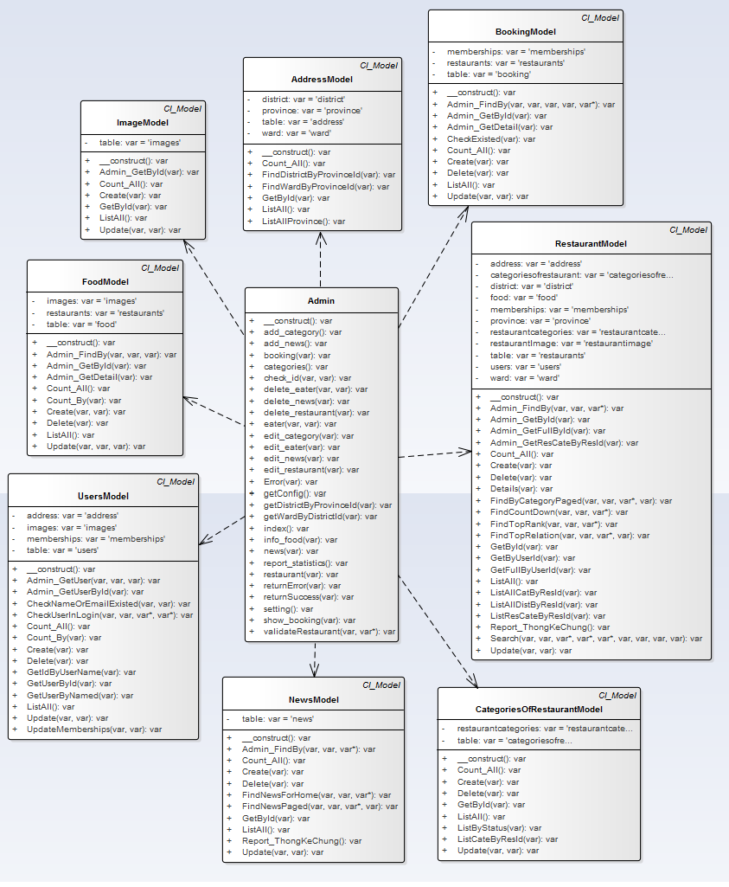

Figure 19 Admin class diagram

#### UC001 – 01 Write news

##### Screen Design

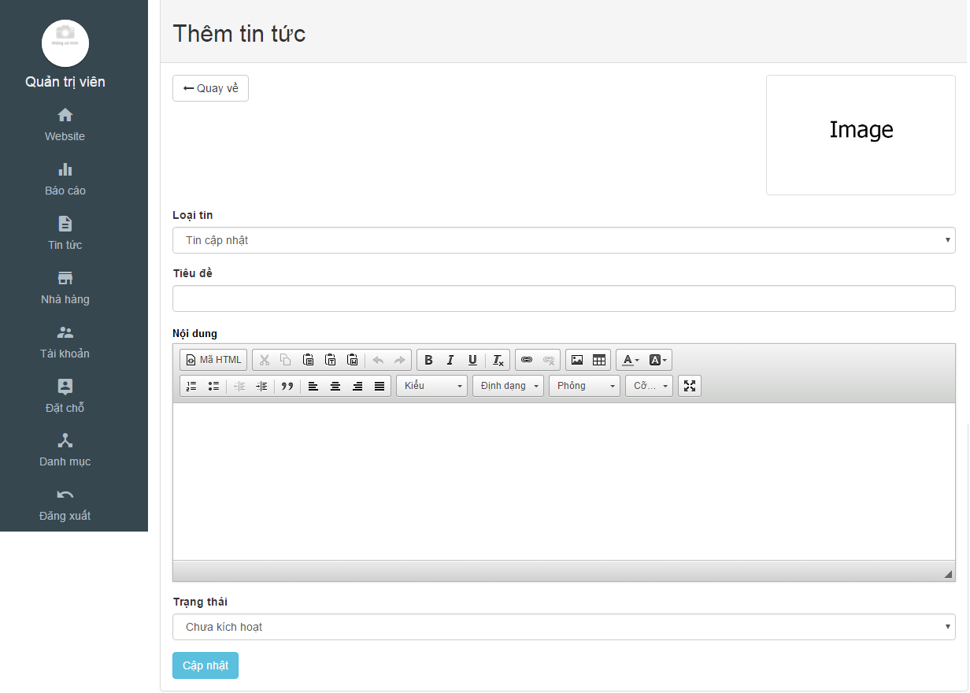

Figure 20 Write new screen

|  |  |  |  |  |  |  |
| --- | --- | --- | --- | --- | --- | --- |
| **No** | **Object/ Control Name** | **Object/ Control Name in English** | **Type** | **Required** | **Length** | **Description** |
| 1 | Image | Image | Image | Yes | N/A | Image of news |
| 2 | Loại tin | Type of news | Text-box | Yes | N/A | Type of news |
| 3 | Tiêu đề | Title | Text-box | Yes | N/A | Title of news |
| 4 | Nội dung | Content | Text-box | Yes | N/A | Content of news |
| 5 | Trạng thái | Status | Combobox | Yes | N/A | Status of news |
| 6 | Cập nhật | Update | Button | Yes | N/A | Click to add a news |
| 7 | Quay về | Back | Button | Yes | N/A | Return to list news |

Table 18: Write new screen description

##### Sequence Diagram

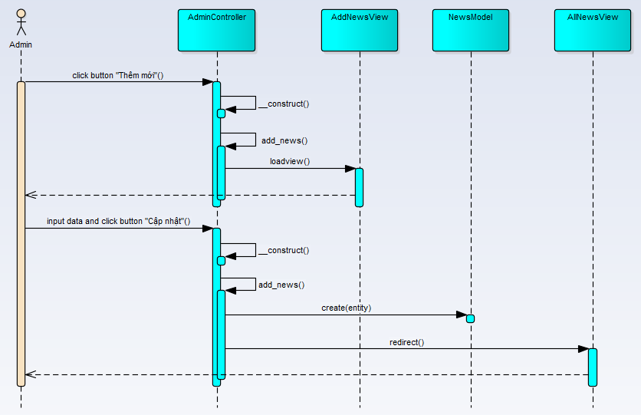

Figure 21 Write news sequence diagram

#### UC001 – 02 Create category

##### Screen Design

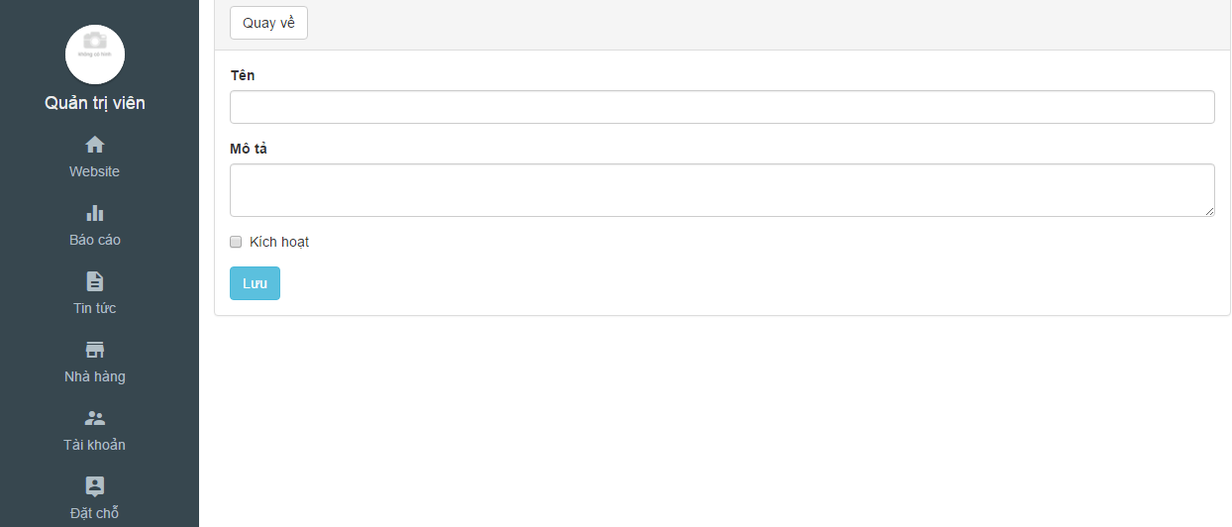

Table 19: Create category screen

|  |  |  |  |  |  |  |
| --- | --- | --- | --- | --- | --- | --- |
| **No** | **Object/ Control Name** | **Object/ Control Name in English** | **Type** | **Required** | **Length** | **Description** |
| 1 | Tên | Name | Text-box | Yes | N/A | Name of category |
| 2 | Mô tả | Description | Text-box | Yes | N/A | Content of category |
| 3 | Kích hoạt | Active | Check-box | Yes | N/A | Status of category |
| 4 | Lưu | Save | Button | Yes | N/A | Click to add a category |
| 5 | Quay về | Back | Button | Yes | N/A | Return to list category |

Table 20: Create category description

##### Sequence Diagram

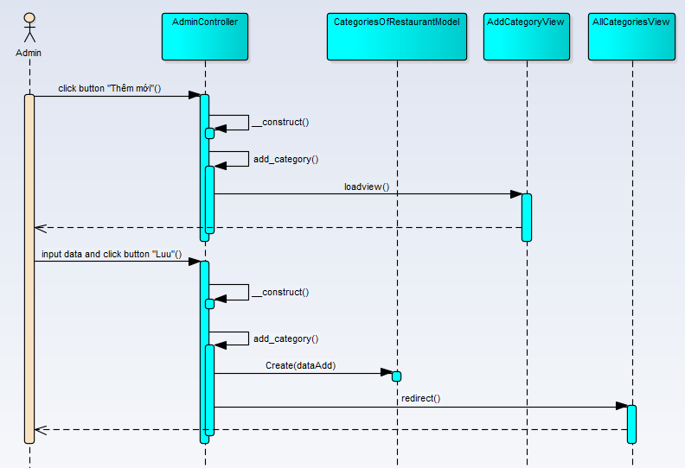

Figure 22 Create category sequence diagram

#### UC001 – 03 Update news

##### Screen Design

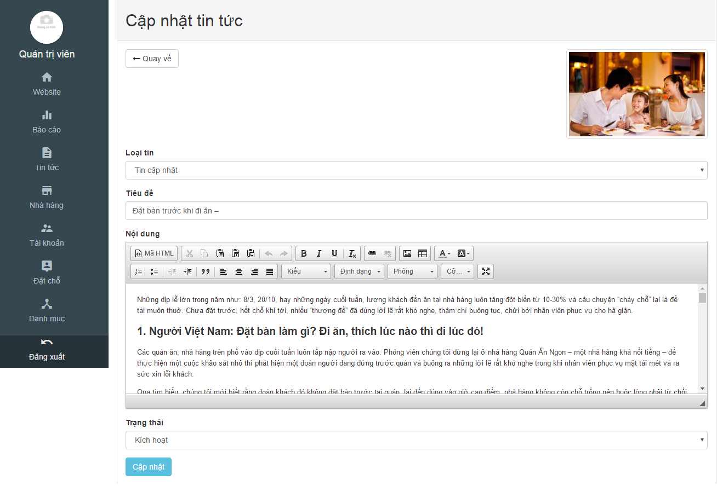

Figure 23 Update new screen

|  |  |  |  |  |  |  |
| --- | --- | --- | --- | --- | --- | --- |
| **No** | **Object/ Control Name** | **Object/ Control Name in English** | **Type** | **Required** | **Length** | **Description** |
| 1 | Image | Image | Image | Yes | N/A | Image of news |
| 2 | Loại tin | Type of news | Text-box | Yes | N/A | Type of news |
| 3 | Tiêu đề | Title | Text-box | Yes | N/A | Title of news |
| 4 | Nội dung | Content | Text-area | Yes | N/A | Content of news |
| 5 | Trạng thái | Status | Check-box | Yes | N/A | Status of news |
| 6 | Cập nhật | Update | Button | Yes | N/A | Click to update news |
| 7 | Quay về | Back | Button | Yes | N/A | Return to list news |

Table 21: Update new description

##### Sequence Diagram

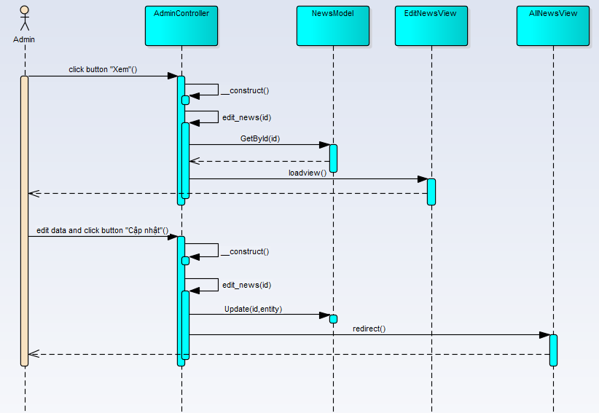

Figure 24 update news sequence diagram

#### UC001 – 04 Update category

##### Screen Design

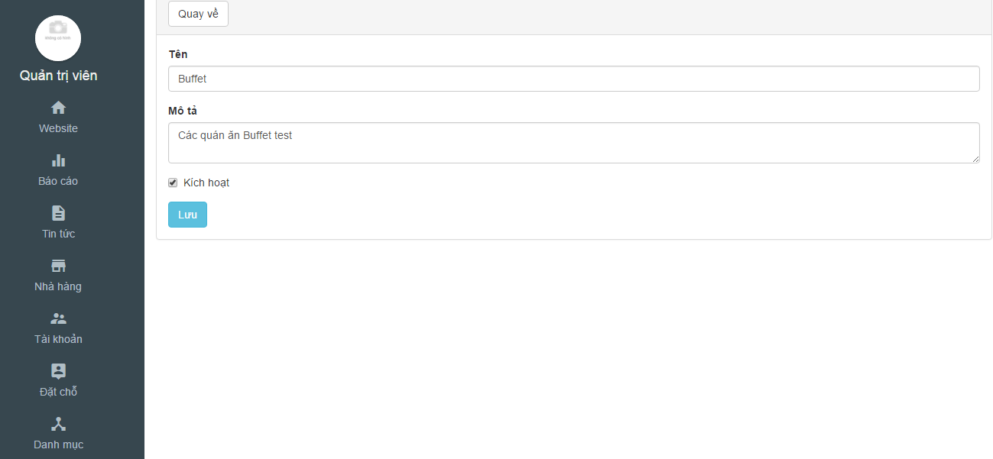

Figure 25 Update category screen

|  |  |  |  |  |  |  |
| --- | --- | --- | --- | --- | --- | --- |
| **No** | **Object/ Control Name** | **Object/ Control Name in English** | **Type** | **Required** | **Length** | **Description** |
| 1 | Tên | Name | Text-box | Yes | N/A | Name of category |
| 2 | Mô tả | Description | Text-box | Yes | N/A | Content of category |
| 3 | Kích hoạt | Active | Check-box | Yes | N/A | Status of category |
| 4 | Lưu | Save | Button | Yes | N/A | Click to update category |
| 5 | Quay về | Back | Button | Yes | N/A | Return to list category |

Table 22: Update category

##### Sequence Diagram

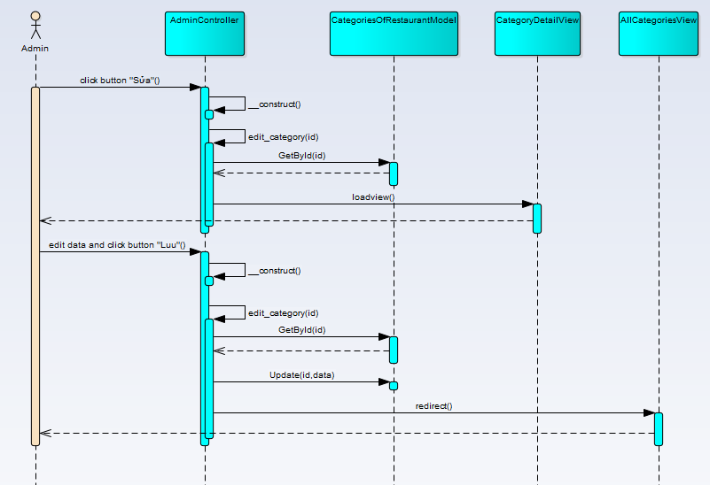

Figure 26 Update category sequence diagram

#### UC001 – 05 Delete category

##### Screen Design

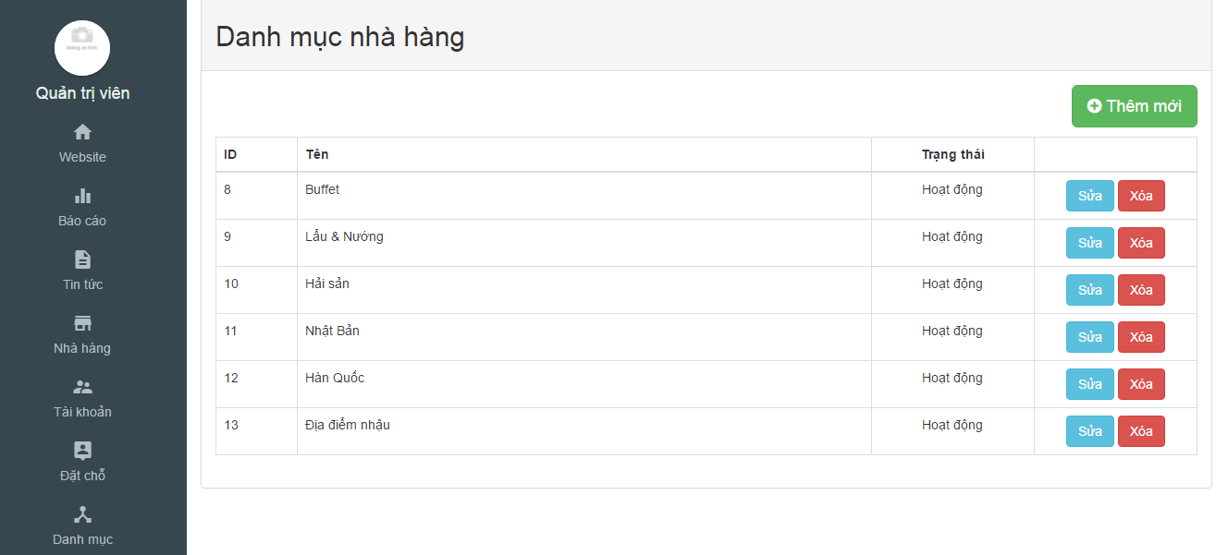Figure 27 Delete category screen

|  |  |  |  |  |  |  |
| --- | --- | --- | --- | --- | --- | --- |
| **No** | **Object/ Control Name** | **Object/ Control Name in English** | **Type** | **Required** | **Length** | **Description** |
| 1 | ID | ID | Integer | Yes | N/A | Id of category |
| 2 | Tên | Name | Text | Yes | N/A | Name of category |
| 3 | Trạng thái | Status | Text | Yes | N/A | Status of category |
| 4 | Xóa | Delete | Button | Yes | N/A | Click to delete category |

Table 23: Delete category

##### Sequence Diagram

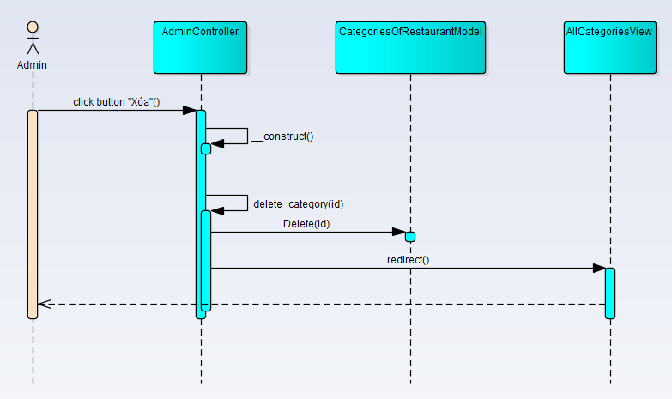

Figure 28 Delete category sequence diagram

#### UC001 – 06 Delete news

##### Screen Design

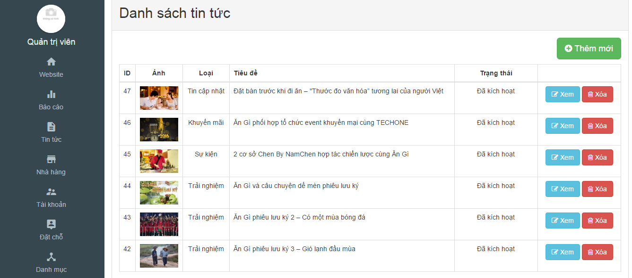

Figure 29 Detele news

|  |  |  |  |  |  |  |
| --- | --- | --- | --- | --- | --- | --- |
| **No** | **Object/ Control Name** | **Object/ Control Name in English** | **Type** | **Required** | **Length** | **Description** |
| 1 | ID | ID | Integer | Yes | N/A | Id of category |
| 2 | Ảnh | Image | Image | Yes | N/A | Image of news |
| 3 | Loại | Category | Text | Yes | N/A | Category of news |
| 4 | Tiêu đề | Title | Text | Yes | N/A | Title of news |
| 5 | Trạng thái | Status | Text | Yes | N/A | Status of news |
| 6 | Xóa | Delete | Button | Yes | N/A | Click to delete news |

Table 24: Delete news

##### Sequence Diagram

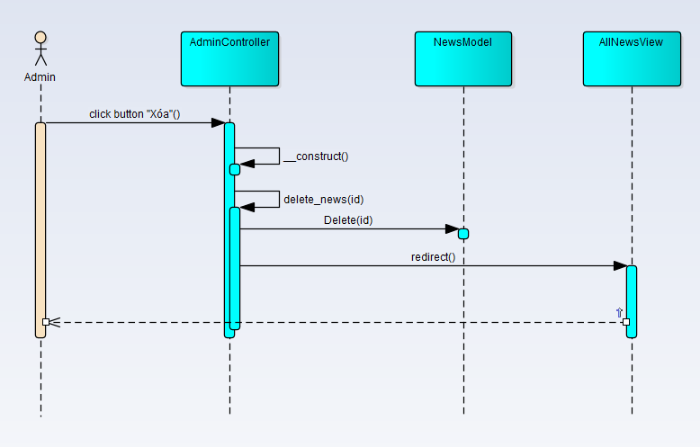

Figure 30 Delete news sequence diagram

#### UC001 – 07, 09 Activate/deactivate and rate restaurant

##### Screen Design

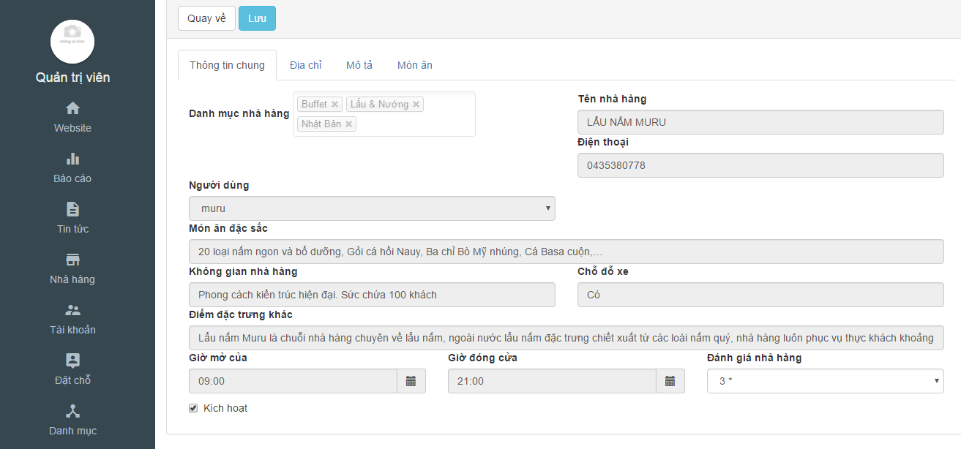

Figure 31 Activate/deactivate and rate restaurant

|  |  |  |  |  |  |  |
| --- | --- | --- | --- | --- | --- | --- |
| **No** | **Object/ Control Name** | **Object/ Control Name in English** | **Type** | **Required** | **Length** | **Description** |
| 1 | Đánh giá nhà hàng | Rate for restaurant | Combo-box | Yes | N/A | Rate for restaurant |
| 2 | Kích hoạt | Active/Deactive | Check-box | Yes | N/A | Active/Deactive for restaurant |
| 3 | Loại | Category | Integer | Yes | N/A | Category of restaurant |
| 4 | Lưu | Save | Button | Yes | N/A | Click to update restaurant |
| 5 | Quay về | Back | Button | Yes | N/A | Return to list restaurant |

Table 25: Activate/deactivate and rate restaurant

##### Sequence Diagram

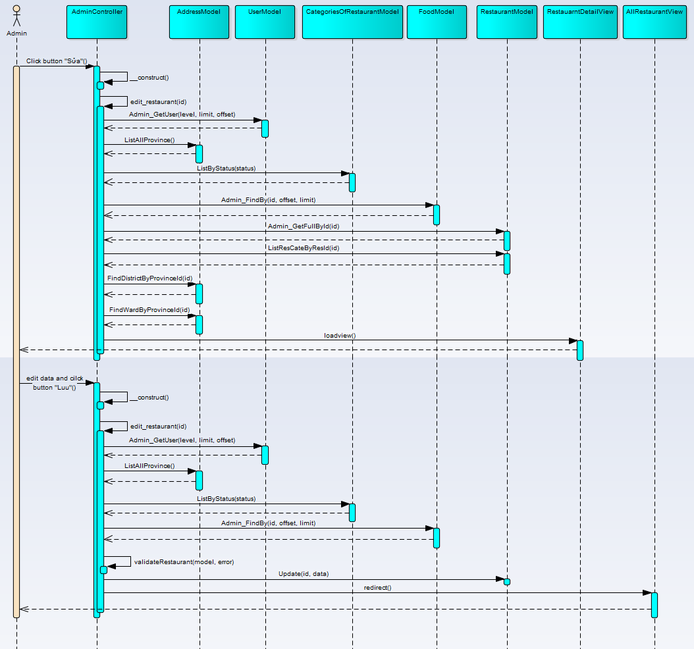

Figure 32 Activate/deactivate and rate restaurant sequence diagram

#### UC001 – 08 Delete restaurant

##### Screen Design

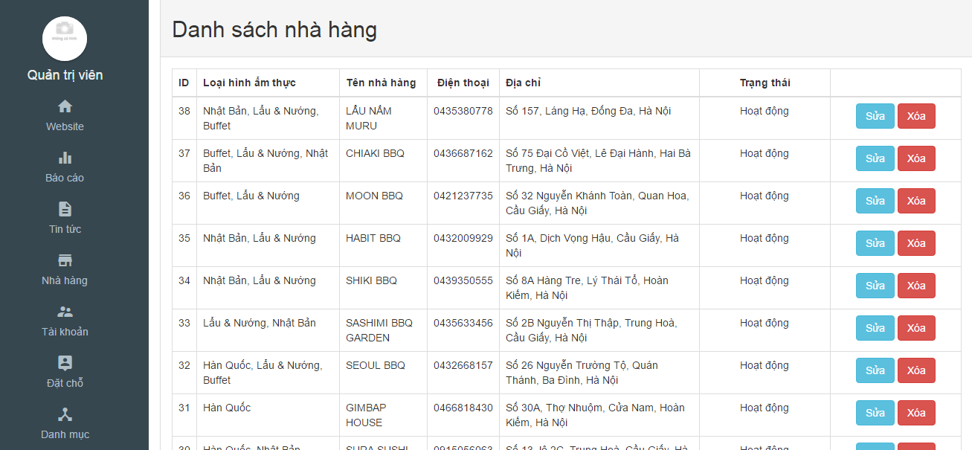

Table 26: Delete restaurant

|  |  |  |  |  |  |  |
| --- | --- | --- | --- | --- | --- | --- |
| **No** | **Object/ Control Name** | **Object/ Control Name in English** | **Type** | **Required** | **Length** | **Description** |
| 1 | ID | ID | Integer | Yes | N/A | Id of category |
| 2 | Loại hình ẩm thực | Categories of restaurant | Text | Yes | N/A | Categories of restaurant |
| 3 | Tên nhà hàng | Name of restaurant | Text | Yes | N/A | Name of restaurant |
| 4 | Điện thoại | Phone of restaurant | Integer | Yes | N/A | Phone of restaurant |
| 5 | Địa chỉ | Address of restaurant | Text | Yes | N/A | Address of restaurant |
| 6 | Trạng thái | Status | Text | Yes | N/A | Status of restaurant |
| 7 | Xóa | Delete | Button | Yes | N/A | Click to delete restaurant |

Table 27: Delete restaurant

##### Sequence Diagram

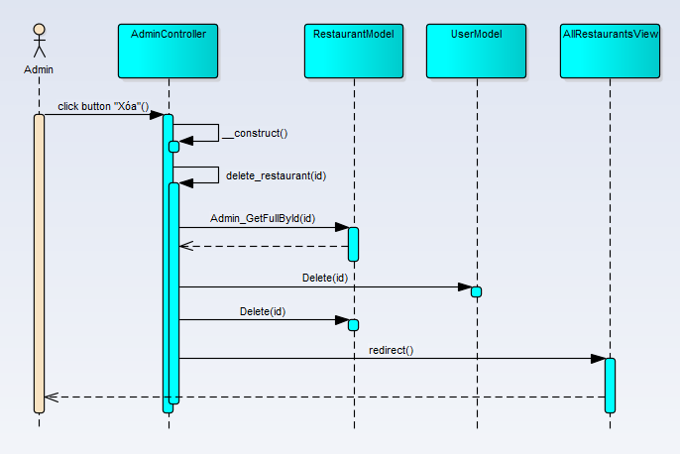

Figure 33 Delete restaurant sequence diagram

#### UC001 – 10 Delete user

##### Screen Design

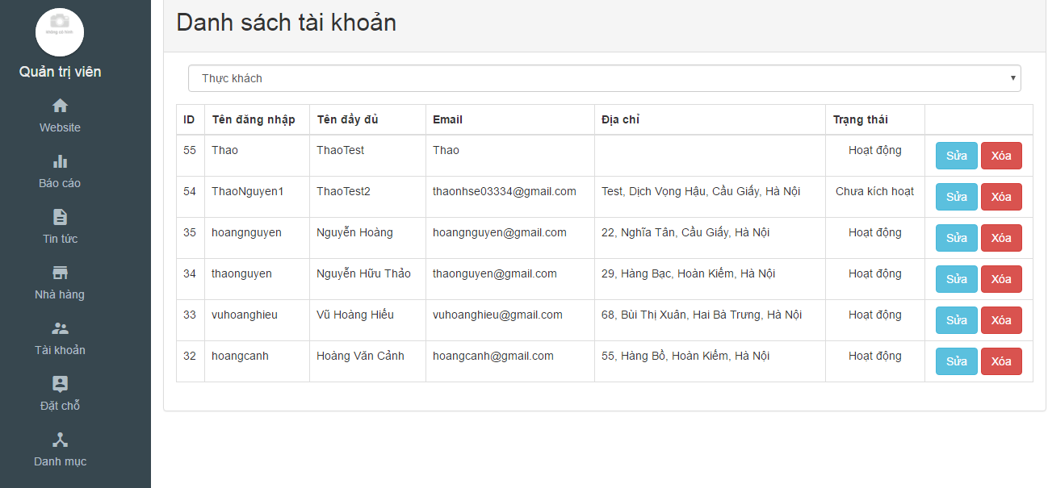

Figure 34 Delete user screen

|  |  |  |  |  |  |  |
| --- | --- | --- | --- | --- | --- | --- |
| **No** | **Object/ Control Name** | **Object/ Control Name in English** | **Type** | **Required** | **Length** | **Description** |
| 1 | ID | ID | Integer | Yes | N/A | Id of category |
| 2 | Tên đăng nhập | Name | Text | Yes | N/A | Name of user use to login |
| 3 | Tên đầy đủ | Fullname | Text | Yes | N/A | Fullname of user |
| 4 | Email | Email | Text | Yes | N/A | Email of user |
| 5 | Địa chỉ | Address | Text | Yes | N/A | Address of user |
| 6 | Trạng thái | Status | Text | Yes | N/A | Status of user |
| 7 | Xóa | Delete | Button | Yes | N/A | Click to delete users |

Table 28: Delete user description

##### Sequence Diagram

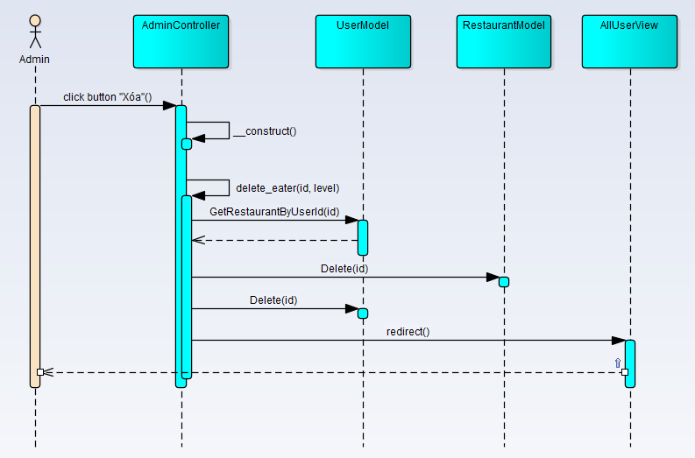

Figure 35 Delete user sequence diagram

#### UC001 – 11 Activate/deactivate user

##### Screen Design

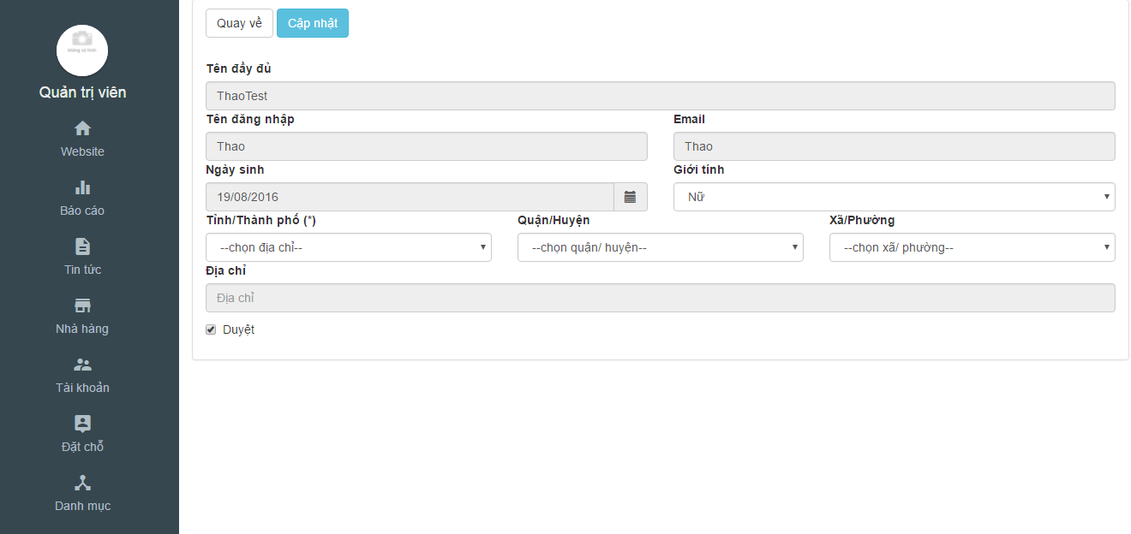

Figure 36 Activate/deactivate user screen

|  |  |  |  |  |  |  |
| --- | --- | --- | --- | --- | --- | --- |
| **No** | **Object/ Control Name** | **Object/ Control Name in English** | **Type** | **Required** | **Length** | **Description** |
| 2 | Duyệt | Active/Deactive | Check-box | Yes | N/A | Active/Deactive for user |
| 4 | Cập nhật | Update | Button | Yes | N/A | Click to update user |
| 5 | Quay về | Back | Button | Yes | N/A | Return to list users |

Table 29: Activate/deactivate user description

##### Sequence Diagram

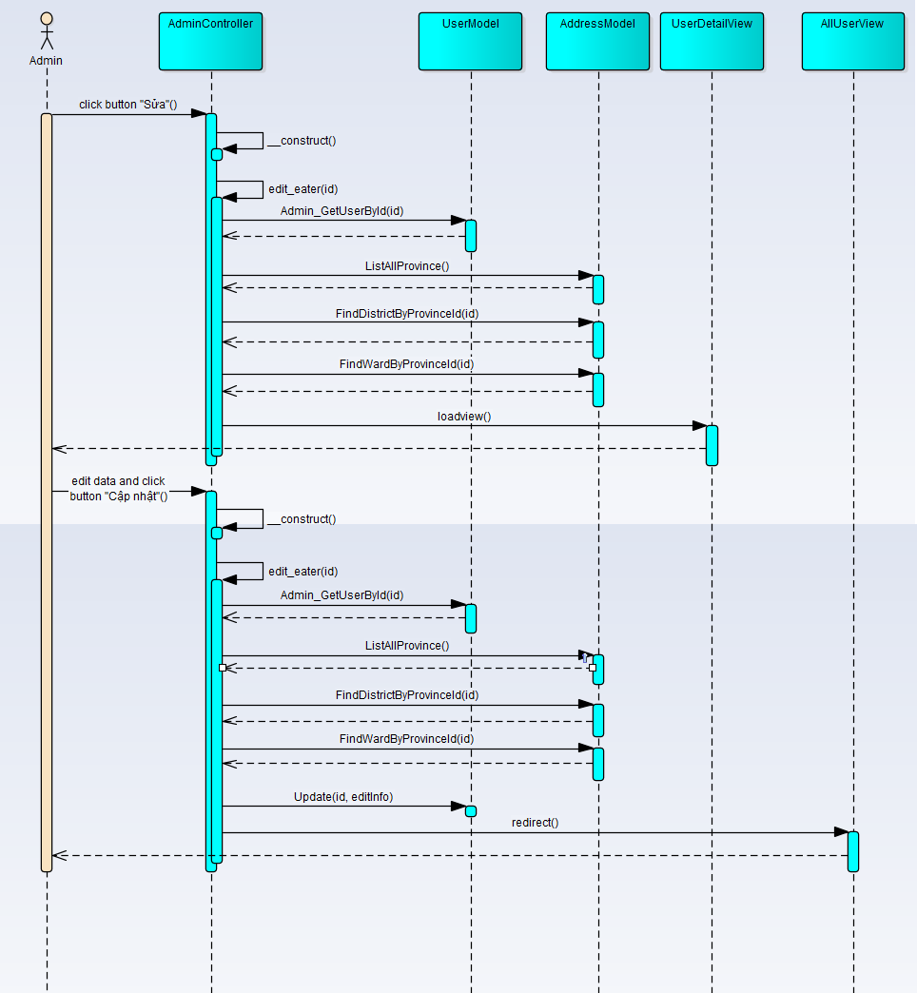

Figure 37 Activate/deactivate sequence diagram

#### UC001 – 12 View all news

##### Screen Design



Figure 38 View all news screen

|  |  |  |  |  |  |  |
| --- | --- | --- | --- | --- | --- | --- |
| **No** | **Object/ Control Name** | **Object/ Control Name in English** | **Type** | **Required** | **Length** | **Description** |
| 1 | Tin tức | News | Button | Yes | N/A | Click to view all news |

Table 30: View all news

##### Sequence Diagram

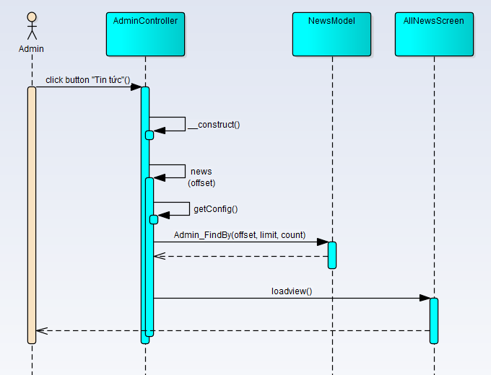

Figure 39 View all news sequence diagram

#### UC001 – 13 View all categories

##### Screen Design



Figure 40 View all categories screen

|  |  |  |  |  |  |  |
| --- | --- | --- | --- | --- | --- | --- |
| **No** | **Object/ Control Name** | **Object/ Control Name in English** | **Type** | **Required** | **Length** | **Description** |
| 1 | Danh mục | Categories | Button | Yes | N/A | Click to view all categories |

Table 31: View all categories

##### Sequence Diagram

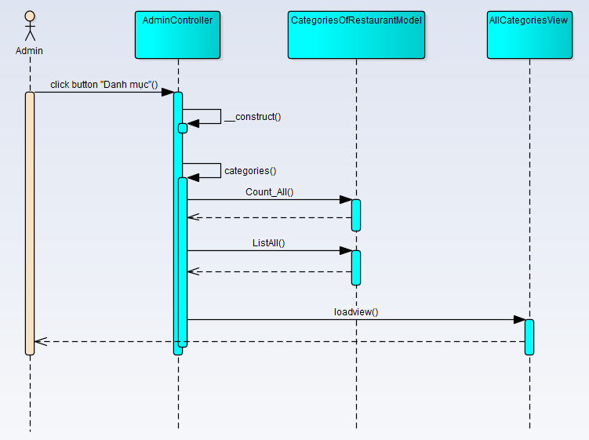

Figure 41 View all categories sequence diagram

#### UC001 – 14 View all restaurants

##### Screen Design



Figure 42 View all restaurants screen

|  |  |  |  |  |  |  |
| --- | --- | --- | --- | --- | --- | --- |
| **No** | **Object/ Control Name** | **Object/ Control Name in English** | **Type** | **Required** | **Length** | **Description** |
| 1 | Nhà hàng | Restaurant | Button | Yes | N/A | Click to view all restaurants |

Table 32: View all restaurants description

##### Sequence Diagram

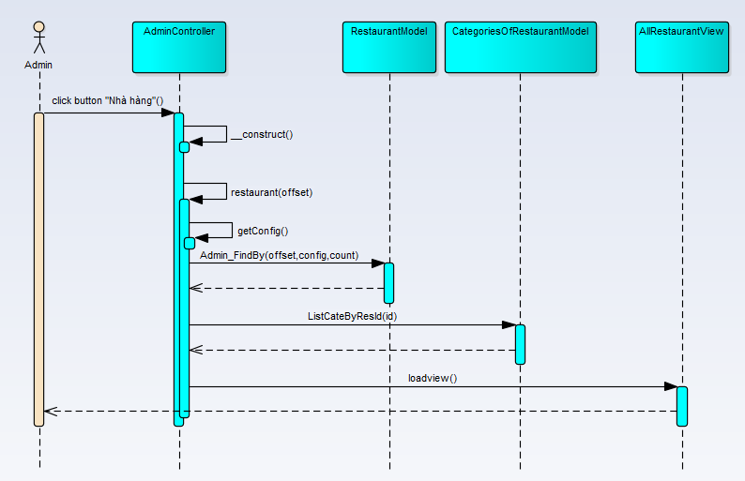

Figure 43 View all restaurants sequence diagram

#### UC001 – 15 View all users

##### Screen Design



Table 33: View all users

|  |  |  |  |  |  |  |
| --- | --- | --- | --- | --- | --- | --- |
| **No** | **Object/ Control Name** | **Object/ Control Name in English** | **Type** | **Required** | **Length** | **Description** |
| 1 | Tài khoản | User | Button | Yes | N/A | Click to view all users |

Table 34: View all users description

##### Sequence Diagram

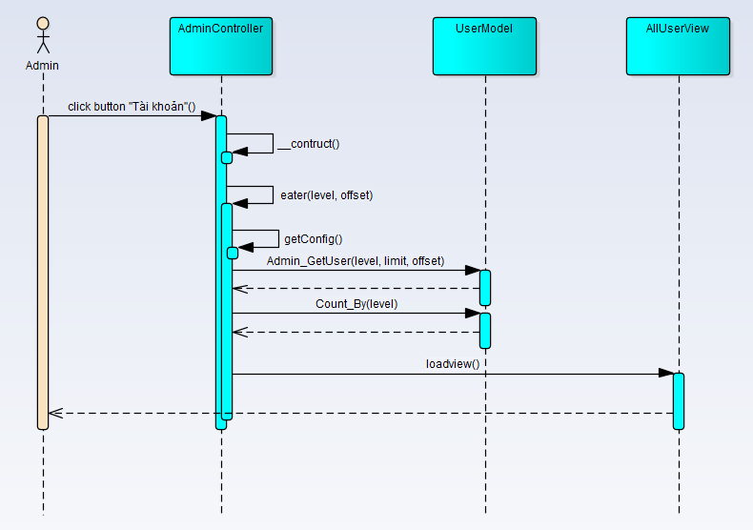

Figure 44 View all users sequence diagram

#### UC001 – 16 View all booking

##### Screen Design

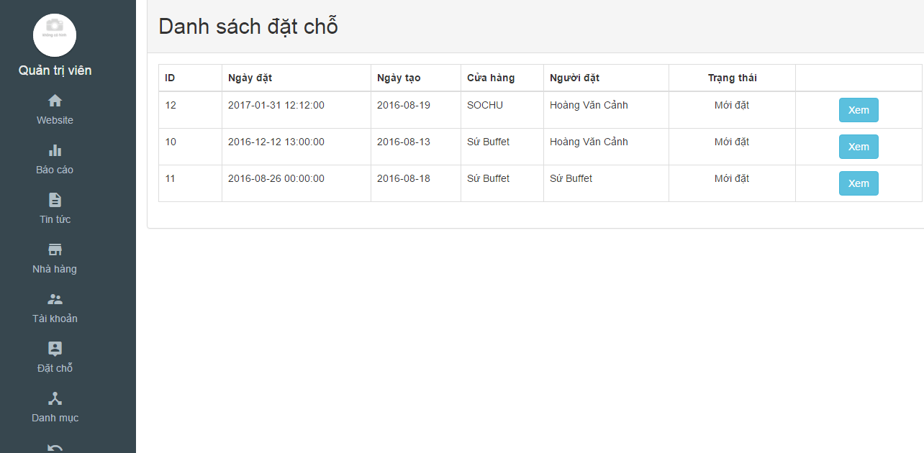

Figure 45 View all booking screen

|  |  |  |  |  |  |  |
| --- | --- | --- | --- | --- | --- | --- |
| **No** | **Object/ Control Name** | **Object/ Control Name in English** | **Type** | **Required** | **Length** | **Description** |
| 1 | Đặt chỗ | Booking | Button | Yes | N/A | Click to view all booking |

Table 35: View all booking description

##### Sequence Diagram

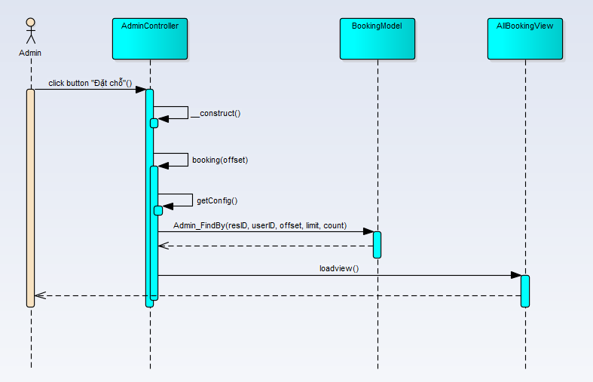

Figure 46 View all booking sequence diagram

#### UC001 – 17 View detail booking

##### Screen Design

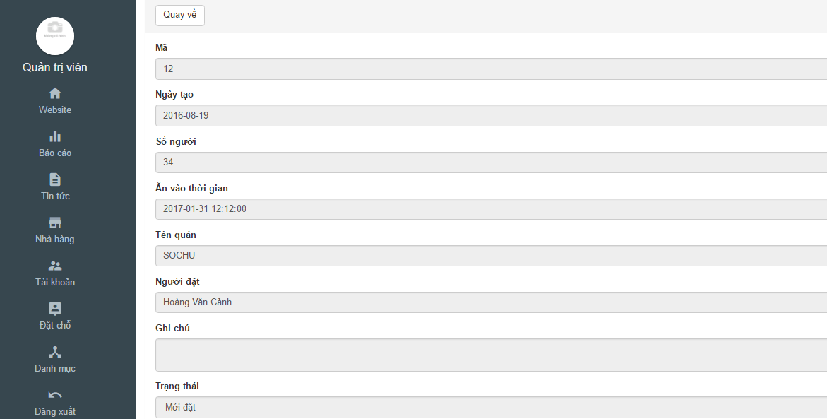

Figure 47 View detail booking

|  |  |  |  |  |  |  |
| --- | --- | --- | --- | --- | --- | --- |
| **No** | **Object/ Control Name** | **Object/ Control Name in English** | **Type** | **Required** | **Length** | **Description** |
| 1 | Quay về | Back | Button | Yes | N/A | Click to return all booking |

Table 36: View detail booking description

##### Sequence Diagram

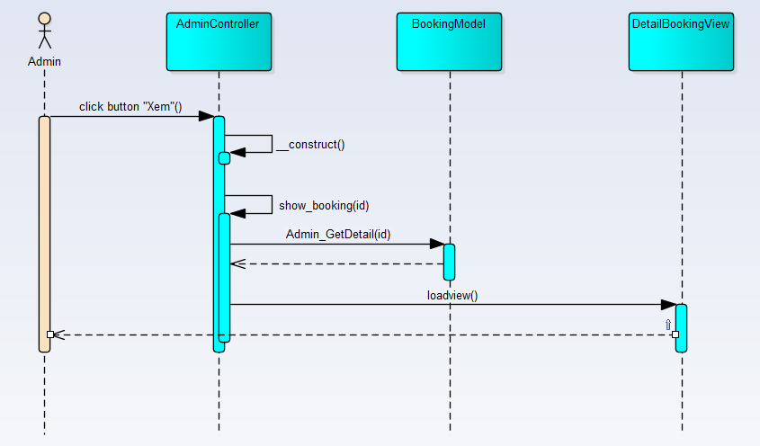

Figure 48 View detail booking sequence diagram

#### UC001 – 18 Report statistics

##### Screen Design

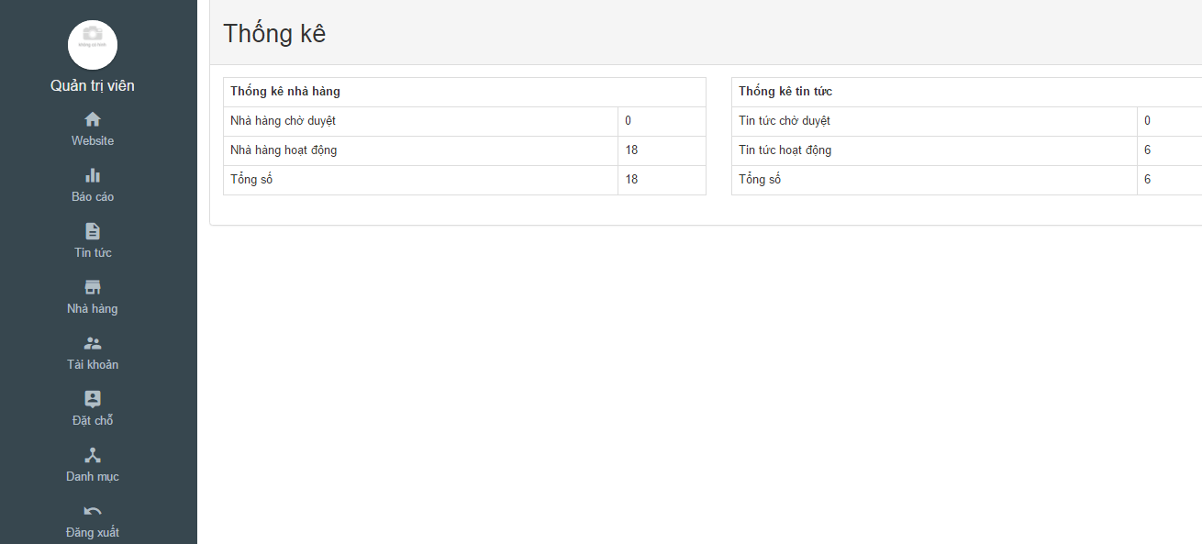

Figure 49 Report statistics screen

|  |  |  |  |  |  |  |
| --- | --- | --- | --- | --- | --- | --- |
| **No** | **Object/ Control Name** | **Object/ Control Name in English** | **Type** | **Required** | **Length** | **Description** |
| 1 | Báo cáo | Back | Button | Yes | N/A | Click to view report statistics |

Table 37: Report statistics description

##### Sequence Diagram

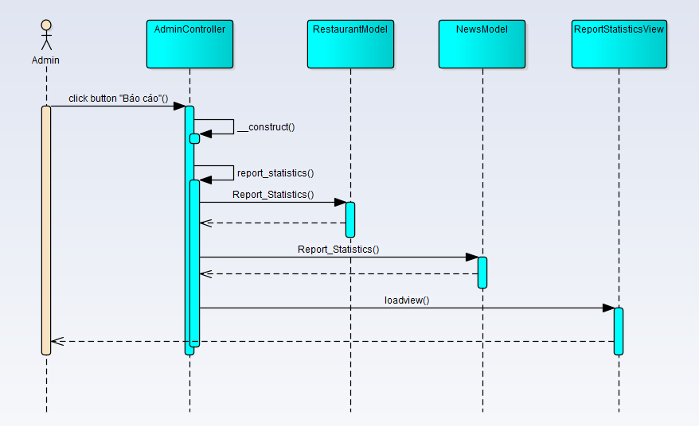

Figure 50 Report statistics sequence diagram

### UC002 Customer Management

#### Class Diagram

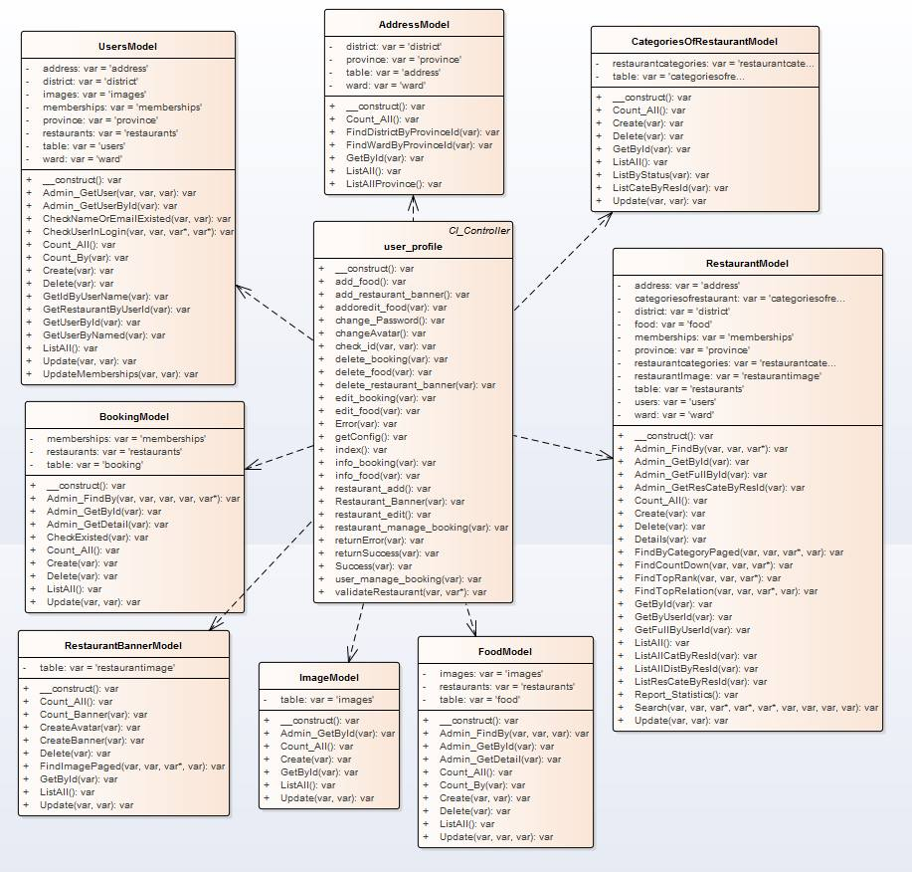

Figure 51 Customer management class diagram

#### UC002 – 01 Login

##### Screen Design

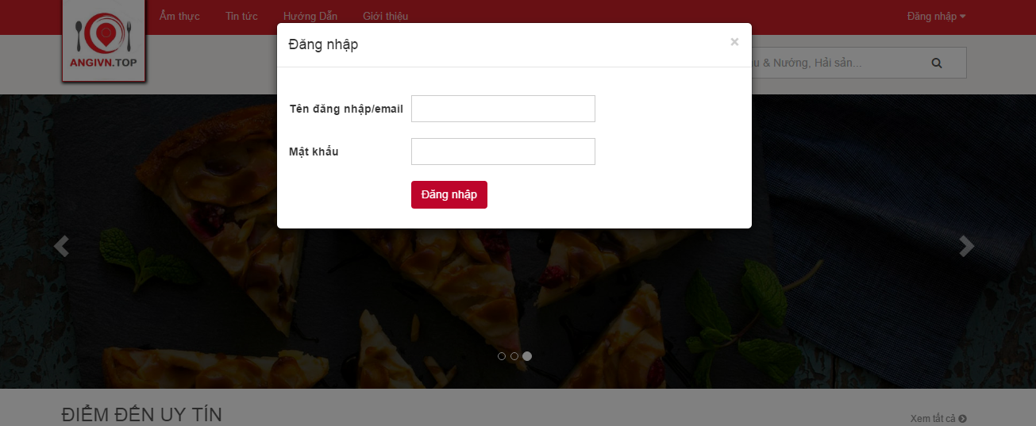

Figure 52 Login screen

|  |  |  |  |  |  |  |
| --- | --- | --- | --- | --- | --- | --- |
| **No** | **Object/ Control Name** | **Object/ Control Name in English** | **Type** | **Required** | **Length** | **Description** |
| 1 | Tên đăng nhập/ Email | Username/Email | Text-box | Yes | N/A | Input username/ email |
| 2 | Mật khẩu | Password | Password | Yes | N/A | Input password |
| 3 | Đăng nhập | Login | Button | Yes | N/A | Click to login website |

Table 38: Login screen description

##### Sequence diagram

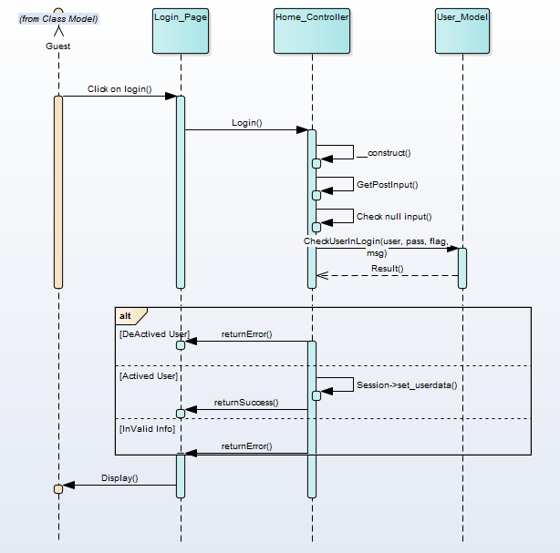

Figure 53 Login sequence diagram

#### UC002 – 02 Log out

##### Screen Design

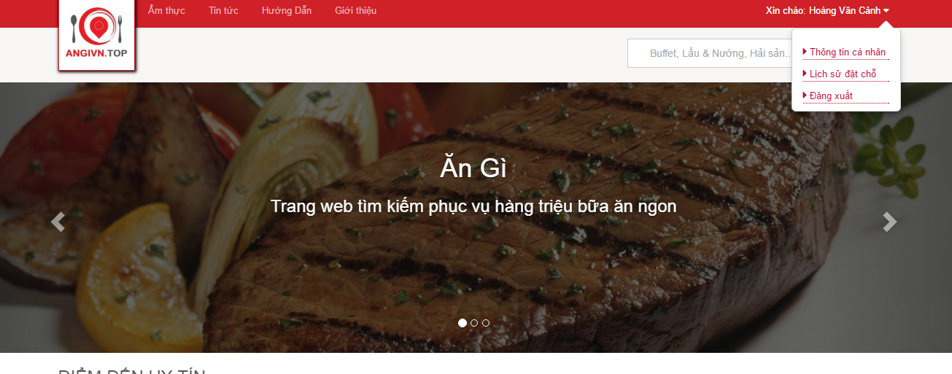

Figure 54 Log out screen

|  |  |  |  |  |  |  |
| --- | --- | --- | --- | --- | --- | --- |
| **No** | **Object/ Control Name** | **Object/ Control Name in English** | **Type** | **Required** | **Length** | **Description** |
| 1 | Đăng xuất | Logout | Button | Yes | N/A | Click to logout website |

Table 39: Log out description

##### Sequence diagram

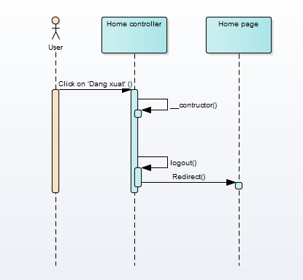

Figure 55 Log out sequence

#### UC002 – 03 View account

##### Screen Design

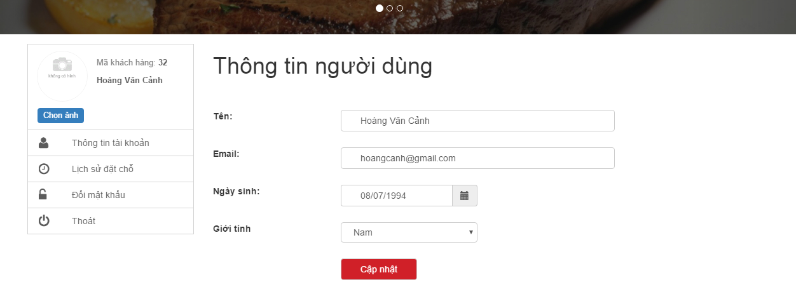

Figure 56 View account screen

|  |  |  |  |  |  |  |
| --- | --- | --- | --- | --- | --- | --- |
| **No** | **Object/ Control Name** | **Object/ Control Name in English** | **Type** | **Required** | **Length** | **Description** |
| 1 | Thông tin tài khoản | Account profile | Button | Yes | N/A | Click to redirect account profile screen |
| 2 | Tên | Name | Textbox | Yes | N/A | Name of user |
| 3 | Email | Email | Textbox | Yes | N/A | Email of user |
| 4 | Ngày sinh | Date of birth | Date-picker | Yes | N/A | Date of birth of user |
| 5 | Giới tính | Gender | Combox | Yes | N/A | Gender of user |
| 6 | Cập nhật | Update | Button | Yes | N/A | Click to update information of user |

Table 40: View account description

##### Sequence diagram

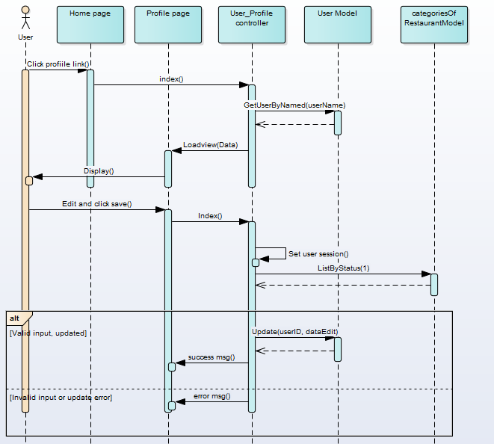

Figure 57 View account sequence

#### UC002 – 04 Update account

##### Screen Design



Figure 58 Update account

|  |  |  |  |  |  |  |
| --- | --- | --- | --- | --- | --- | --- |
| **No** | **Object/ Control Name** | **Object/ Control Name in English** | **Type** | **Required** | **Length** | **Description** |
| 1 | Thông tin tài khoản | Account profile | Button | Yes | N/A | Click to redirect account profile screen |
| 2 | Tên | Name | Textbox | Yes | N/A | Name of user |
| 3 | Email | Email | Textbox | Yes | N/A | Email of user |
| 4 | Ngày sinh | Date of birth | Date-picker | Yes | N/A | Date of birth of user |
| 5 | Giới tính | Gender | Combox | Yes | N/A | Gender of user |
| 6 | Cập nhật | Update | Button | Yes | N/A | Click to update information of user |

Figure 59 Update accountSequence diagram

##### Sequence diagram



Figure 60 Book restaurant

#### UC002 – 05 Update password

##### Screen Design

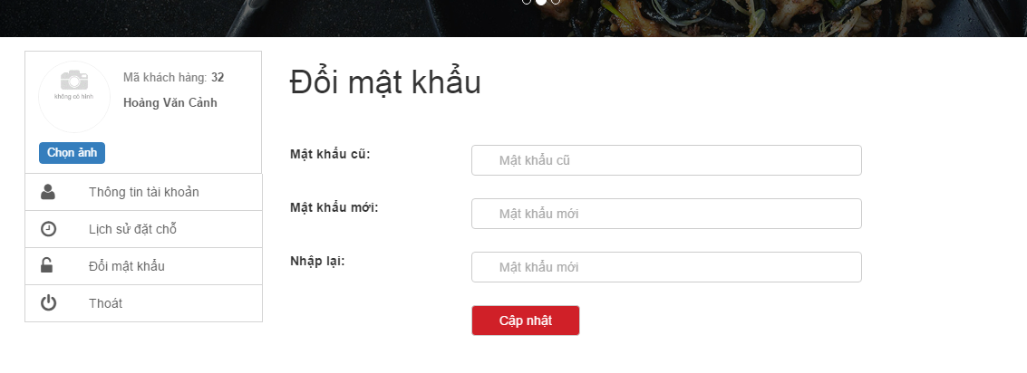

Figure 61 Update password

|  |  |  |  |  |  |  |
| --- | --- | --- | --- | --- | --- | --- |
| **No** | **Object/ Control Name** | **Object/ Control Name in English** | **Type** | **Required** | **Length** | **Description** |
| 1 | Đổi mật khẩu | Change password | Button | Yes | N/A | Click to redirect change password screen |
| 2 | Mật khẩu cũ | Old password | Text-box | Yes | N/A | Old password of user |
| 3 | Mật khẩu mới | New password | Text-box | Yes | >= 6 character | New password of user |
| 4 | Nhập lại | Confirm password | Date-picker | Yes | N/A | Confirm password |
| 5 | Cập nhật | Update | Button | Yes | N/A | Click to change password of user |

Table 41: Update password description

##### Sequence diagram

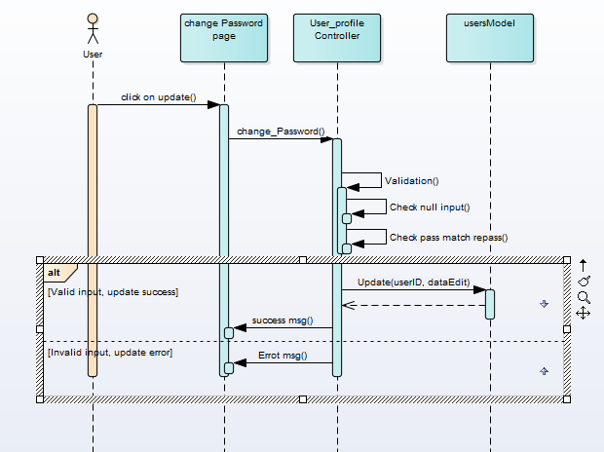

Figure 62 Update password sequence diagram

#### UC002 – 06 Book restaurant

##### Screen Design

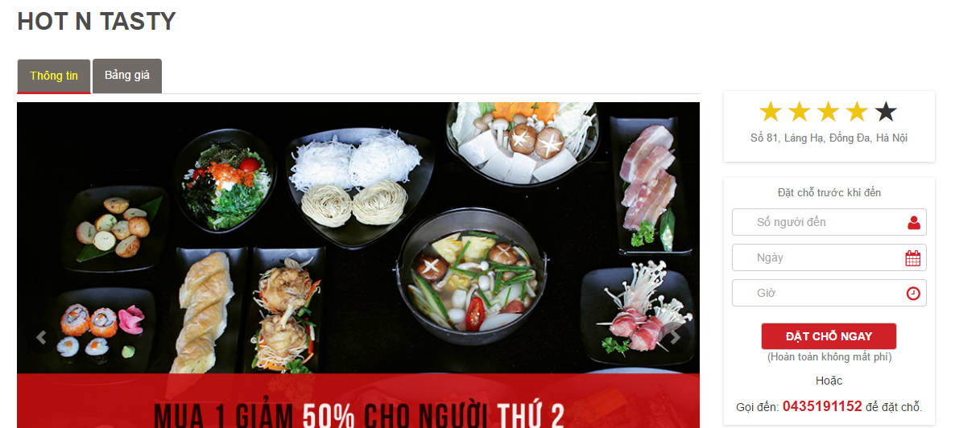

Figure 63 Book restaurant

|  |  |  |  |  |  |  |
| --- | --- | --- | --- | --- | --- | --- |
| **No** | **Object/ Control Name** | **Object/ Control Name in English** | **Type** | **Required** | **Length** | **Description** |
| 1 | Số người đến | Number of customer | Textbox | Yes | N/A | Input number of customer |
| 2 | Ngày | Date | Textbox | Yes | N/A | Date of booking |
| 3 | Giờ | Time | Textbox | Yes | N/A | Time of booking |
| 4 | Đặt chỗ ngay | Booking now | Button | Yes | N/A | Click to send booking |

Table 42: Book restaurant

##### Sequence diagram

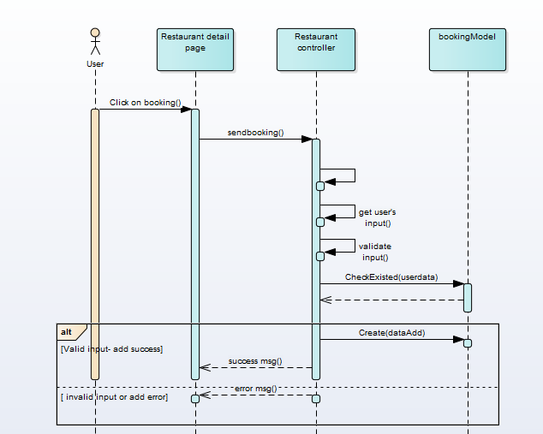

Figure 64 Booking restaurant sequence diagram

#### UC002 – 07 Upload avatar

##### Screen Design

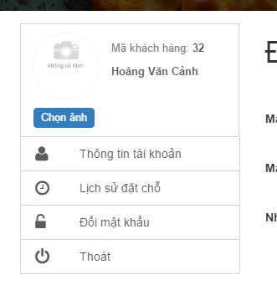

Figure 65 Select image

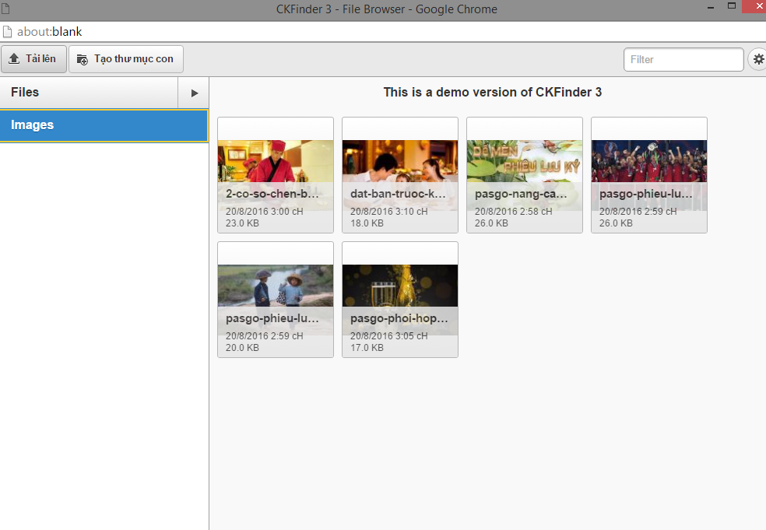

Figure 66 Upload and select image

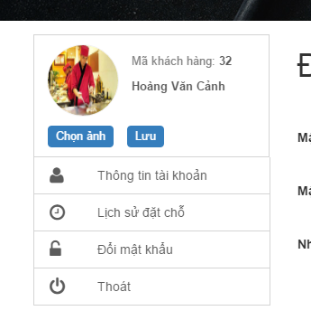

Figure 67 Save new avatar

|  |  |  |  |  |  |  |
| --- | --- | --- | --- | --- | --- | --- |
| **No** | **Object/ Control Name** | **Object/ Control Name in English** | **Type** | **Required** | **Length** | **Description** |
| 1 | Chọn ảnh | Choose image | Button | Yes | N/A | Click to change avatar |
| 2 | Lưu | Save | Button | Yes | N/A | Click to save new avatar |

Table 43: Update avatar

##### Sequence diagram

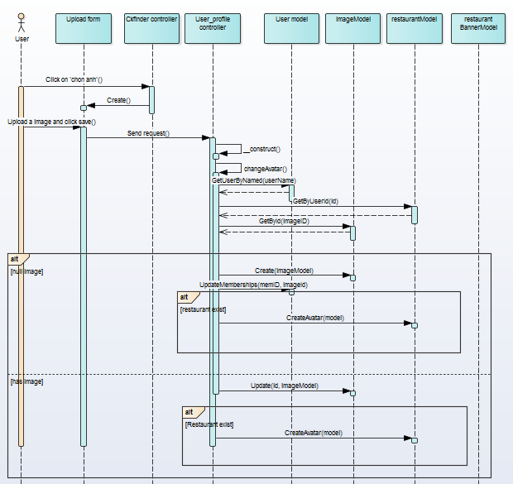

Figure 68 Upload avatar sequence diagram

#### UC002 – 08 View booking history

##### Screen Design

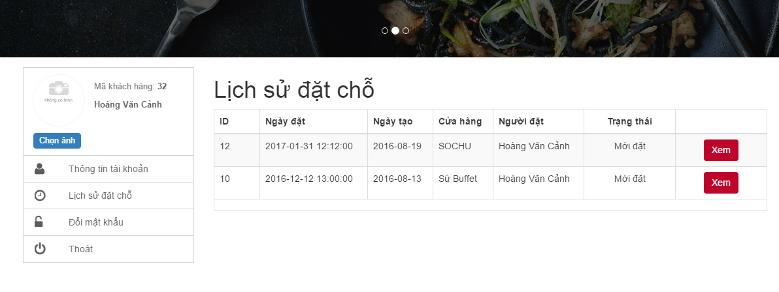Figure 69 View booking history

|  |  |  |  |  |  |  |
| --- | --- | --- | --- | --- | --- | --- |
| **No** | **Object/ Control Name** | **Object/ Control Name in English** | **Type** | **Required** | **Length** | **Description** |
| 1 | Lịch sử đặt chỗ | History of booking | Button | Yes | N/A | Click to redirect history of booking screen |
| 2 | Xem | View | Button | Yes | N/A | Click to view booking detail |

Table 44: View booking history

##### Sequence diagram

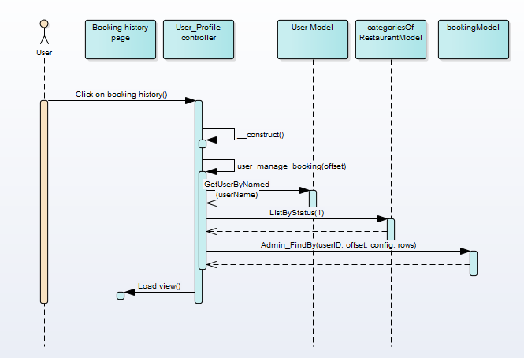

Figure 70 View booking history sequence diagram

### UC003 Restaurant Owner Management

#### Class Diagram



Figure 71 Restaurant Owner management

#### UC003 – 01 Add restaurant information

##### Screen Design

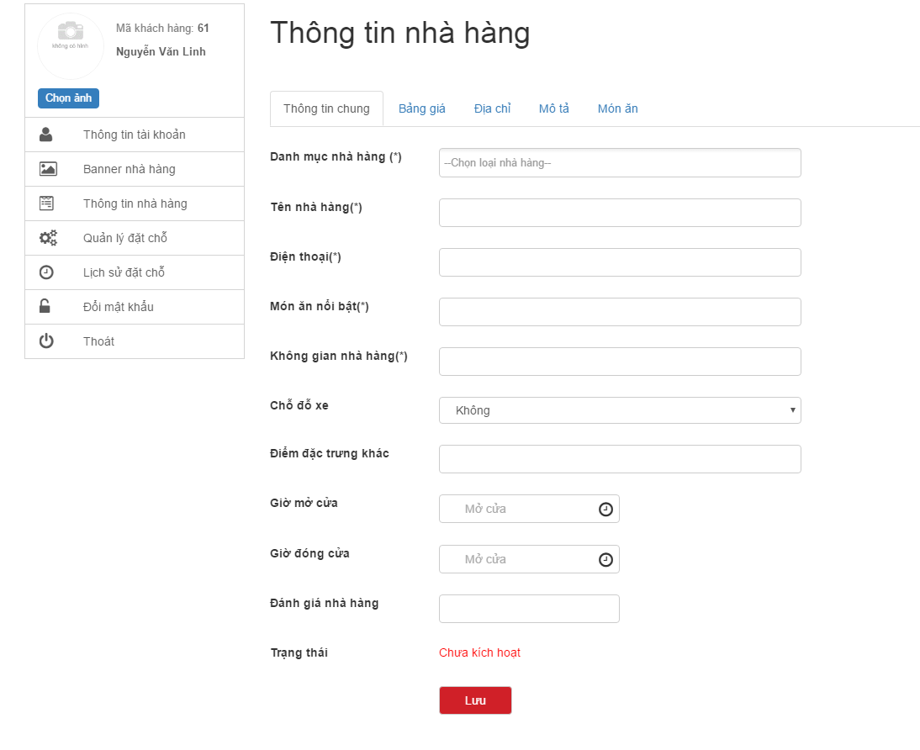

Figure 72 Add restaurant information

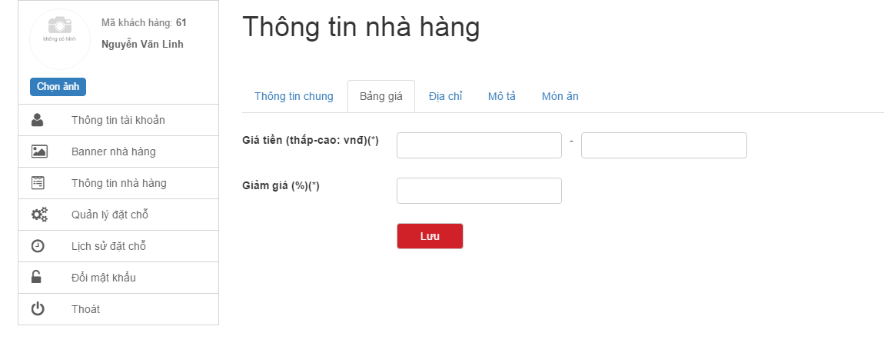

Figure 73 Add average price

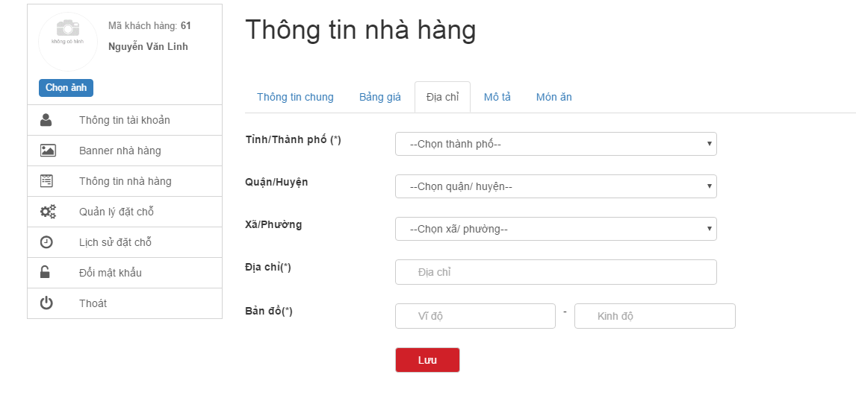

Figure 74 Add restaurant address

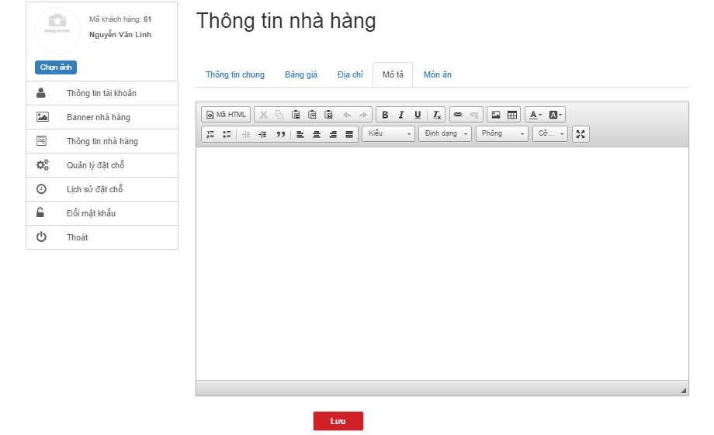

Figure 75 Add description for restaurant

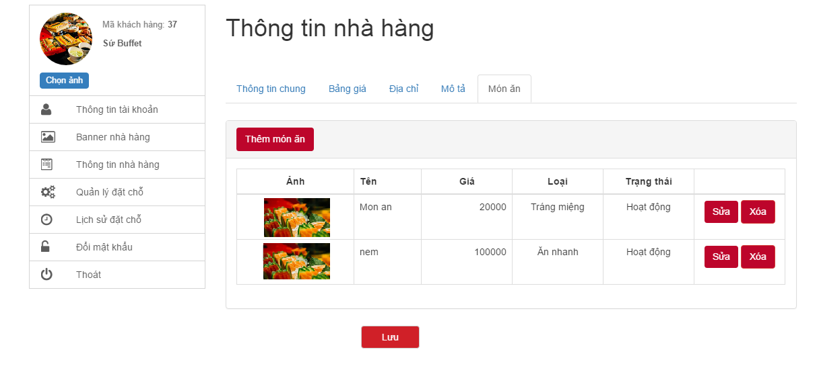

Figure 76 Add foods

|  |  |  |  |  |  |  |
| --- | --- | --- | --- | --- | --- | --- |
| **No** | **Object/ Control Name** | **Object/ Control Name in English** | **Type** | **Required** | **Length** | **Description** |
| 1 | Thông tin nhà hàng | Restaurant information | Button | Yes | N/A | Click to redirect restaurant information screen |
| 2 | Danh mục nhà hàng | Categories of restaurant | Combo-box | Yes | N/A | Select categories of restaurant |
| 3 | Tên nhà hàng | Name of restaurant | Textbox | Yes | N/A | Input name of restaurant |
| 4 | Điện thoại | Phone | Textbox | Yes | N/A | Input phone of restaurant |
| 5 | Món ăn nổi bật | Favourite foods | Textbox | Yes | N/A | Input favourite foods of restaurant |
| 6 | Không gian nhà hàng | Restaurant space | Textbox | Yes | N/A | Input restaurant space |
| 7 | Chỗ đỗ xe | Parking | Combo-box | Yes | N/A | Select parking of restaurant |
| 8 | Điểm đặc trưng khác | Others | Textbox | No | N/A | Input others of restaurant |
| 9 | Giờ mở cửa | Open time | Textbox | Yes | N/A | Input open time of restaurant |
| 10 | Giờ đóng cửa | Close time | Textbox | Yes | N/A | Input close time of restaurant |
| 11 | Giá tiền (thấp - cao) | Price (min-max) | Textbox | Yes | N/A | Input price of restaurant |
| 12 | Giảm giá | Discount | Textbox | Yes | N/A | Input discount of restaurant |
| 13 | Tỉnh/ thành phố | Province | Combo-box | Yes | N/A | Select province of restaurant |
| 14 | Quận/ huyện | District | Combo-box | Yes | N/A | Select district of restaurant |
| 15 | Xã/ phường | Ward | Combo-box | Yes | N/A | Select ward of restaurant |
| 16 | Địa chỉ | Address | Textbox | Yes | N/A | Input address of restaurant |
| 17 | Bản đồ | Map | Textbox | Yes | N/A | Input latitude and longitude of restaurant |
| 18 | Mô tả | Description | TextArea | Yes | N/A | Input description of restaurant |
| 19 | Lưu | Save | Button | Yes | N/A | Click to add restaurant |

Table 45: Add restaurant information

##### Sequence diagram

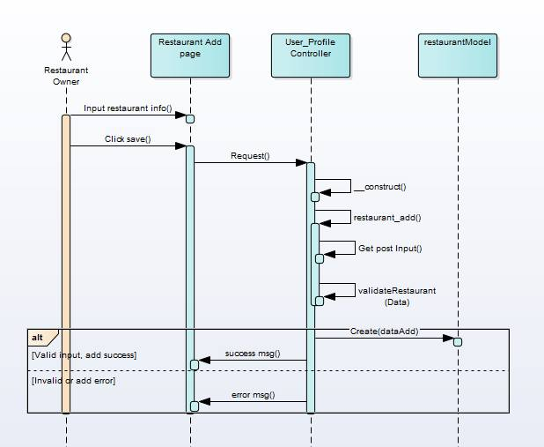

Figure 77 Add restaurant information sequence diagram

#### UC003 – 02 Update restaurant info

##### Screen Design

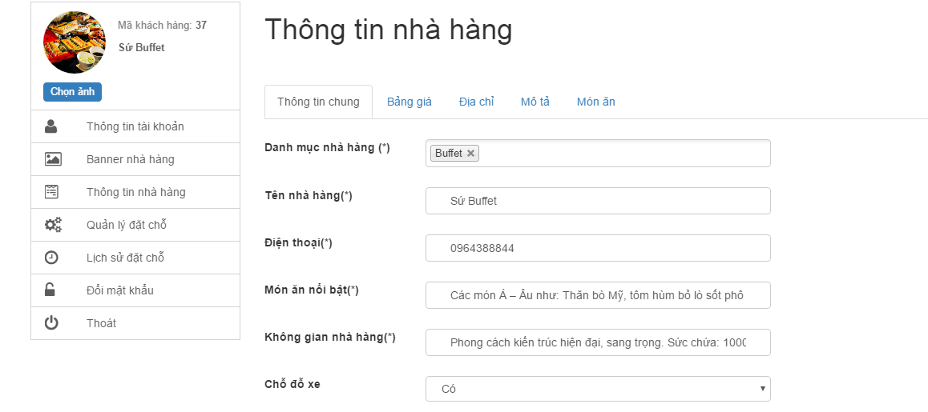

Figure 78 Update restaurant information

|  |  |  |  |  |  |  |
| --- | --- | --- | --- | --- | --- | --- |
| **No** | **Object/ Control Name** | **Object/ Control Name in English** | **Type** | **Required** | **Length** | **Description** |
| 1 | Thông tin nhà hàng | Restaurant information | Button | Yes | N/A | Click to redirect restaurant information screen |
| 2 | Danh mục nhà hàng | Categories of restaurant | Combo-box | Yes | N/A | Select categories of restaurant |
| 3 | Tên nhà hàng | Name of restaurant | Textbox | Yes | N/A | Input name of restaurant |
| 4 | Điện thoại | Phone | Textbox | Yes | N/A | Input phone of restaurant |
| 5 | Món ăn nổi bật | Favourite foods | Textbox | Yes | N/A | Input favourite foods of restaurant |
| 6 | Không gian nhà hàng | Restaurant space | Textbox | Yes | N/A | Input restaurant space |
| 7 | Chỗ đỗ xe | Parking | Combo-box | Yes | N/A | Select parking of restaurant |
| 8 | Điểm đặc trưng khác | Others | Textbox | No | N/A | Input others of restaurant |
| 9 | Giờ mở cửa | Open time | Textbox | Yes | N/A | Input open time of restaurant |
| 10 | Giờ đóng cửa | Close time | Textbox | Yes | N/A | Input close time of restaurant |
| 11 | Giá tiền (thấp - cao) | Price (min-max) | Textbox | Yes | N/A | Input price of restaurant |
| 12 | Giảm giá | Discount | Textbox | Yes | N/A | Input discount of restaurant |
| 13 | Tỉnh/ thành phố | Province | Combo-box | Yes | N/A | Select province of restaurant |
| 14 | Quận/ huyện | District | Combo-box | Yes | N/A | Select district of restaurant |
| 15 | Xã/ phường | Ward | Combo-box | Yes | N/A | Select ward of restaurant |
| 16 | Địa chỉ | Address | Textbox | Yes | N/A | Input address of restaurant |
| 17 | Bản đồ | Map | Textbox | Yes | N/A | Input latitude and longitude of restaurant |
| 18 | Mô tả | Description | TextArea | Yes | N/A | Input description of restaurant |
| 19 | Lưu | Save | Button | Yes | N/A | Click to add restaurant |

Table 46: Update restaurant information

##### Sequence diagram

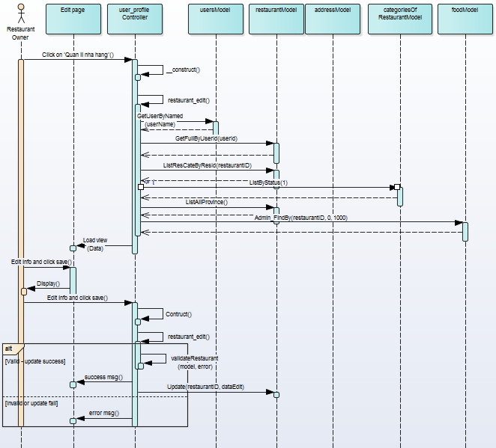

Figure 79 Update restaurant information sequence diagram

#### UC003 – 03 Add restaurant banner

##### Screen Design

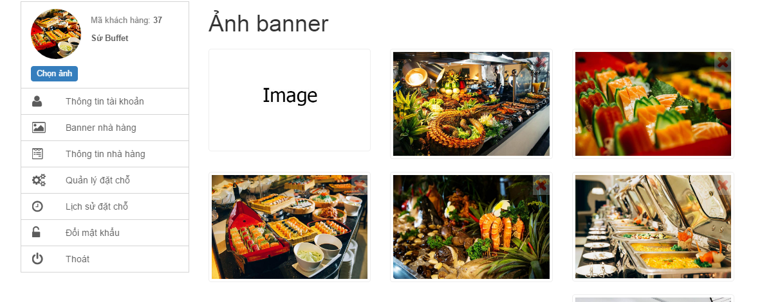

Table 47: Add restaurant banner

|  |  |  |  |  |  |  |
| --- | --- | --- | --- | --- | --- | --- |
| **No** | **Object/ Control Name** | **Object/ Control Name in English** | **Type** | **Required** | **Length** | **Description** |
| 1 | Banner nhà hàng | Banner of restaurant | Button | Yes | N/A | Click to view all banners of restaurant |
| 2 | Image | Image | Button | Yes | N/A | Click to add banner of restaurant |

Table 48: Add restaurant banner

##### Sequence diagram

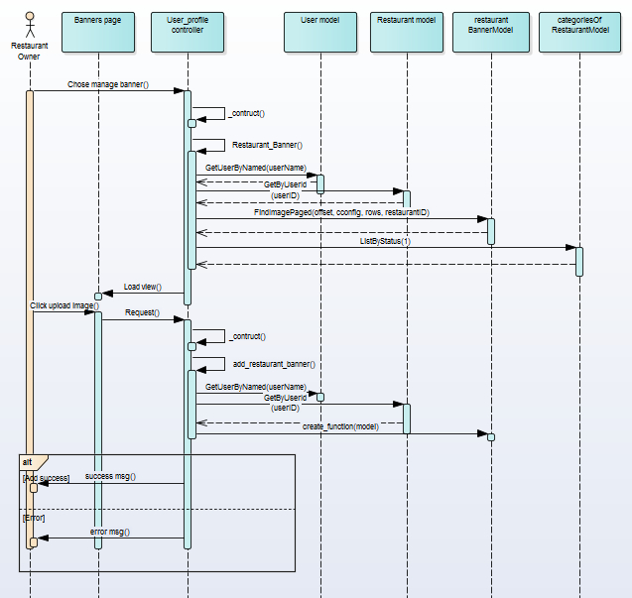

Figure 80 Add restaurant banner sequence diagram

#### UC003 – 04 Delete restaurant banner

##### Screen Design

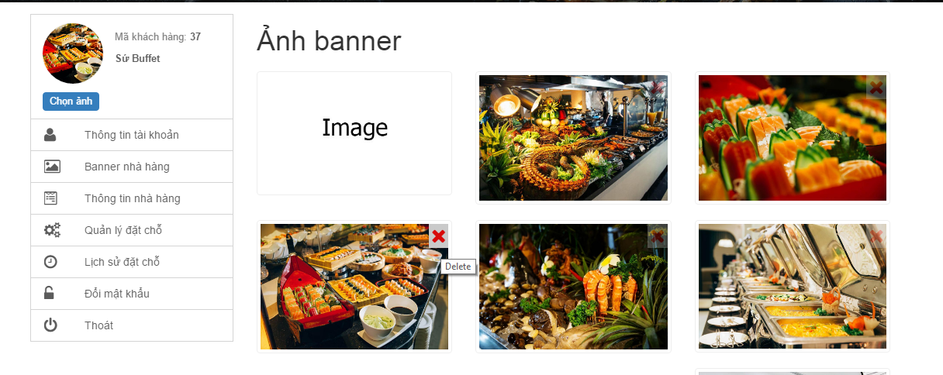

Figure 81 Delete restaurant banner

|  |  |  |  |  |  |  |
| --- | --- | --- | --- | --- | --- | --- |
| **No** | **Object/ Control Name** | **Object/ Control Name in English** | **Type** | **Required** | **Length** | **Description** |
| 1 | Delete (X) | Delete (X) | Button | Yes | N/A | Click to delete banners of restaurant |

Table 49: Delete restaurant banner

##### Sequence diagram

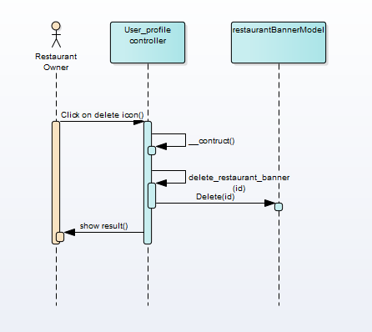

Figure 82 Delete restaurant banner

#### UC003 – 05 Add food

##### Screen Design



Figure 83 List of foods

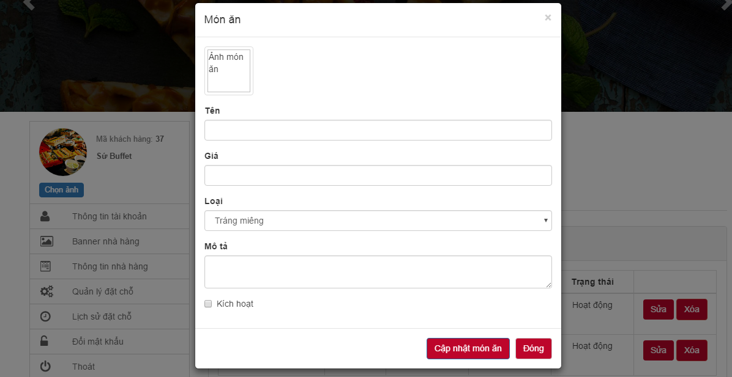

Figure 84 Add new food

|  |  |  |  |  |  |  |
| --- | --- | --- | --- | --- | --- | --- |
| **No** | **Object/ Control Name** | **Object/ Control Name in English** | **Type** | **Required** | **Length** | **Description** |
| 1 | Ảnh món ăn | Image | Button | Yes | N/A | Click to add image of food |
| 2 | Tên | Name | Textbox | Yes | N/A | Input name of food |
| 3 | Giá | Price | Textbox | Yes | N/A | Input price of food |
| 4 | Loại | Category | Combo-box | Yes | N/A | Select category of food |
| 5 | Mô tả | Description | Textbox | No | N/A | Input description of food |
| 6 | Kích hoạt | Active | Check-box | Yes | N/A | Select to active/deactive food |
| 7 | Cập nhật món ăn | Update food | Button | Yes | N/A | Click to add food |
| 8 | Đóng | Close | Button | Yes | N/A | Click to return list foods screen |

Table 50: Add new food

##### Sequence diagram

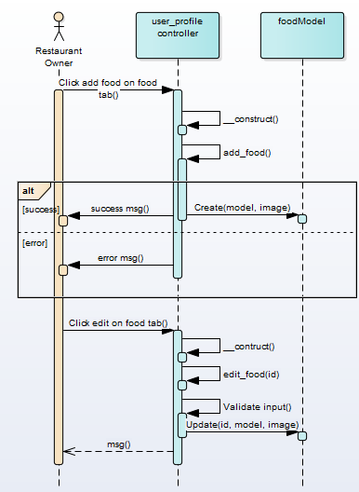

Figure 85 Add new food sequence diagram

#### UC003 – 06 Update food information

##### Screen Design

  
Figure 86 Update food’s information

|  |  |  |  |  |  |  |
| --- | --- | --- | --- | --- | --- | --- |
| **No** | **Object/ Control Name** | **Object/ Control Name in English** | **Type** | **Required** | **Length** | **Description** |
| 1 | Ảnh món ăn | Image | Button | Yes | N/A | Click to add image of food |
| 2 | Tên | Name | Textbox | Yes | N/A | Input name of food |
| 3 | Giá | Price | Textbox | Yes | N/A | Input price of food |
| 4 | Loại | Category | Combo-box | Yes | N/A | Select category of food |
| 5 | Mô tả | Description | Textbox | No | N/A | Input description of food |
| 6 | Kích hoạt | Active | Check-box | Yes | N/A | Select to active/deactive food |
| 7 | Cập nhật món ăn | Update food | Button | Yes | N/A | Click to add food |
| 8 | Đóng | Close | Button | Yes | N/A | Click to return list foods screen |

Table 51: Update food’s information

##### Sequence diagram



Figure 87 Update food’s information sequence diagram

#### UC003 – 07 Update booking status

##### Screen Design

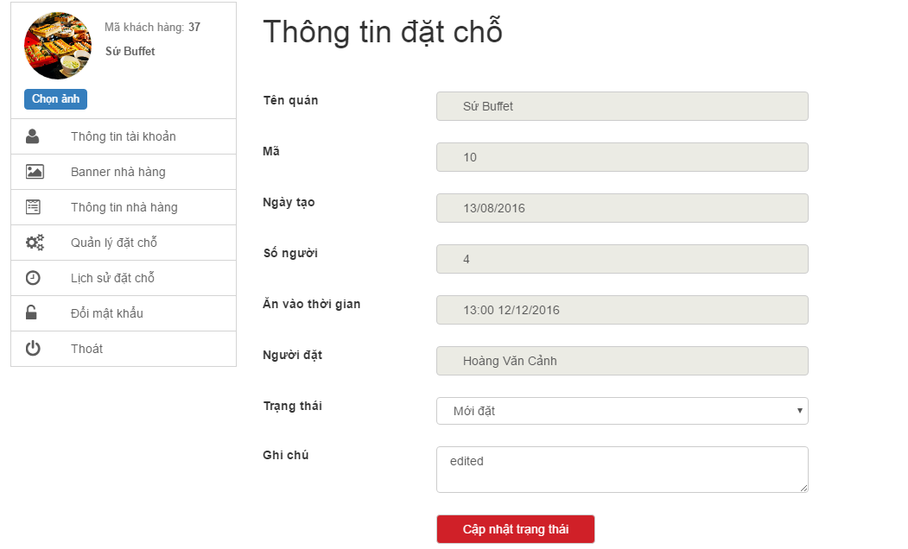

Figure 88 Update booking status

|  |  |  |  |  |  |  |
| --- | --- | --- | --- | --- | --- | --- |
| **No** | **Object/ Control Name** | **Object/ Control Name in English** | **Type** | **Required** | **Length** | **Description** |
| 1 | Trạng thái | Status | Combo-box | Yes | N/A | Select status of booking |
| 2 | Ghi chú | Note | TextArea | No | N/A | Input note of booking |
| 3 | Cập nhật trạng thái | Update status | Button | Yes | N/A | Click to update booking |

Table 52: Update booking status

##### Sequence diagram

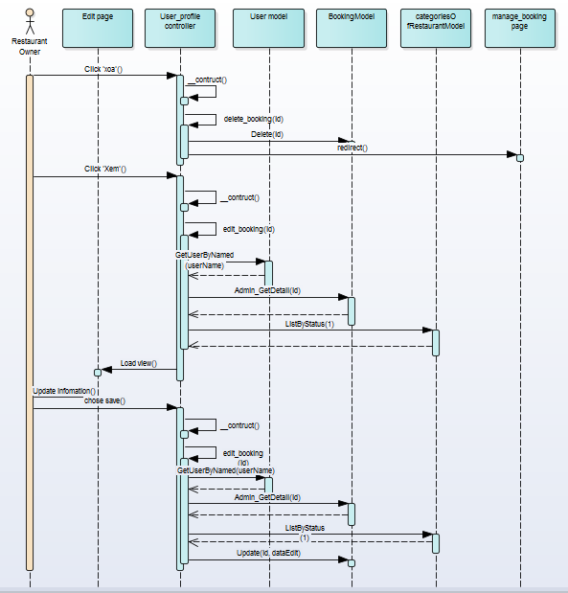

Figure 89 Update booking status sequence diagram

#### UC002 – 08 View booking history

##### Screen Design

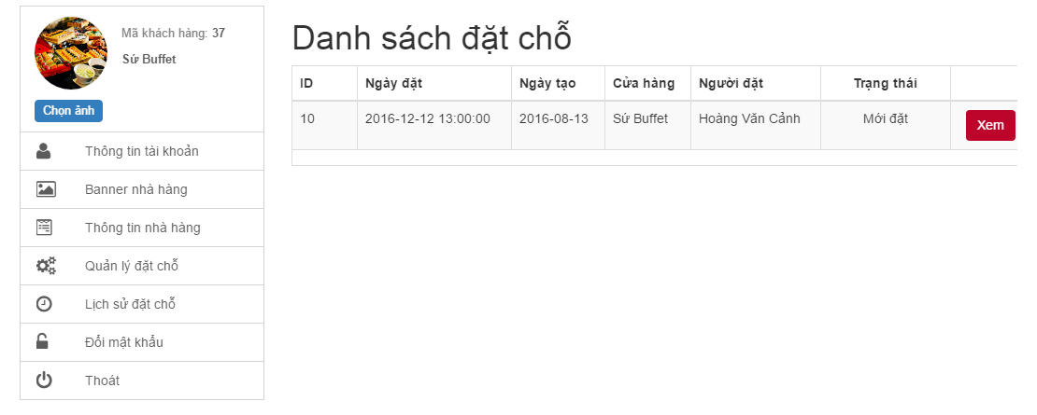

Figure 90 View booking history

|  |  |  |  |  |  |  |
| --- | --- | --- | --- | --- | --- | --- |
| **No** | **Object/ Control Name** | **Object/ Control Name in English** | **Type** | **Required** | **Length** | **Description** |
| 1 | Quản lý đặt chỗ | Booking manager | Button | Yes | N/A | Click to display list booking of restaurant |

Table 53: View booking history

##### Sequence diagram

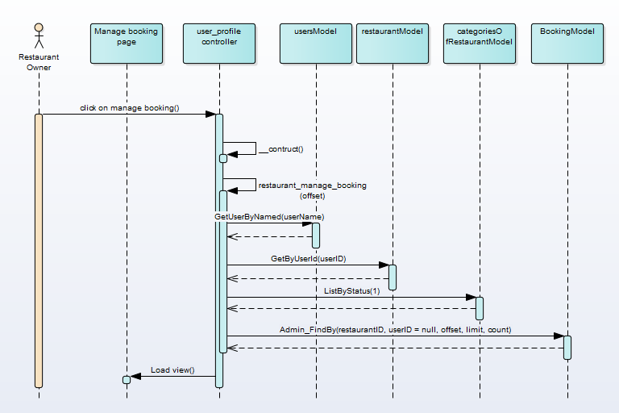

Figure 91 View booking history sequence diagram

### UC004 Guest

#### Class Diagram

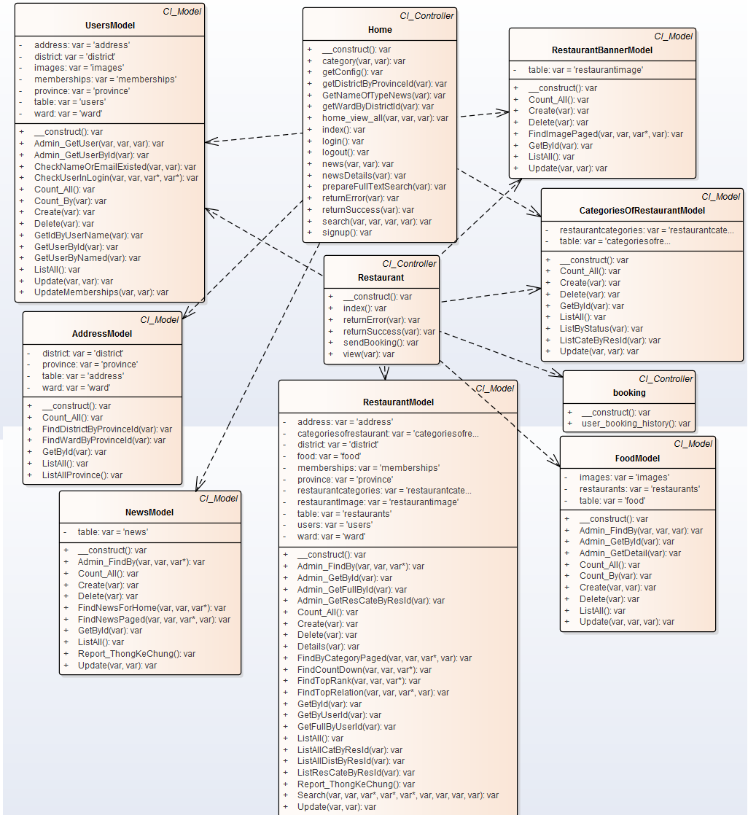

Figure 92 Guest class diagram

#### UC004 – 01 Register

##### Screen Design

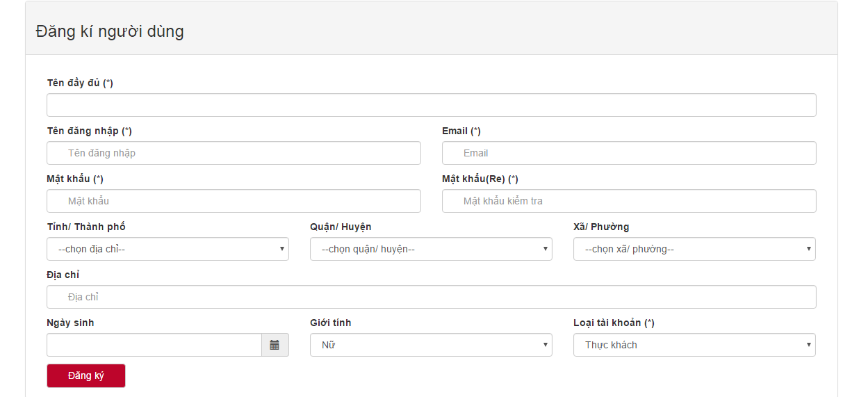

Figure 93 Register

|  |  |  |  |  |  |  |
| --- | --- | --- | --- | --- | --- | --- |
| **No** | **Object/ Control Name** | **Object/ Control Name in English** | **Type** | **Required** | **Length** | **Description** |
| 1 | Tên đầy đủ | Full name | Textbox | Yes | N/A | Input full name |
| 2 | Tên đăng nhập | Username | Textbox | Yes | >=6 characters | Input username |
| 3 | Email | Email | Textbox | Yes | N/A | Input email |
| 4 | Mật khẩu | Password | Textbox | Yes | >=6 characters | Input password |
| 5 | Mật khẩu(Re) | Confirm password | Textbox | Yes | N/A | Input confirm password |
| 6 | Tỉnh/ thành phố | Province | Combo-box | No | N/A | Select province |
| 7 | Quận/ huyện | District | Combo-box | No | N/A | Select district |
| 8 | Xã/ phường | Ward | Conbo-box | No | N/A | Select ward |
| 9 | Ngày sinh | Date of birth | Date-picker | No | N/A | Select date of birth |
| 10 | Giới tính | Gender | Combo-box | No | N/A | Select gender |
| 11 | Loai tài khoản | Type of account | Combo-box | No | N/A | Select type of account |
| 12 | Đăng ký | Register | Button | Yes | N/A | Click to register |

Table 54: Register

##### Sequence diagram

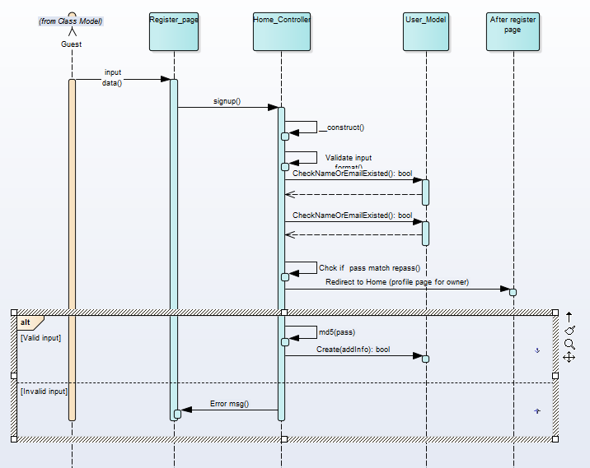

Figure 94 Register diagram

#### UC004 – 02 View news by category

##### Screen Design

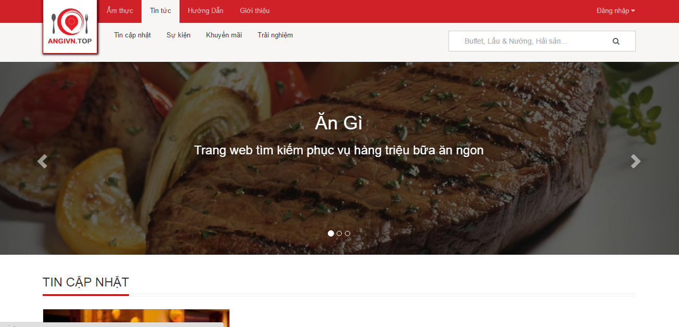

Figure 95 View news by category

|  |  |  |  |  |  |  |
| --- | --- | --- | --- | --- | --- | --- |
| **No** | **Object/ Control Name** | **Object/ Control Name in English** | **Type** | **Required** | **Length** | **Description** |
| 1 | Tin tức | News | Button | Yes | N/A | Click to display categories of news |

Table 55: View news by category

##### Sequence diagram

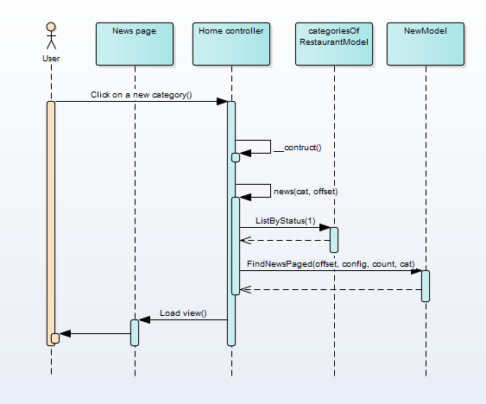

Figure 96 View news by category sequence diagram

#### UC004 – 03 View news detail

##### Screen Design

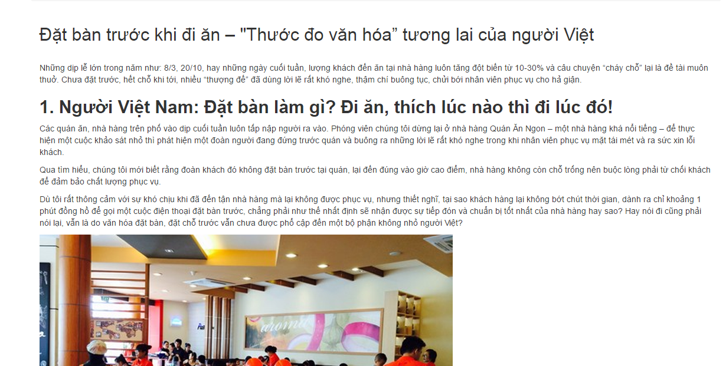

Table 56: View news detail

##### Sequence diagram

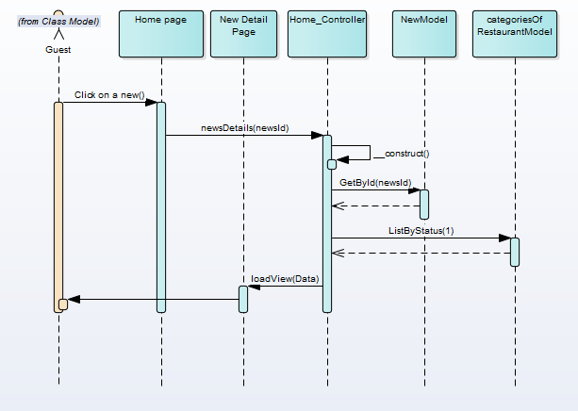

Figure 97 View news detail sequence diagram

#### UC004 – 04 Filter restaurant by category

##### Screen Design

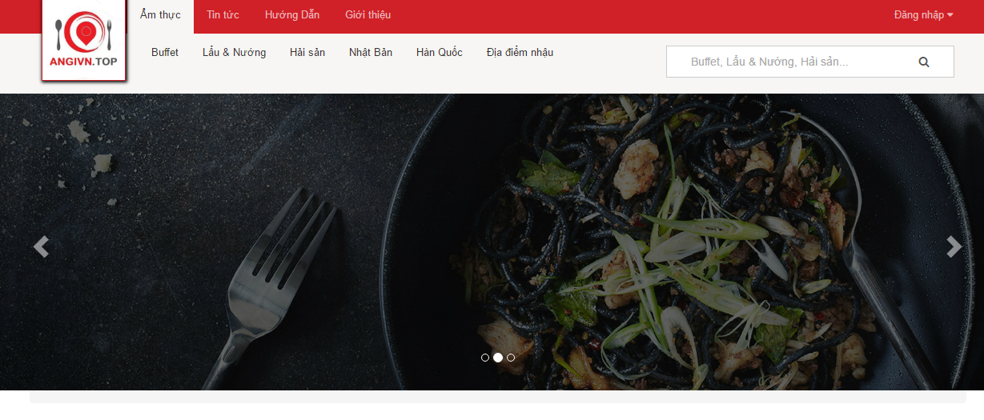 Figure 98 Filter restaurant by category

|  |  |  |  |  |  |  |
| --- | --- | --- | --- | --- | --- | --- |
| **No** | **Object/ Control Name** | **Object/ Control Name in English** | **Type** | **Required** | **Length** | **Description** |
| 1 | Ẩm thực | Cuisine | Button | Yes | N/A | Click to display categories of restaurant |

Table 57: Filter restaurant by category

##### Sequence diagram

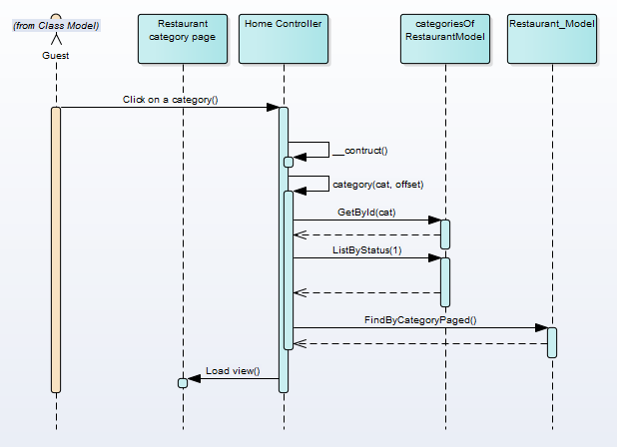

Figure 99 Filter restaurant by category sequence diagram

#### UC004 – 05 View restaurant detail

##### Screen Design

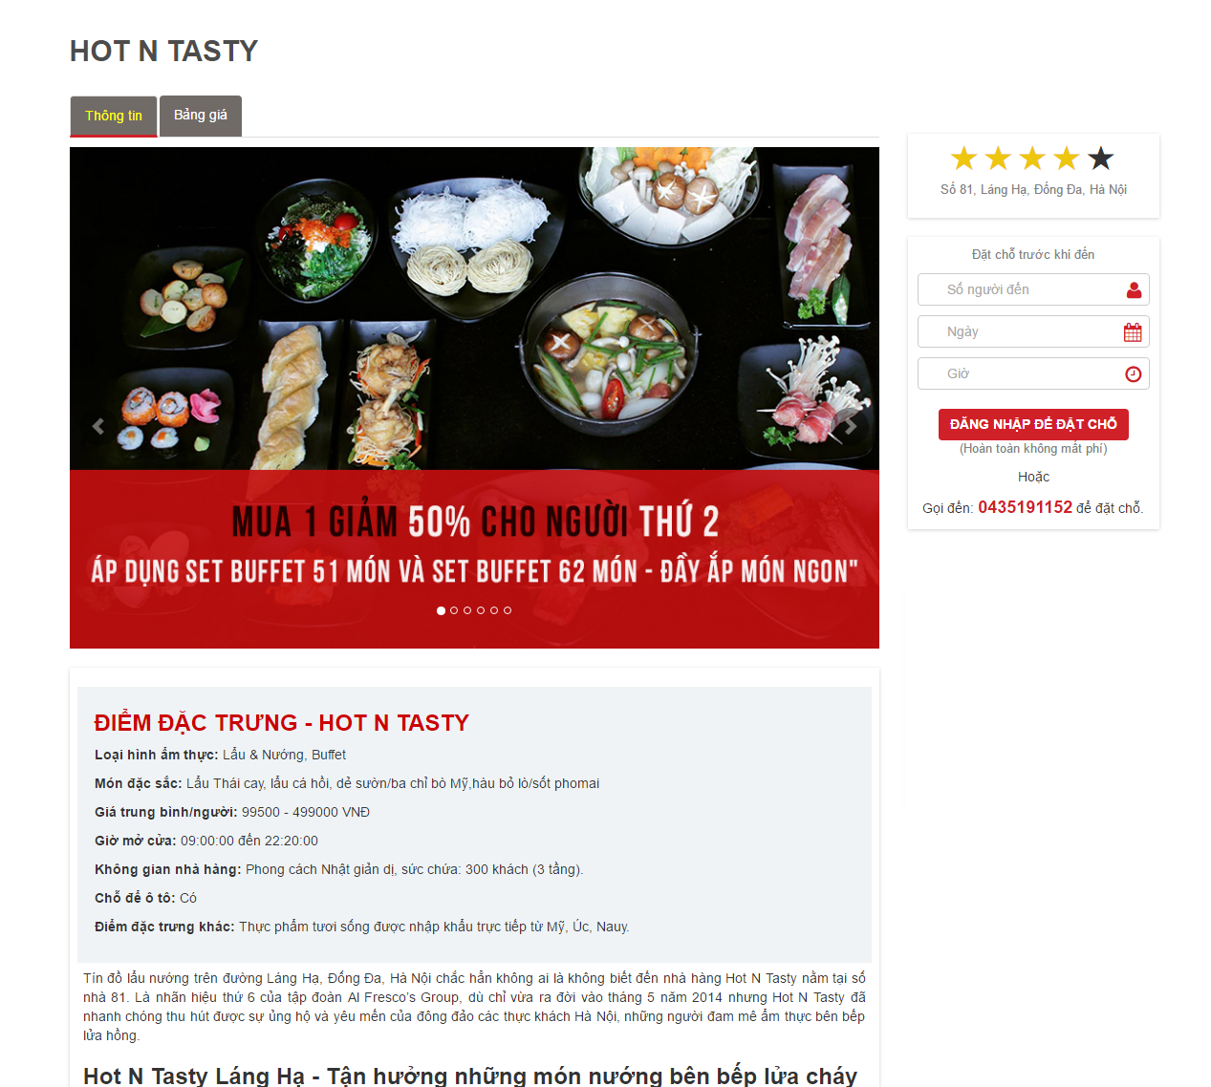

Figure 100 View restaurant detail

##### Sequence diagram

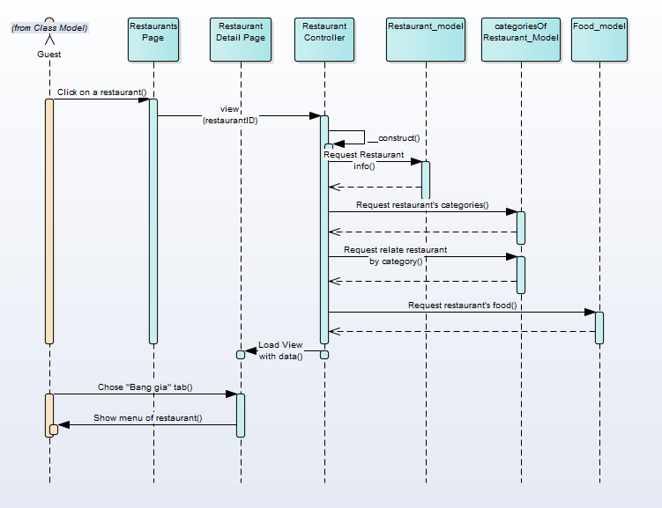

Figure 101 View restaurant detail sequence diagram

#### UC004 – 06 Like/Unlike

##### Screen Design

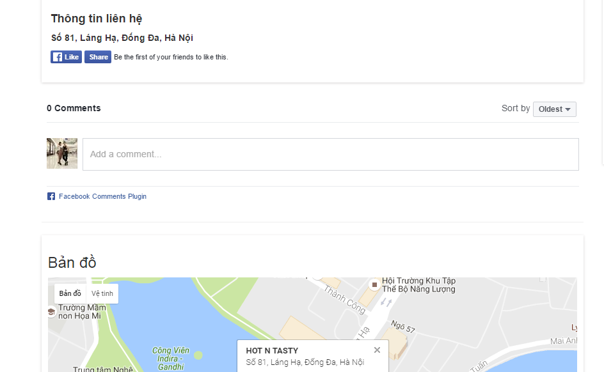

Figure 102 Like/unlike by Facebook

|  |  |  |  |  |  |  |
| --- | --- | --- | --- | --- | --- | --- |
| **No** | **Object/ Control Name** | **Object/ Control Name in English** | **Type** | **Required** | **Length** | **Description** |
| 1 | Like | Like | Button | Yes | N/A | Click to like/unlike restaurant |

Table 58: Like/unlike by Facebook

##### Sequence diagram

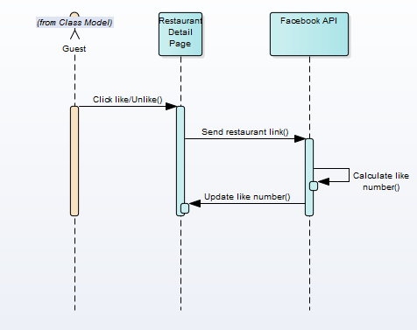

Figure 103 Like/unlike sequence diagram

#### UC004 – 07 Comment

##### Screen Design



Figure 104 Comment by Facebook

|  |  |  |  |  |  |  |
| --- | --- | --- | --- | --- | --- | --- |
| **No** | **Object/ Control Name** | **Object/ Control Name in English** | **Type** | **Required** | **Length** | **Description** |
| 1 | Add a comment | Add a comment | Textbox | Yes | N/A | Input comment of guest |

Table 59: Comment by Facebook

##### Sequence diagram

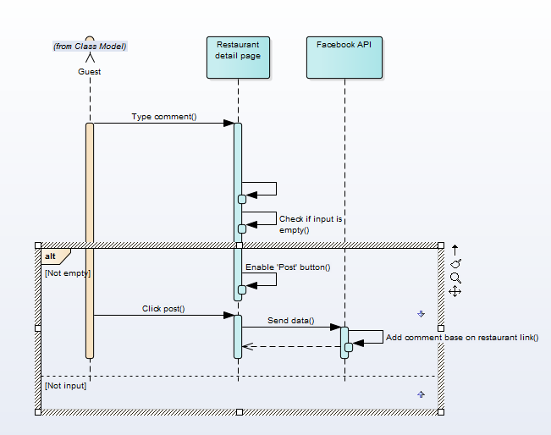

Figure 105 Comment sequence diagram

#### UC004 – 08 Share

##### Screen Design

\

Figure 106 Social network share

|  |  |  |  |  |  |  |
| --- | --- | --- | --- | --- | --- | --- |
| **No** | **Object/ Control Name** | **Object/ Control Name in English** | **Type** | **Required** | **Length** | **Description** |
| 1 | Share | Share | Button | Yes | N/A | Click to share restaurant |

Table 60: Social network share

##### Sequence diagram

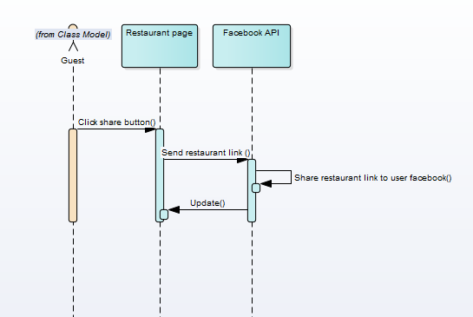

Figure 107 Social network share sequence diagram

## DATABASE DESIGN

### Database Diagram

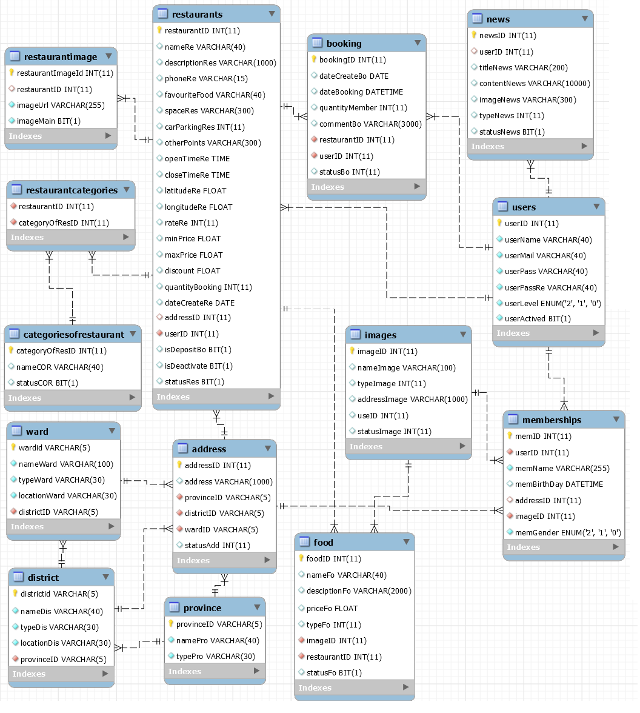

Figure 108 AGC database diagram

### Table Descriptions

#### Table address

|  |  |  |  |  |  |  |
| --- | --- | --- | --- | --- | --- | --- |
| No | Attribute | Type | Size | Nullable | Constraints | Description |
| 1 | addressID | int |  | no | primary key | unique value identifies address, auto increment |
| 2 | address | nvarchar | 100 | no |  | specific address |
| 3 | provinceID | nvarchar | 5 | no | foreign key constraint, referral table province | unique value identifies province |
| 4 | districtID | nvarchar | 5 | no | foreign key constraint, referral table district | unique value identifies district |
| 5 | wardID | nvarchar | 5 | no | foreign key constraint, referral table ward | unique value identifies ward |

Table 61: Address table

#### Table booking

|  |  |  |  |  |  |  |
| --- | --- | --- | --- | --- | --- | --- |
| No | Attribute | Type | Size | Null able | Constraints | Description |
| 1 | bookingID | int |  | no | primary key | unique value identifies booking, auto increment |
| 2 | dateCreateBo | date |  | yes |  | the date that customers make reservation |
| 3 | dateBooking | dateTime |  | no |  | date and time that customers will visit restaurant |
| 4 | quantityMember | int |  | no |  | number of people |
| 5 | commentBo | nvarchar | 300 | yes |  | other feedback or request |
| 6 | restaurantID | int |  | no | foreign key constraint, referral table restaurants | unique value identifies restaurant |
| 7 | userID | int |  | no | foreign key constraint, referral table users | unique value identifies user |

Table 62: Booking table

#### Table categoriesofrestaurant

|  |  |  |  |  |  |  |
| --- | --- | --- | --- | --- | --- | --- |
| No. | Attribute | Type | Size | Null able | Constraints | Description |
| 1 | categoryOfResID | int |  | no | primary key | unique value identifies restaurant category, auto increment |
| 2 | nameCOR | nvarchar | 300 | no |  | restaurant category name |

Table 63: CategoriesofRestaurant

#### Table district

|  |  |  |  |  |  |  |
| --- | --- | --- | --- | --- | --- | --- |
| No | Attribute | Type | Size | Nullable | Constraints | Description |
| 1 | districtID | nvarchar | 5 | no | primary key | unique value identifies district |
| 2 | nameDis | nvarchar | 100 | no |  | district name |
| 3 | typeDis | nvarchar | 30 | no |  | type of districts in Vietnam |
| 4 | locationDis | nvarchar | 30 | yes |  | latitude and longitude of the district |

Table 64: Distric table

#### Table food

|  |  |  |  |  |  |  |
| --- | --- | --- | --- | --- | --- | --- |
| No | Attribute | Type | Size | Null able | Constraints | Description |
| 1 | foodID | int |  | no | primary key | unique value identifies food, auto increment |
| 2 | nameFo | nvarchar | 30 | no |  | food name |
| 3 | descriptionFo | nvarchar | 2000 | yes |  | description of food |
| 4 | priceFo | float |  | yes |  | food price |
| 5 | typeFo | int |  | yes |  | type of food 0 to be “tráng miêng”, 1 to be “ăn nhanh” 2 to be “bữa chính” |
| 6 | imageID | int |  | no | foreign key constraint, referral table images | unique value identifies food’s image, |
| 7 | restaurantID | int |  | no | foreign key constraint, referral table restaurants | unique value identifies restaurant |

Table 65: Food table

#### Table images

|  |  |  |  |  |  |  |
| --- | --- | --- | --- | --- | --- | --- |
| No | Attribute | Type | Size | Null able | Constraints | Description |
| 1 | imageID | int |  | no | primary key | unique value identifies image, auto increment |
| 2 | nameImage | nvarchar | 100 | no |  | image name |
| 3 | typeImage | int |  | no |  | type of image |
| 4 | addressImage | nvarchar | 200 | no |  | url or path to images’ files |

Table 66: Image table

#### Table memberships

|  |  |  |  |  |  |  |
| --- | --- | --- | --- | --- | --- | --- |
| No | Attribute | Type | Size | Null able | Constraints | Description |
| 1 | memID | int |  | no | primary key | unique value identifies membership, auto increment |
| 2 | userID | int |  | no | foreign key constraint, referral table users | unique value identifies user |
| 3 | memName | nvarchar | 40 | no |  | membership name |
| 4 | addressID | int |  | no | foreign key constraint, referral table address | unique value identifies address |
| 5 | imageID | int |  | no | foreign key constraint, referral table images | unique value identifies image |
| 6 | memGender | enum(‘2’, ‘1’, ‘0’) |  | no |  | gender 2 to be male 1 to be female and 0 to be other |

Table 67: Membership table

#### Table news

|  |  |  |  |  |  |  |
| --- | --- | --- | --- | --- | --- | --- |
| No | Attribute | Type | Size | Null able | Constraints | Description |
| 1 | newsID | int |  | no | primary key | unique value identifies news, auto increment |
| 2 | userID | int |  | no | foreign key constraint, referral table users | unique value identifies user |
| 3 | titleNews | nvarchar | 100 | no |  | news title |
| 4 | contentNews | nvarchar | 10000 | no |  | content of news |
| 5 | imageNews | nvarchar |  | yes |  | images used in news content |
| 6 | typeNews | int |  | yes |  | type of news 0 is “tin cập nhật” 1 is “sự kiện” 2 is “khuyền mãi” 3 is “trải nhiệm” |

Table 68: News table

#### Table province

|  |  |  |  |  |  |  |
| --- | --- | --- | --- | --- | --- | --- |
| No. | Attribute | Type | Size | Null able | Constraints | Description |
| 1 | provinceID | nvarchar | 5 | no | primary key | unique value identifies province, auto increment |
| 2 | namePro | nvarchar | 40 | no |  | province name |
| 3 | typePro | nvarchar | 30 | no |  | province type |

Table 69: Province table

#### Table restaurantcategories

|  |  |  |  |  |  |  |
| --- | --- | --- | --- | --- | --- | --- |
| No | Attribute | Type | Size | Null able | Constraints | Description |
| 1 | restaurantID | int |  | no | foreign key constraint, ,referral table restaurants | unique value identifies restaurant |
| 2 | categoryOfResID | int |  | no | foreign key constraint, referral table categoriesofrestaurant | unique value identifies restaurant category |

Table 70: Restaurantcategory table

#### Table restaurantImage

|  |  |  |  |  |  |  |
| --- | --- | --- | --- | --- | --- | --- |
| No | Attribute | Type | Size | Null able | Constraints | Description |
| 1 | restaurantImageID | int |  | no | primary key | unique value identifies restaurant image, auto increment |
| 2 | restaurantID | int |  | no | foreign key constraint, referral table restaurants | unique value identifies restaurant |
| 3 | imageUrl | nvarchar | 200 | no |  | url or path to the images’ files |
| 4 | imageMain | bit |  | yes |  | is the image is as restaurant profile 1 is used 0 is not |

Table 71: RestaurantImage table

#### Table restaurants

|  |  |  |  |  |  |  |
| --- | --- | --- | --- | --- | --- | --- |
| No. | Attribute | Type | Size | Null able | Constraints | Description |
| 1 | restaurantID | int |  | no | primary key | unique value identifies restaurant, auto increment |
| 2 | nameRe | nvarchar | 40 | no |  | name of the restaurant |
| 3 | descriptionRes | nvarchar | 1000 | yes |  | restaurant description |
| 4 | phoneRe | nvarchar | 15 | no |  | phone number |
| 5 | favouriteFood | nvarchar | 40 | yes |  | special of famous dishes |
| 6 | spaceRes | nvarchar | 300 | yes |  | how big the restaurant is |
| 7 | carparkingRes | int |  | yes |  | is there a car parking 0 is yes 1 is no |
| 8 | openTimeRe | time |  | yes |  | restaurant opening time |
| 9 | closeTimeRe | time |  | yes |  | restaurant closing time |
| 10 | latitudeRe | float |  | yes |  | latitude of the restaurant |
| 11 | longitudeRe | float |  | yes |  | longitude of the restaurant |
| 12 | rateRe | int |  | no |  | restaurant rating |
| 13 | minPrice | float |  | yes |  | minimum price per meal |
| 14 | maxPrice | float |  | yes |  | max price per meal |
| 15 | discount | float |  | yes |  | restaurant discount for customer |
| 16 | quantityBooking | int |  | no |  | number of booking times |
| 17 | dateCreateRe | date |  | no |  | date restaurant register on the system |
| 18 | addressID | int |  | no | foreign key constraint, referral table address | unique value identifies address |
| 19 | userID | int |  | no | foreign key constraint, referral table users | unique value identifies user |
| 20 | statusRes | bit |  | no |  | is restaurant is active or not 0 is active 1 is inactive |

Table 72: Restaurants table

#### Table users

|  |  |  |  |  |  |  |
| --- | --- | --- | --- | --- | --- | --- |
| No. | Attribute | Type | Size | Null able | Constraints | Description |
| 1 | userID | int |  | no | primary key | unique value identifies user |
| 2 | userName | nvarchar | 40 | no |  | unique user name |
| 3 | userMail | nvarchar | 40 | no |  | user email |
| 4 | userPass | nvarchar | 40 | no |  | user password |
| 5 | userPassRe | nvarchar | 40 | no |  | user confirm password |
| 6 | userLevel | enum(‘2’,’1’,’0’) |  | no |  | level of user 2 is admin 1 is restaurant owner 0 is customer |
| 7 | userActived | bit |  | no |  | is user is active or not 0 is yes 1 is not |

Table 73: User table

#### Table ward

|  |  |  |  |  |  |  |
| --- | --- | --- | --- | --- | --- | --- |
| No | Attribute | Type | Size | Null able | Constraints | Description |
| 1 | wardID | nvarchar | 5 | no | primary key | unique value identifies district |
| 2 | nameWard | nvarchar | 40 | no |  | village name |
| 3 | typeWard | nvarchar | 40 | yes |  | type of villages in Vietnam |
| 4 | locationWard | nvarchar | 40 | no |  | latitude and longitude |
| 5 | districtID | nvarchar | 5 | no | foreign key constraint, referral table district | unique value identifies district |

Table 74: Ward table

**PART 5  
SOFTWARE TEST   
DOCUMENTS**

# SOFTWARE TEST DOCUMENTS

## INTRODUCTION

### Purposes

This document aims to describe testing strategies, methodologies, and activities used to perform software testing for AGC system. Also helps in estimating the testing effort required, test coverage, requirement tracking/tracing, etc.

### System Overview

AGC is a web application aiming to connect customers and restaurants together. AGC will be available on modern web browsers which is also compatible for mobile and tablets devices. The site is reliable and convenient which help users to easily access, search for information about the most suitable restaurants, promotions, food and services provided. Besides, AGC provides information of restaurants addresses, food, and table booking service.

## TEST PLAN

### Scope of Testing

* Perform three levels of testing, unit testing, integration testing and system testing.
* Perform functional testing, user interface testing and data integrity testing.
* Test all functions defined in software requirement specification of AGC101, as well as others scenarios those not existed in SRS.

### Requirements for Testing

#### Test Items

The following functions must be tested and also check their user interface

|  |  |  |  |
| --- | --- | --- | --- |
| Use case No | Group of function | Function | Description |
| UC001 | Admin management | Activate/deactivate user | allow users who have account to use system or not |
| Activate/deactivate restaurant | allow restaurant information to display on AGC website or not |
| Rate restaurant | increase or decrease restaurant rating |
| Delete restaurant | remove all restaurant data |
| Delete user | delete account registered in AGC system |
| View statistical data | view total number of restaurant, table booking, etc. |
| Add/delete category | add new or delete category to be used by restaurant |
| Write/delete/update news | fully modify and publish news |
| View all users | view users’ accounts |
| View all categories | view restaurant’ categories those available on AGC system |
| View all restaurant | View restaurants’ information to decide whether to activate or deactivate |
| View all news | Views all news those have been written in AGC system |
| View all booking | View all tables booking |
| View detail booking | Views each table booking in detail |
| UC002 | Customer management | login | general function used for login to the system |
| logout | general function used for logout of the system |
| View restaurant information | view index page of the restaurant |
| Book restaurant | book tables in a restaurant |
| View booking history | view all his/her own tables booking details |
| View account | view information related to personnel information |
| Update password | change password |
| UC003 | Restaurant owner management | Add/update/delete restaurant information | fully modify his/her own restaurant information |
| Add/update/delete restaurant banner | fully modify his/her own restaurant banner images |
| Set restaurant profile picture | choose image from banner images to use us restaurant profile picture |
| Add/update/delete food information | fully modify dishes/menu in his/her own restaurant |
| Update booking status | change table booking status for customers |
| UC004 | Guest management | register | become a member or customer of AGG website |
| View general information | view all general information which is not reserved for only specific users |
| View restaurant information | view restaurant information in detail in restaurant index page |
| Search | general function used for search restaurant based on users keyword |
| Like | Like a restaurant using Facebook account |
| Comment | comment a restaurant using Facebook account |
| Share | share a restaurant using Facebook account |
| Note: Admin and Restaurant owners are able to perform all functionalities those customers are able to, Customer can perform all functionalities those Guest is able to except register | | | |

Table 75: Testing items

#### Acceptance Test Criteria

AGC system is developed for thesis defence in FPT University. Therefore, there is no actual end users, acceptance testing will be omitted.

#### Test Completion Criteria

Testing processes will be completed if it meets all of the following criteria.

* Test coverage >= 90%
* 0 severity bug found, less than 10 bugs those are less harmful found.
* Passed unit test
* Passed integration test
* Accepted by the AGC advisor

However, testing processes will be stopped if the testing deadline has met.

#### Testing Risks

* There might be undiscovered bugs.
* Disclosed bugs those have not enough time to fix.
* Testing devices/environment might not enough to implement testing operation.
* Personnel work slower than expected.

### Test Strategies

#### Test Policies

* Try to generate as many bugs as possible.
* Identify and document all bugs found.
* Test all possible scenarios.
* Test with real devices, no simulation.
* All AGC team members much involve in testing phased.
* Test much be involved in every stage of software development life cycle (SDLC).

#### Test Model (change v-model image to default)

AGC system used Verification and Validation model (V – model) to implement all testing process.

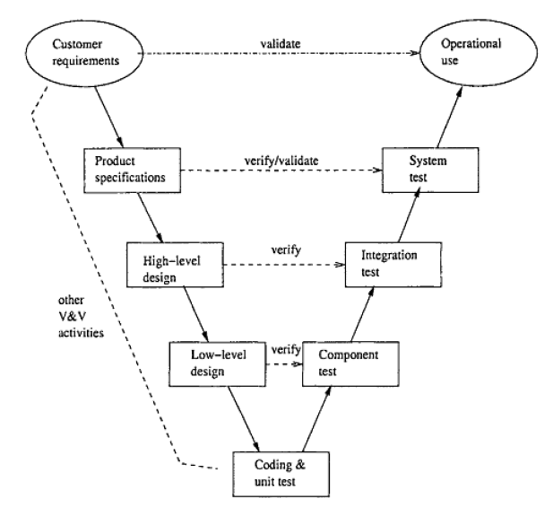

Figure 109 V-model

* **Unit Testing:** Unit tests designed in the module design phase are executed on the code during this validation phase. Tra Da members who will carry out this task consist of Soulivong Phimmathong, Hoang Van Canh, Vu Hoang Hieu, and Nguyen Hoang, which will use White Box testing technique.
* **Integration Testing:** Integration testing is associated with the architectural design phase. All Tra Da members will carry out this task and the techniques to be used are both black box and white box testing.
* **System Testing:** System testing is directly associated with the System design phase. System tests check the entire system functionality and the communication of the system under development with external systems. All Tra Da members will carry out this task.
* **Acceptance Testing:** Acceptance testing is associated with the business requirement analysis phase and involves testing the product in user environment. However, AGC system is develop for thesis defense in FPT University Therefore, there is no actual end users, as the result, acceptance testing will be omitted.

#### Types of Testing

There are 3 types of testing in AGC system: user interface, functional testing and data and data integrity testing.

##### User Interface Testing

This type of testing is to check physical appearance of the whole system. Element to be tested will be everything that are visible to users specifically fonts, layouts, buttons, images, colours, textboxes, checkboxes, radio buttons, etc. This testing is applied to 3 type of devices: smart phone, tablet and computer.

|  |  |
| --- | --- |
| **Test objective** | To ensure every element in the system will be displayed as expected |
| **Testing process** | * Testers will go through all screens then check all elements and overall looking and feel of pages * Enter both right and wrong data into the input fields to check notification and error messages * Every defect found will be recorded in Defect Log section in this documentation and send to development team to fix, then this testing will be performed again until it meets testing completion or stopping criteria |
| **Technique** | use white box testing, based on number of pages in the system |
| **completion criteria** | passed all test cases |

Table 76: User interface testing strategy

##### Functional testing

Functional testing is to check whether users can perform functions as needed or not, this test mainly focuses on the changes after perform specific functions as well as interaction between pages.

|  |  |
| --- | --- |
| **Test objective** | To ensure every function work correctly |
| **Testing process** | * Testers will test all test cases specified in AGC software requirement specification * Enter both right and wrong data into the input fields to check whether function handle errors correctly or not * Every defect found will be recorded in Defect Log section in this document and send to development team to fix, then this testing will be performed again until it meets completion or stopping criteria |
| **Technique** | use both black box and white box testing, based on use case specification |
| **Completion criteria** | passed all test cases |

Table 77: Functional testing strategy

##### Data and data integrity testing

This is Relational Database Management System (RDBMS) test which will check all data in the database, this test should be performed together with functional test since most of the processes has interaction with database. However, pure database test is also carried out to check data integrity.

|  |  |
| --- | --- |
| **Test objective** | To check data integrity and to ensure the system reads, inserts, updates, and deletes data in the database correctly |
| **Testing process** | * while performing system test, developer team will also check data in the database * check data being displayed on AGC system if it matches with data in the database * check primary key, foreign key, null able values * Every defect found will be recorded in Defect Log section in this document and send to development team to fix, then this testing will be performed again until it meets completion or stopping criteria |
| **Technique** | use RDBMS development environment tool |
| **Completion criteria** | passed all test cases |

Table 78: data and data integrity testing strategy

#### Test Stages

Common tests are carried out as in the table below:

|  |  |  |  |
| --- | --- | --- | --- |
| Type of Tests | Stage of Test | | |
| Unit | Integration | System |
| Function Test | x | x | x |
| User Interface test | x |  | x |
| Data and Data integrity test | x |  |  |

Table 79: common test stages

#### Tools

##### Hardware

|  |  |
| --- | --- |
| Name | Purpose |
| Laptop computers | test all activities in laptop computers |
| Android phones | test if the system work correctly in android system, with responsive screen |
| iPad mini 2, iPad 4 | test if the system work correctly in iPad/tablet system, with responsive screens |
| iPhone 5 | test if the system work correctly in IOS system, with responsive screens |

Table 80: testing devices

##### Software

|  |  |  |
| --- | --- | --- |
| Name | version | Purpose |
| Microsoft word | 2013 | write test plan and keep tracking defects |
| Microsoft excel | 2013 | write test case, checklist, and test report |
| MySQL workbench | 6.3 CE | perform database testing |
| Google chrome | 52.0.2743.116 m | web browser testing |
| Firefox | 48.0 | web browser testing |
| Safari | 5.0.6 | Apple web browser testing |
| Coc Coc | 41.0.2272.119 | Vietnamese web browser testing |

Table 81: testing software

#### Resources

|  |  |  |
| --- | --- | --- |
| Member | Position | Responsibilities |
| Nguyen Hoang | Test leader | * creates and views overall testing plan * assigns and keep track of testing tasks * approve testing completion |
| Nguyen Huu Thao | Tester | * creates and executes test cases * records defects in defect logs section in this documentation |
| Vu Hoang Hieu | Tester | * creates and executes test cases * records defects in defect logs section in this documentation |
| Hoang Van Canh | Tester | * creates and executes test cases * records defects in defect logs section in this documentation |
| Soulivong Phimmathong | Tester | * creates and executes test cases * records defects in defect logs section in this documentation |

Table 82: human resources testing planning

## TEST CASES

See AGC\_Test\_Cases\_V1.0.xlsx for detail.

## CHECKLISTS

### Functionalities checklists

|  |  |  |  |  |
| --- | --- | --- | --- | --- |
| **No.** | **Question** | **Yes** | **No** | **N/A** |
| 1 | Do all links take users to the right pages or position? |  |  |  |
| 2 | Have all form validation and submission tested? |  |  |  |
| 3 | Have all searching and filtering functions tested? |  |  |  |
| 4 | Have all Viewing function tested? |  |  |  |
| 5 | Have others functions tested? |  |  |  |

Table 83: Functionalities checklists

### User interface checklists

#### Colour

|  |  |  |  |  |
| --- | --- | --- | --- | --- |
| **No.** | **Question** | **Yes** | **No** | **N/A** |
| 1 | Are hyperlink colours standard? |  |  |  |
| 2 | Are the field backgrounds the correct colour? |  |  |  |
| 3 | Are the field prompts the correct colour? |  |  |  |
| 4 | Are the screen and field colours adjusted correctly for non-editable mode? |  |  |  |
| 5 | Are all the buttons are in standard format and size |  |  |  |
| 6 | Is the general screen background the correct colour? |  |  |  |

Table 84: UI color checklists

#### Content

|  |  |  |  |  |
| --- | --- | --- | --- | --- |
| **No.** | **Question** | **Yes** | **No** | **N/A** |
| 1 | Are contents displayed to the correct types of users? |  |  |  |
| 2 | All [fonts](http://www.testinggeek.com/uichklst.asp) to be the same? |  |  |  |
| 3 | Are all the screen prompts specified in the correct screen font? |  |  |  |
| 4 | Does content remain if you need to go back to a previous page, or if you move forward to another new page? |  |  |  |
| 5 | Is all text properly aligned? |  |  |  |
| 6 | Is the text in all fields specified in the correct screen font? |  |  |  |
| 7 | Is all the heading are left aligned? |  |  |  |

Table 85: UI content checklists

#### Images

|  |  |  |  |  |
| --- | --- | --- | --- | --- |
| **No.** | **Question** | **Yes** | **No** | **N/A** |
| 1 | Are all graphics properly aligned? |  |  |  |
| 2 | Are graphics being used the most efficient use of [file size](http://www.testinggeek.com/uichklst.asp)? |  |  |  |
| 3 | Banner style & size & display exact same as existing windows |  |  |  |
| 4 | Does text wrap properly around pictures/graphics? |  |  |  |
| 5 | Are font-awesome and glyphicon correctly displayed? |  |  |  |

Table 86: UI images checklists

#### Instructions

|  |  |  |  |  |
| --- | --- | --- | --- | --- |
| **No.** | **Question** | **Yes** | **No** | **N/A** |
| 1 | Is all the error message text spelt correctly on screens? |  |  |  |
| 2 | Is all notification message text spelt correctly on screens? |  |  |  |

Table 87: UI instruction checklists

#### Navigation

|  |  |  |  |  |
| --- | --- | --- | --- | --- |
| **No.** | **Question** | **Yes** | **No** | **N/A** |
| 1 | Are all disabled fields avoided in the TAB sequence? |  |  |  |
| 2 | Can all screens accessible via buttons from previous screen be accessed correctly? |  |  |  |
| 3 | Does a [scrollbar](http://www.testinggeek.com/uichklst.asp) appear if required? |  |  |  |
| 4 | Is there a link to home on every single page? |  |  |  |

Table 88: UI navigation checklists

#### Usability

|  |  |  |  |  |
| --- | --- | --- | --- | --- |
| **No.** | **Question** | **Yes** | **No** | **N/A** |
| 1 | Are some English text displayed understandable by Vietnamese people? |  |  |  |
| 2 | Are fonts too large or too small to read? |  |  |  |
| 3 | Are names in command button & option box names are not abbreviations. |  |  |  |
| 4 | Assure that option boxes, option buttons, and command buttons are logically grouped together in clearly demarcated areas "Group Box" |  |  |  |
| 5 | Can the typical user run the [system](http://www.testinggeek.com/uichklst.asp) without frustration? |  |  |  |
| 6 | Do pages print legibly without cutting off text? |  |  |  |
| 7 | Does AGC system convey a clear sense of its intended audience? |  |  |  |
| 8 | Does the site have a consistent, clearly recognizable "look-&-feel"? |  |  |  |
| 9 | Does AGC system correctly displayed on smartphone, iPad/tablet, and computer |  |  |  |
| 10 | Is all terminology understandable for all of the AGC system’s intended users? |  |  |  |

Table 89: UI usability checklists

## TEST LOGS

### Defect Logs

See AGC\_Defect\_Logs.xlsx for detail.

### Test Reports

|  |  |  |  |
| --- | --- | --- | --- |
| **Project Name** | AGC | **Creator** | Nguyen Hoang |
| **Project Code** | AGC101 | **Reviewer/Approver** | Nguyen Van Sang |
| **Document Code** | AGC\_Report5\_STD | **Issue Date** | 22 Aug 2016 |

|  |  |  |  |  |  |  |
| --- | --- | --- | --- | --- | --- | --- |
| **No** | **Module code** | **Pass** | **Fail** | **Untested** | **N/A** | **Number of test cases** |
| **Admin Management Module** | | | | | | |
| 1 | Login | 5 | 0 | 0 | 0 | 5 |
| 2 | write news | 9 | 0 | 0 | 0 | 9 |
| 3 | create category | 5 | 0 | 0 | 0 | 5 |
| 4 | update news | 2 | 0 | 0 | 0 | 2 |
| 5 | update category | 2 | 0 | 0 | 0 | 2 |
| 6 | delete news | 2 | 0 | 0 | 0 | 2 |
| 7 | delete category | 2 | 0 | 0 | 0 | 2 |
| 8 | activate/deactivate restaurant | 4 | 0 | 0 | 0 | 4 |
| 9 | delete restaurant | 2 | 0 | 0 | 0 | 2 |
| 10 | rate restaurant | 1 | 0 | 0 | 0 | 1 |
| 11 | delete user | 2 | 0 | 0 | 0 | 2 |
| 12 | activate/deactivate user | 4 | 0 | 0 | 0 | 4 |
| 13 | view all news | 2 | 0 | 0 | 0 | 2 |
| 14 | view all categories | 2 | 0 | 0 | 0 | 2 |
| 15 | view all restaurants | 2 | 0 | 0 | 0 | 2 |
| 16 | view all users | 2 | 0 | 0 | 0 | 2 |
| 17 | view all booking | 1 | 0 | 0 | 0 | 1 |
| 18 | view detail booking | 1 | 0 | 0 | 0 | 1 |
| 19 | report statistics | 1 | 0 | 0 | 0 | 1 |
| 20 | Logout | 2 | 0 | 0 | 0 | 2 |
| **Customer Management Module** | | | | | | |
| 21 | login | 5 | 0 | 0 | 0 | 5 |
| 22 | Logout | 2 | 0 | 0 | 0 | 2 |
| 23 | View account | 2 | 0 | 0 | 0 | 8 |
| 24 | update account | 8 | 0 | 0 | 0 | 8 |
| 25 | update password | 6 | 0 | 0 | 0 | 6 |
| 26 | book restaurant | 5 | 0 | 0 | 0 | 5 |
| 27 | view booking history | 2 | 0 | 0 | 0 | 2 |
| 28 | update avatar | 3 | 0 | 0 | 0 | 3 |
| **Restaurant Owner Management Module** | | | | | | |
| 29 | Login | 5 | 0 | 0 | 0 | 5 |
| 30 | Logout | 2 | 0 | 0 | 0 | 2 |
| 31 | add restaurant | 8 | 0 | 0 | 0 | 8 |
| 32 | update restaurant | 1 | 0 | 0 | 0 | 1 |
| 33 | add restaurant banner | 2 | 0 | 0 | 0 | 2 |
| 34 | Set restaurant profile picture | 1 | 0 | 0 | 0 | 1 |
| 35 | delete restaurant banner | 1 | 0 | 0 | 0 | 1 |
| 36 | add food | 6 | 0 | 0 | 0 | 6 |
| 37 | update food | 1 | 0 | 0 | 0 | 1 |
| 38 | update booking status | 1 | 0 | 0 | 0 | 1 |
| **Guest Management Module** | | | | | | |
| 39 | Home screen | 10 | 0 | 0 | 0 | 10 |
| 40 | register | 15 | 0 | 0 | 0 | 15 |
| 41 | view news by category | 2 | 0 | 0 | 0 | 2 |
| 42 | view news detail | 1 | 0 | 0 | 0 | 1 |
| 43 | view user guide | 2 | 0 | 0 | 0 | 2 |
| 44 | view about as | 1 | 0 | 0 | 0 | 1 |
| 45 | restaurant by category | 1 | 0 | 0 | 0 | 1 |
| 46 | restaurant detail | 2 | 0 | 0 | 0 | 2 |
| 47 | social | 6 | 0 | 0 | 0 | 6 |
| 48 | search | 3 | 0 | 0 | 0 | 3 |
| Total | | 152 | 0 | 0 | 0 | 152 |
| Test coverage | | 100% | | | | |
| Test successful coverage | | 100% | | | | |

**PART 6   
SOFTWARE USER’S   
MANUALS**

# SOFTWARE USER’S MANUALS

## INSTALLATION GUIDE

### Purposes

This part contains guidelines for admin to deploy and manage site on web host.

### Environments

- Operating System: Windows XP or higher

- Application server: AGC application system requires an application server running on Linux

- Browsers: Firefox 48, Chrome 50 or higher.

- Database: MySQL 5.6 or higher

- PHP 5.6 or higher

### Application Installation

#### Upload application to host

Note: We assume that you already have a host sever with a domain name.

* After login to your host account you can see host manage page as bellow (different host may has different UI but main Item that will be used in this guide is the same)

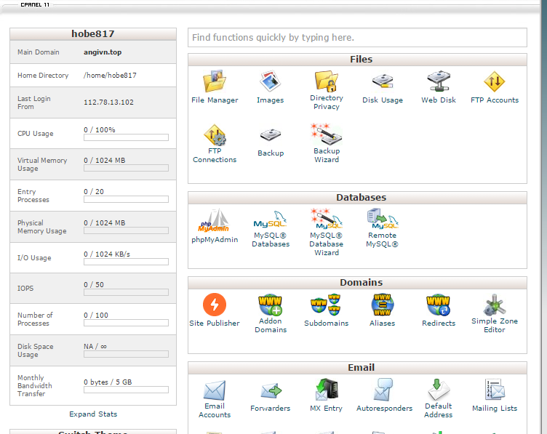

Figure 110 Host management page

* From here, click on ‘File manager’ in Files group

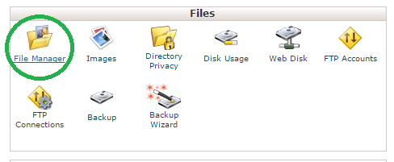

Figure 111: File Manager

* Then go to ‘public\_html’ folder

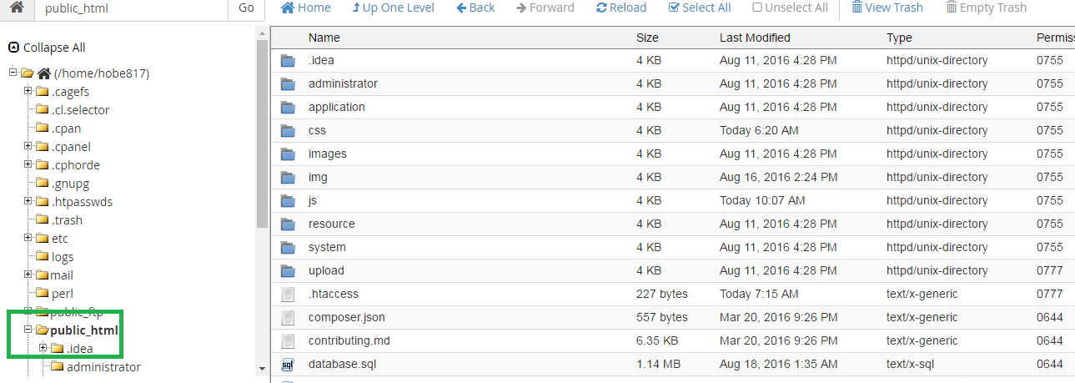

Figure 112: ‘public\_html’ folder

* After that, go to AGC project folder and compressed this folder to .zip format (can be done by using some compressed software like Winrar, 7zip …)

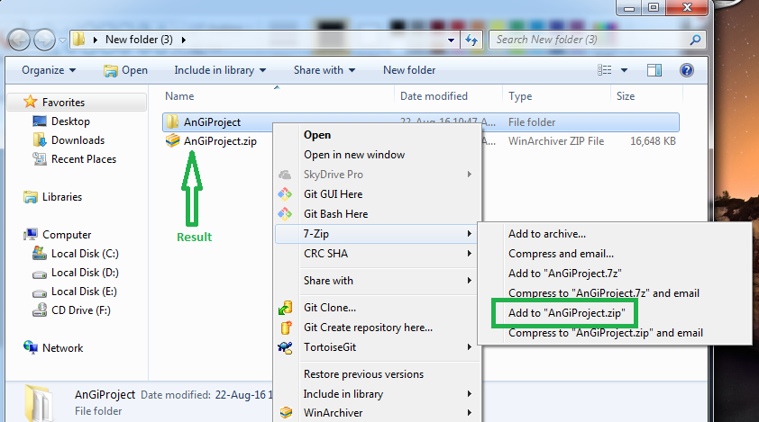

Figure 113: Compressed project

* Then comeback to ‘public\_html’ in browser and click on ‘upload’ in menu bar to upload .zip project.

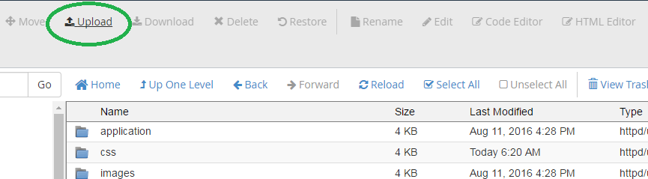

Figure 114: Upload in menu

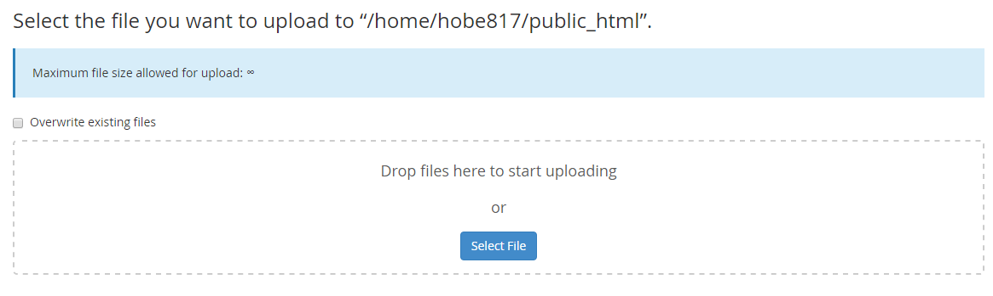

Figure 115: Upload form

* After upload, go ‘pubcic\_html’ click on file that you uploaded and extract it

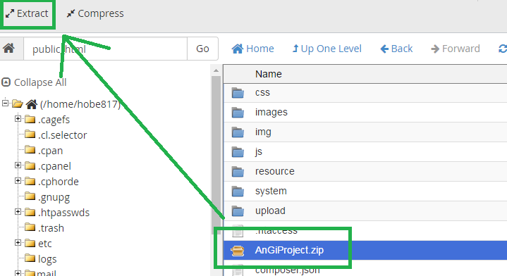

Figure 116: Extract project

#### Configure database script file and project

* You can modify database file and change project to adapt with new database
* You can find Database script file in our project at “…\AngiProject\ database.sql” then try to open it with Notepad++.

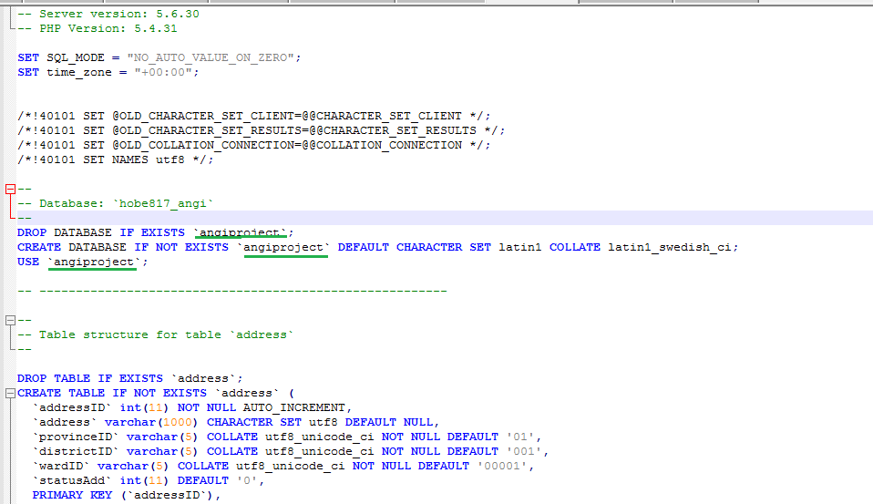

Figure 117: Database script

* From there, you can change database name (here is ‘angiproject’), the script bellow is the script define structure of database, you can modify for future update application.
* After that, you have to configure database connection at ‘…\AngiProject\application\config\database.php’. After open it by Notepad++ you can configure to match with your database and your host

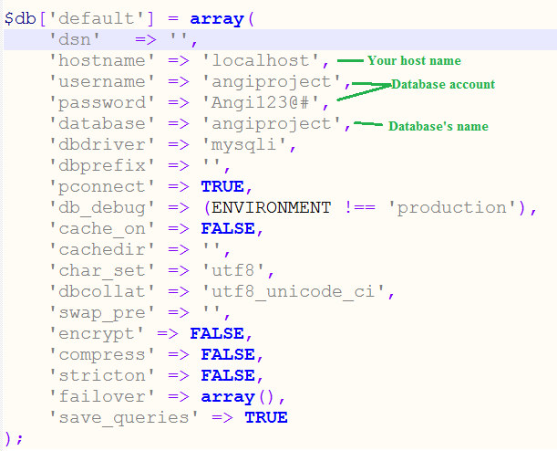

Figure 118: Database.php file

* Then open config.php file at ‘..AngiProject\application\config.php’ and configure base Url to your website domain

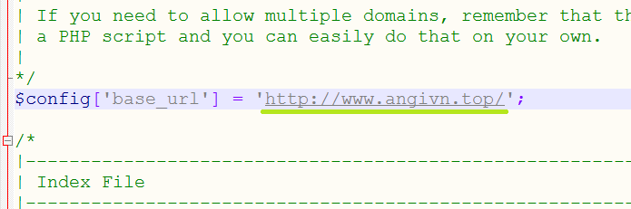

Figure 119: Base url

* After that,open file ‘…\AngiProject\resource\ckeditor\config.js’ to change link to your website domain

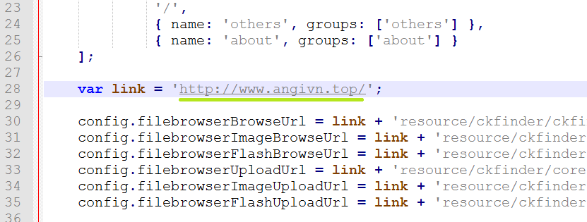

Figure 120: Ckeditor file

#### Installing database

* In host manager page, find and click on ‘phpMyAdmin’ in Databases group

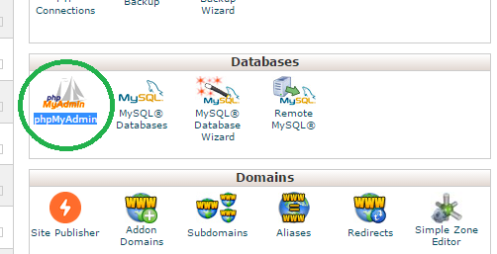

Figure 121: phpMyAdmin icon

* After that, a new phpMyAdmin page will be displayed in your browser. From there click on SQL tab (1) then copy Database script content that we provide (can be found in project folder: \AngiProject\ database.sql) to input form (2) and click Go to create database (3).

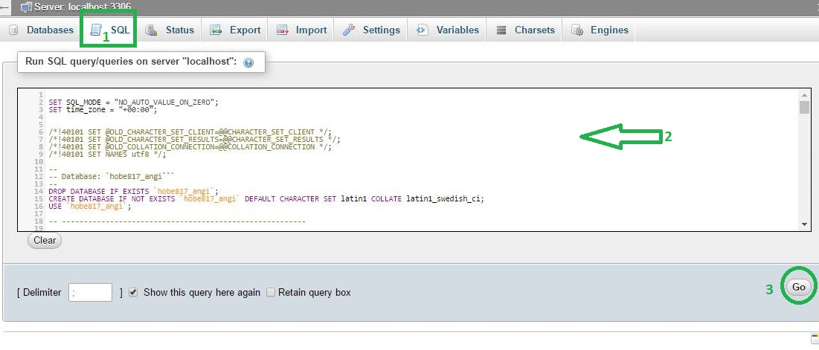

Figure 122: Create database

* After this step, you can use Application normally by access to your domain.

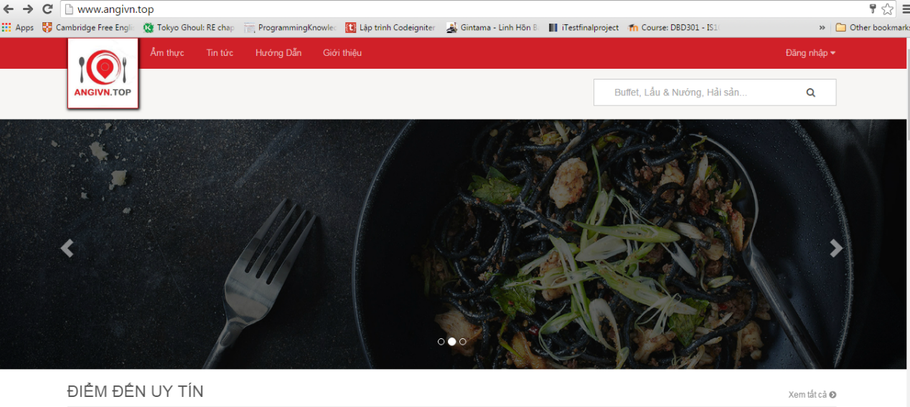

Figure 123: Web application

#### Manage Admin account

* After install application, the default admin account is:

User name: admin

Password: 123456

* You can login to admin and go to profile page (login guide can be found below in user guide)
* After that go to admin profile by ‘Thông tin cá nhân’ link

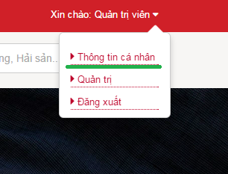

Figure 124: Profile link

* In admin’s profile page go to tab ‘Đổi mật khẩu’ to change password:

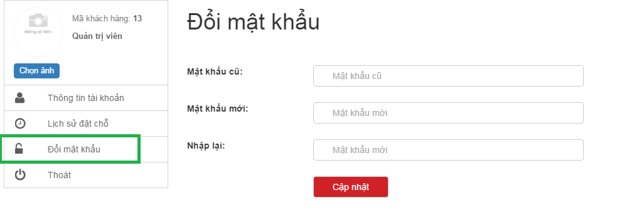

Figure 125: Change password form

* From there change password to make admin account become private for use in the future.

## USER's GUIDE

### Purposes

This document is created to instruct users of how to use main function in AGC system in computers, especially for restaurant owner to manage his/her content.

### Functional Description

Users need only a device that has intenet connection and a web browser to access and perform general function in AGC system. Meanwhile, AGC also reserves functions for specific types of users, means that they can access and manage theirs own privilege functionalilies while others cannot. The only requirement is users need to register on AGC system and are approved by admin (Admin account is manually created by Tra Da developing team).

### Detailed Guidelines

#### Guide line for Admin management

##### How to access admin page

* 1. Login as admin (similar with Login – customer guide)
  2. Hover mouse over “Xin chào Quản trị viên” text on the top right of the navigation bar, then click on “Quản trị” link

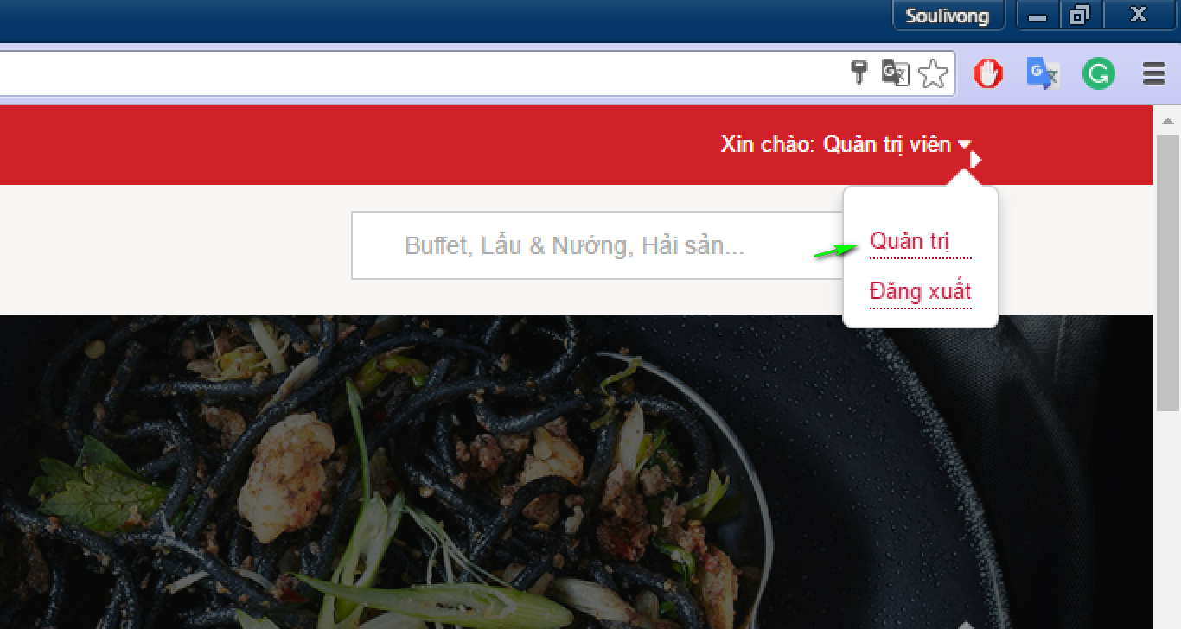

Figure 126: Profile link

##### Step by step to write a new

* + Access admin page then click on “Tin tức”, then “Thêm mới” and enter data as needed and click “Cập nhật” button

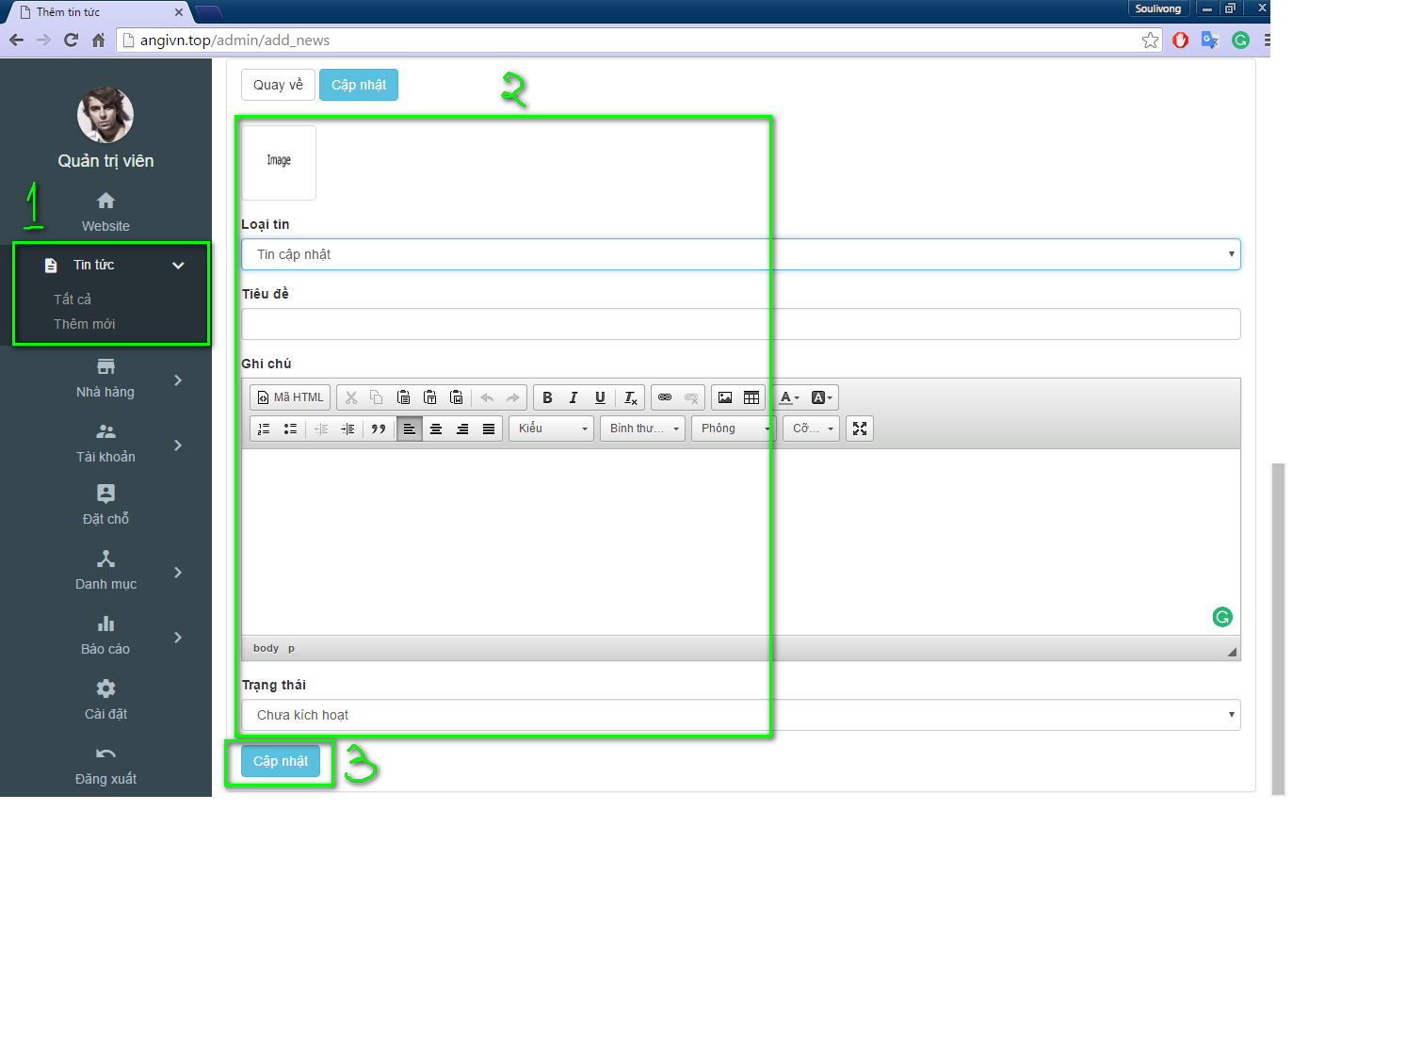

Figure 127: Add new

##### Way to update or edit your news

* 1. Access admin page, then click on “Tin tức”, then “Tất cả”, and click on “Xem” button

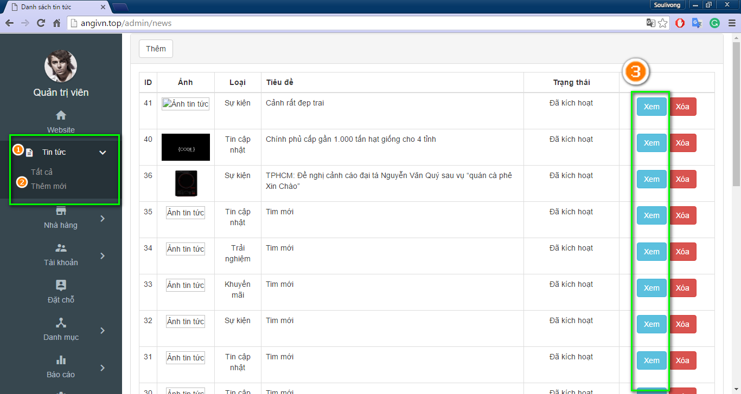

Figure 128: Admin view new

* 1. Modify information as needed and click on “Cập nhật” button. You can also show/hide news by change status to active/ deactive.

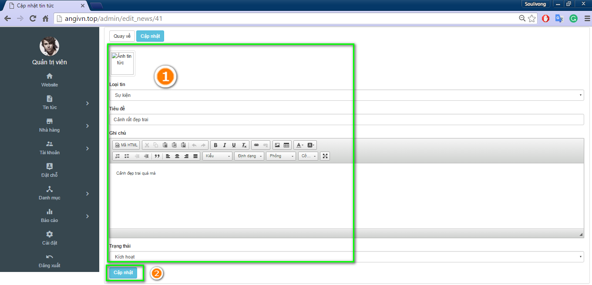

Figure 129: Edit new

##### Plan to add category to website

* + Access admin page, click on “Danh mực” tab, “Thêm mới” tab, then insert information as needed and click “Lưu” button

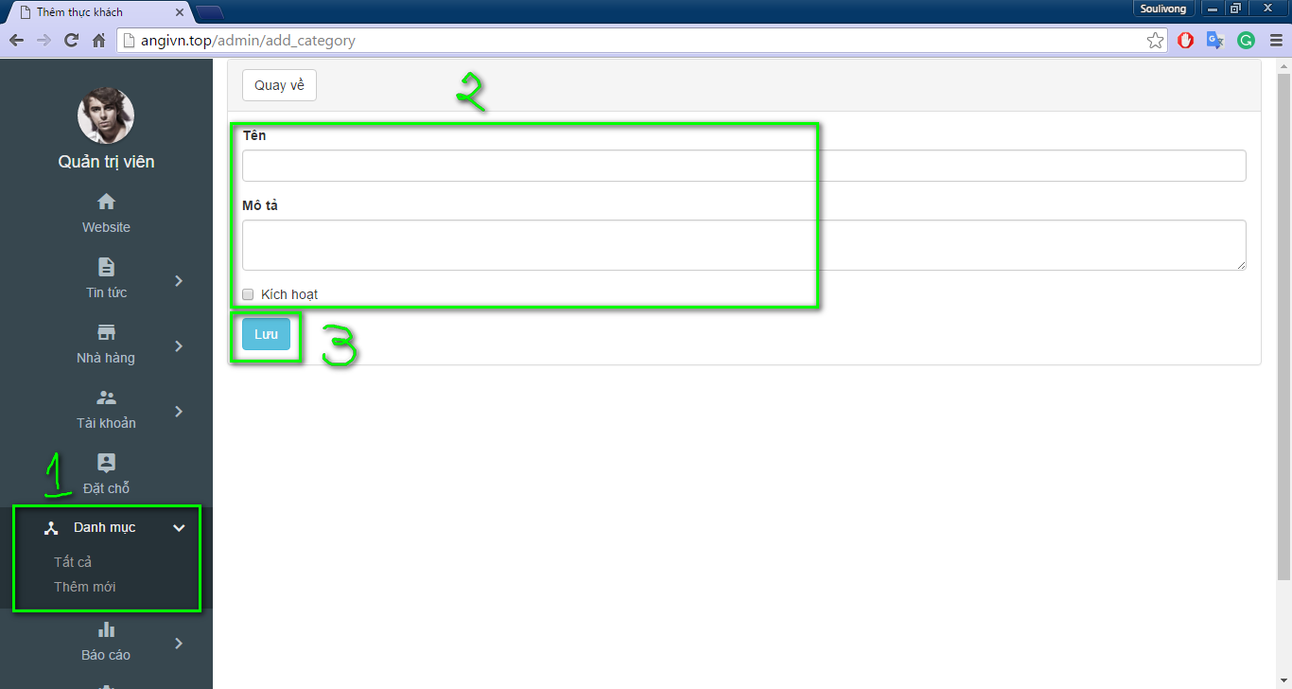

Figure 130: Add category

##### Update category

* 1. Access admin page, click on “Danh mực” tab, “Tất cả” tab, and then “Sửa” button

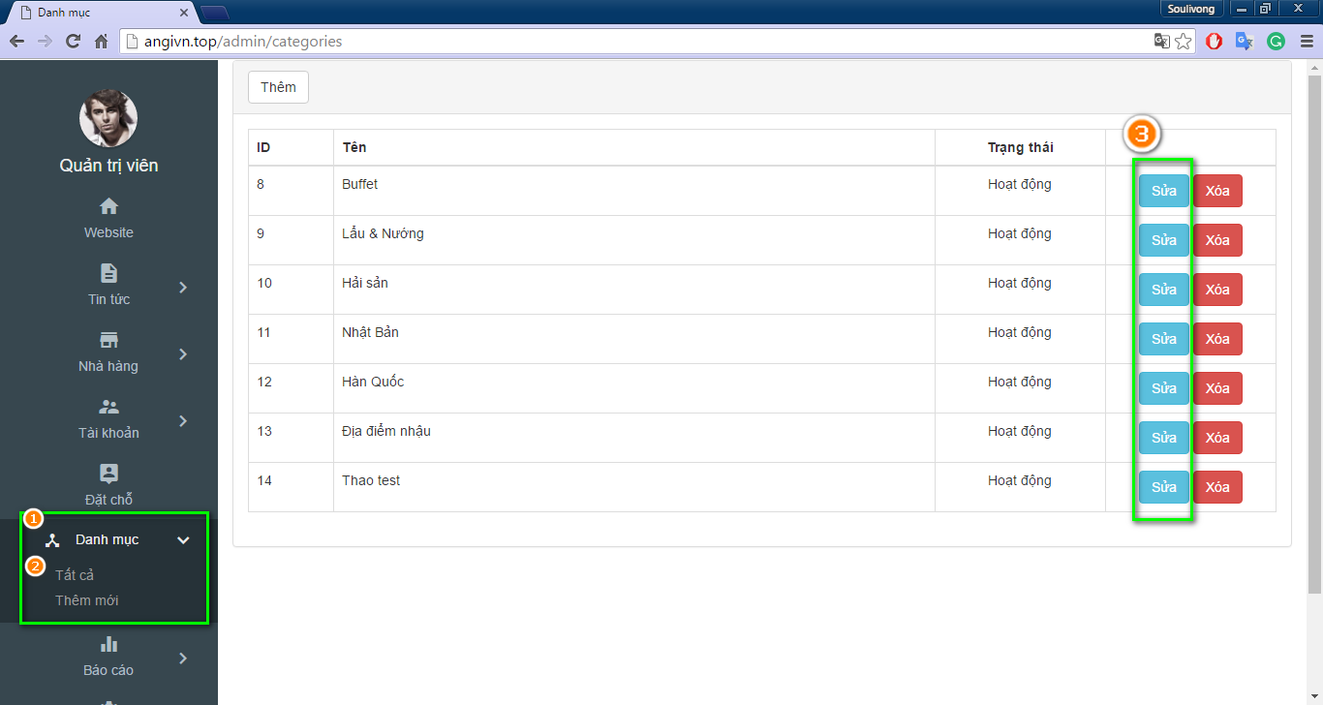

Figure 131: Edit category

* 1. Modify information as needed and click on “Lưu” button

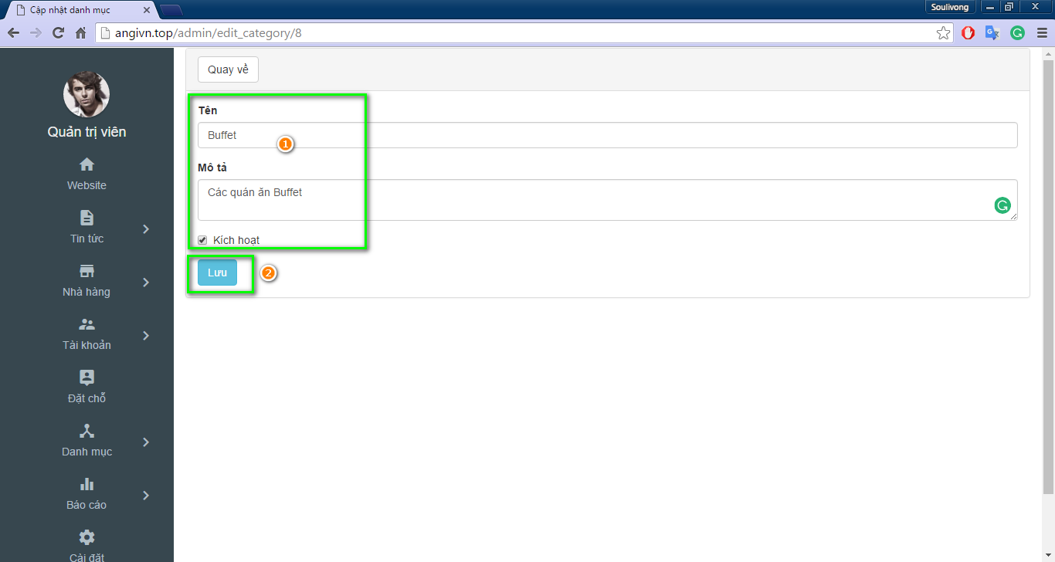

Figure 132: Save change

##### How to activate or deactivate user

* 1. Access admin page then click on “Tài khoàn”, click on “Tất cả” tab

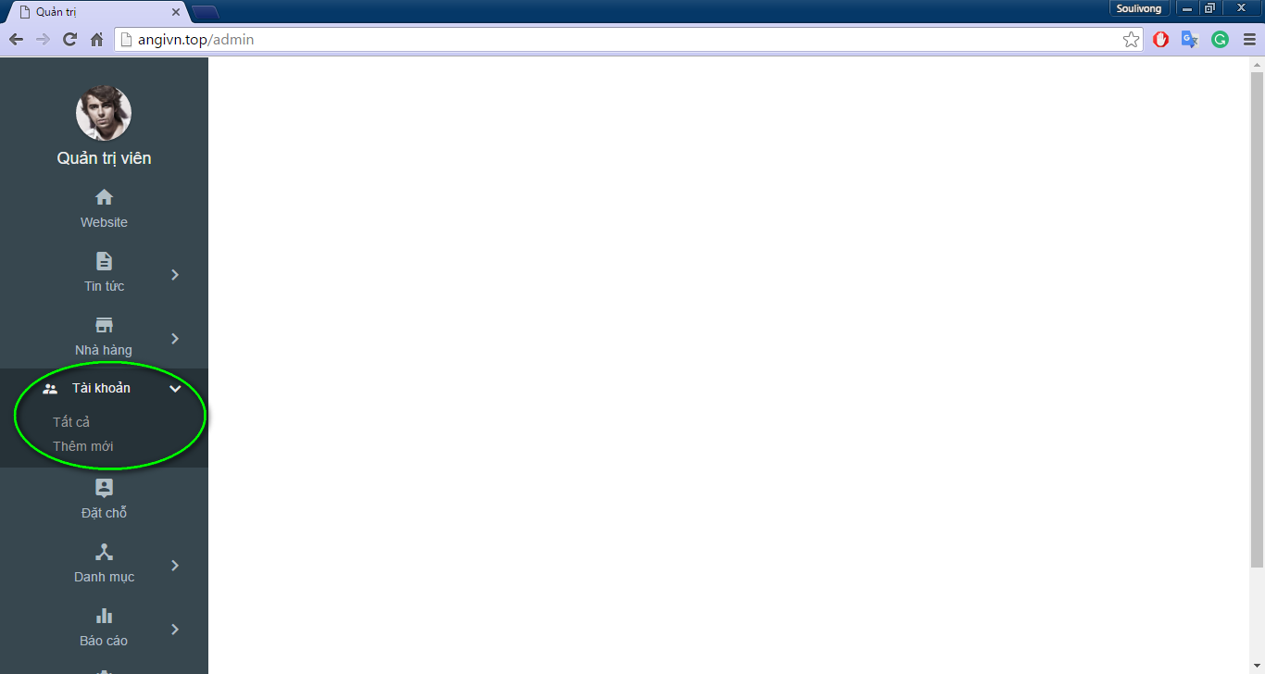

Figure 133 View user

* 1. Choose your desired restaurant and click on “Sửa” button

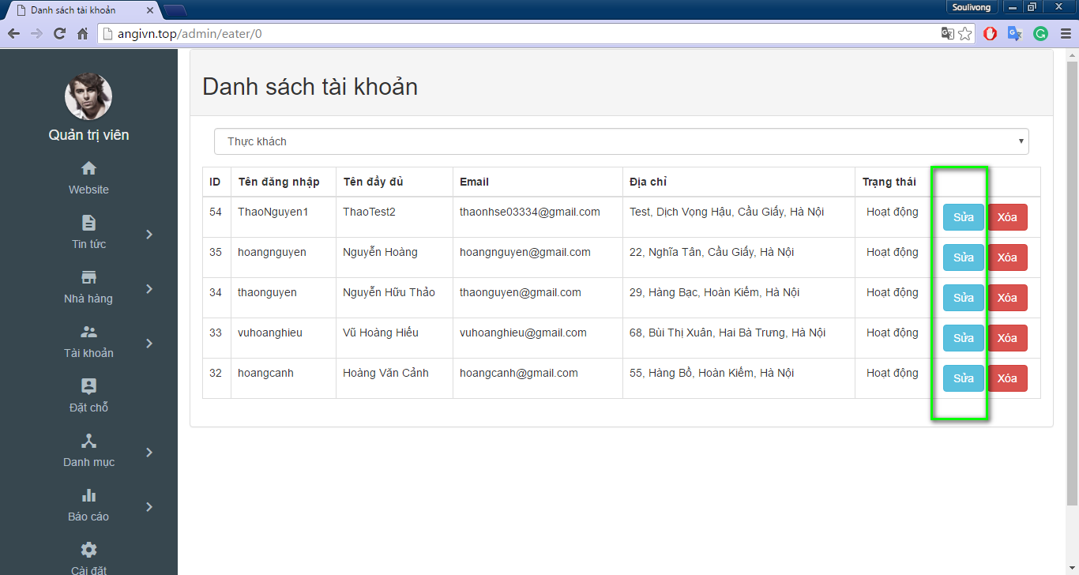

Figure 134: Edit restaurant

* 1. Click on “Duyện” check box to activate or deactivate user

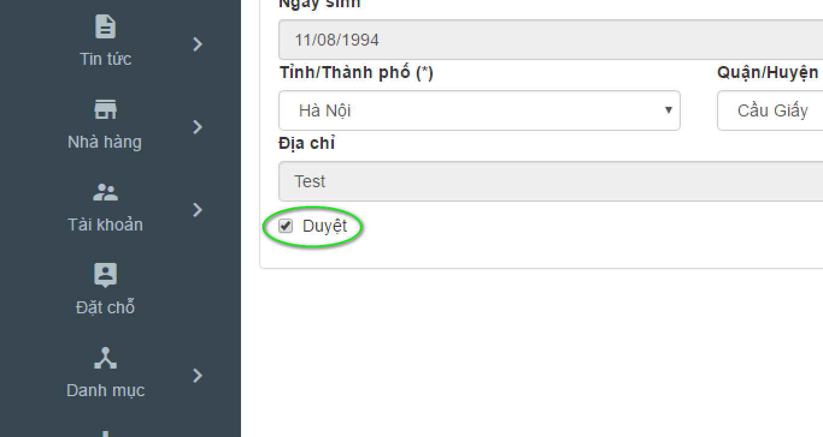

Figure 135: Active user

##### Activate or deactivate restaurant guide

* 1. Access admin page and click on “Tài khoàn” click on “Nhà hàng” tab

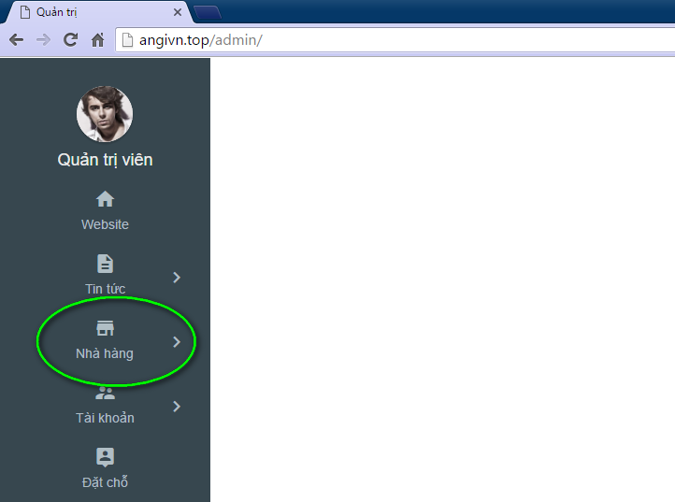

Figure 136: Manage restaurant

* 1. Choose your desired restaurant and click on “Sửa” button

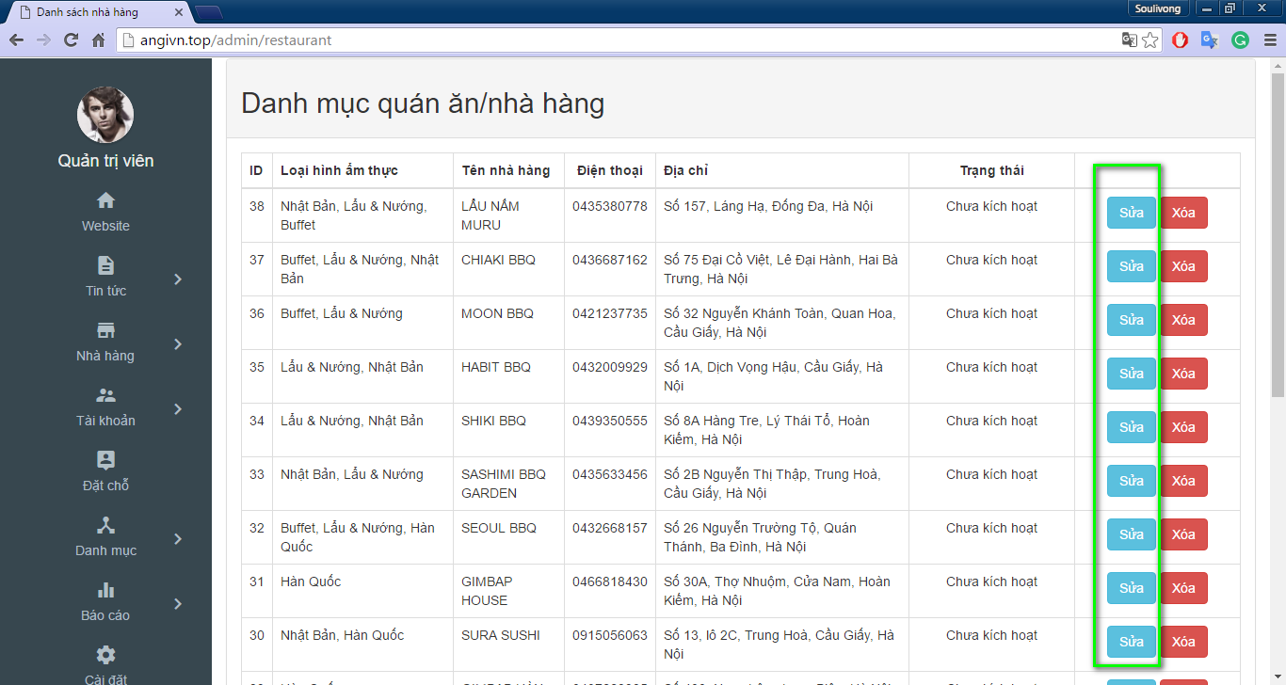

Figure 137: Edit restaurant

* 1. Click on “Kích hoạt” checkbox to activate or deactivate restaurant

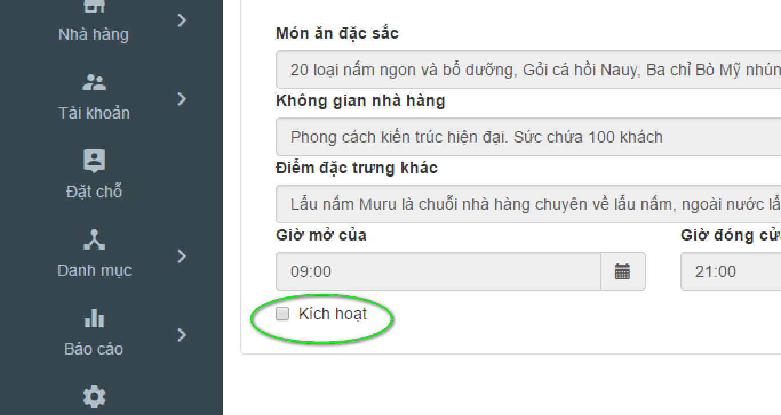

Figure 138: Active restaurant

##### How to rate a restaurant

* + Follow steps similar to UC004 – 07: activate or deactivate restaurant, but instead of clicking on “Kích thoát” checkbox click on “Đánh giá nhà hàng” dropdownlist.

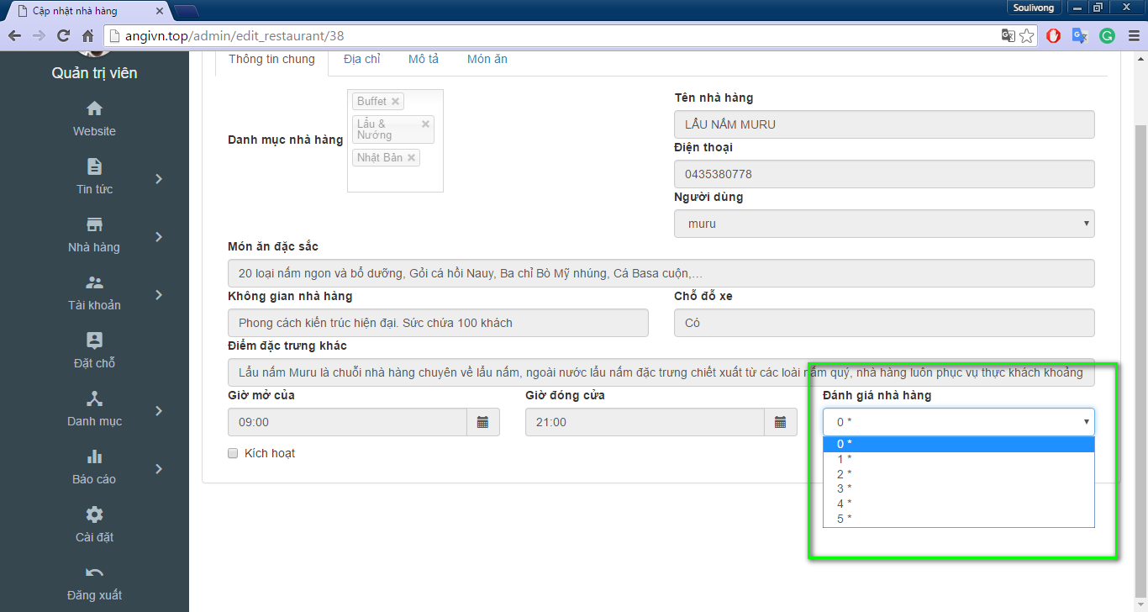

Figure 139: Rate restaurant

##### Delete a restaurant or user

* + Delete restaurant follow steps similar to activate or deactivate restaurant, but instead of clicking on “Sửa” button click on “Xóa” button, then click on “OK” button in the dialog box

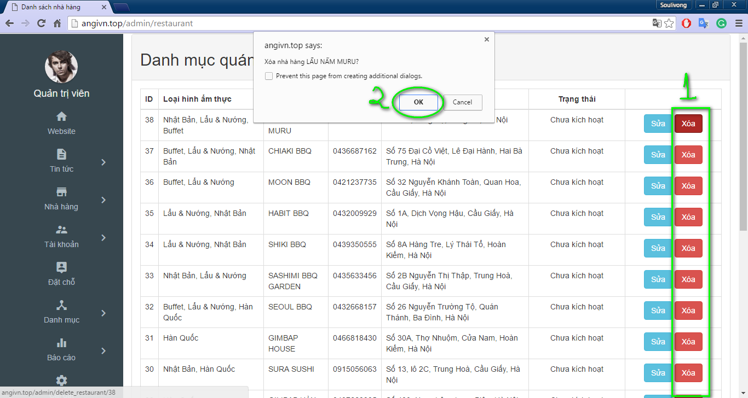

Figure 140: Delete restaurant

* To delete user, change to tab ‘Tài khoản’ and click delete corresponding to user then click ok in dialog to confirm that similar to delete restaurant

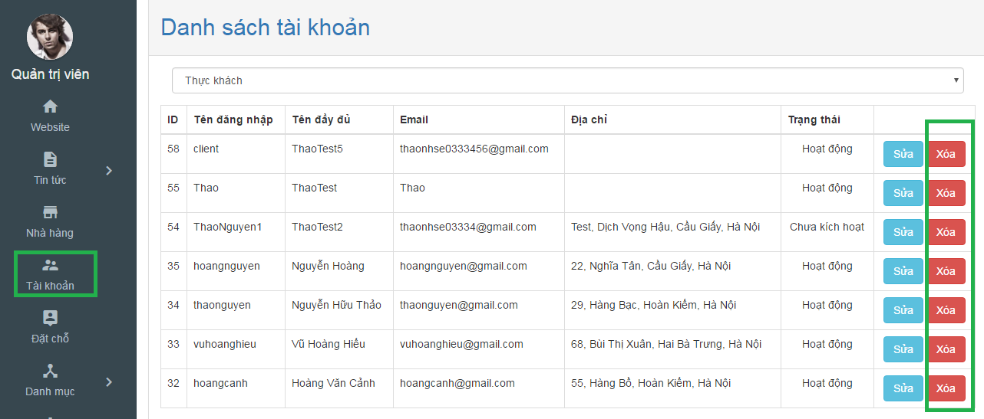

Figure 141: Delete user

##### How to manage all booking in your website

* In admin page move to ‘Đặt chỗ’ tab in left navigation to view list of booking

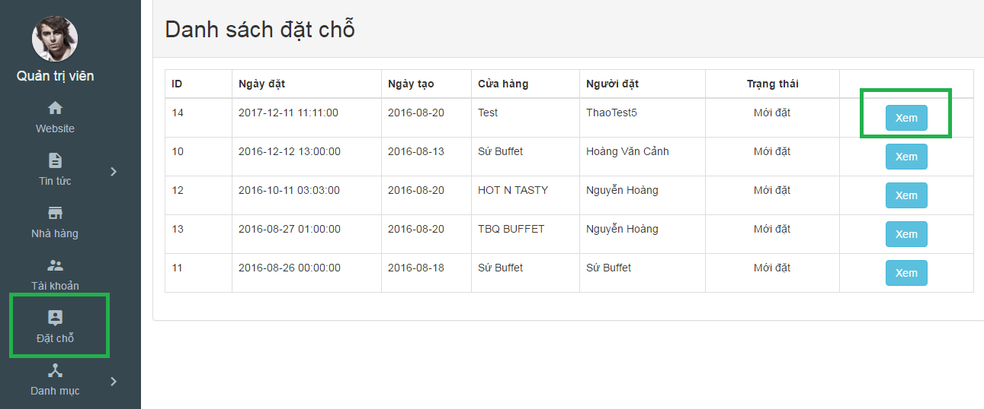

Figure 142: View booking

* Then you can click on ‘xem’ to view more detail about booking

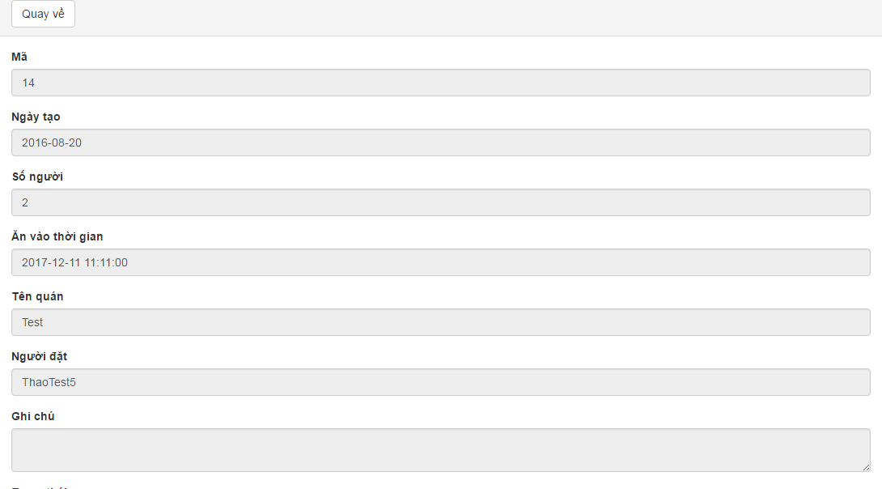

Figure 143: Booking detail

* After that, you can click on ‘Quay ve’ to come back to booking list

##### View website statistic

* In admin page, click on ‘Báo cáo’ tab to view more information

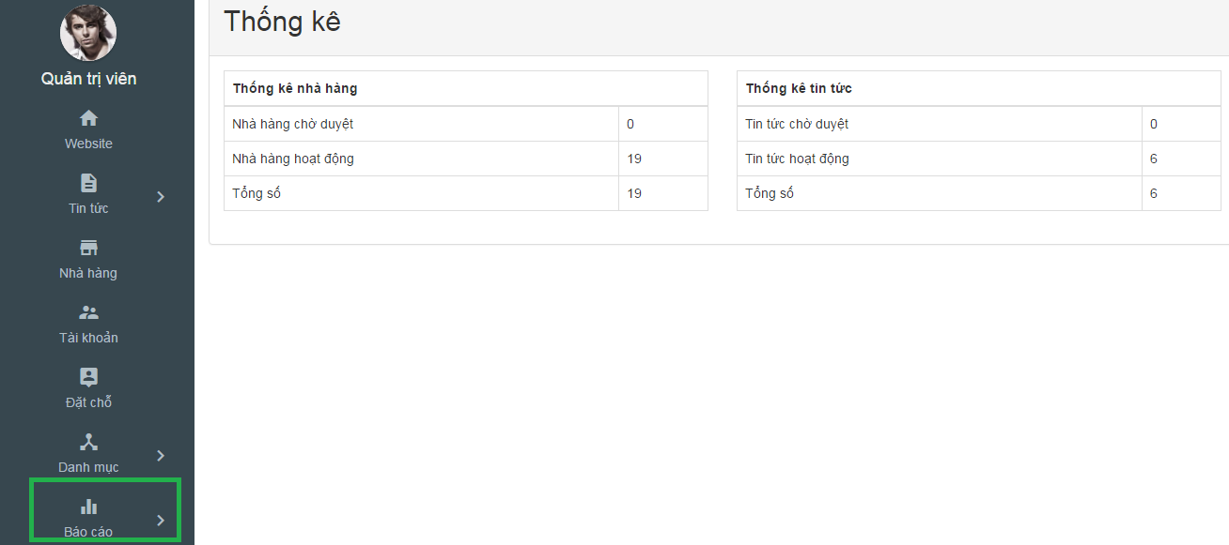

Figure 144: Report

#### Guide line for Customer

##### How to login to your account?

1. Hover mouse over “Đăng nhập” text on the top right of the navigation bar

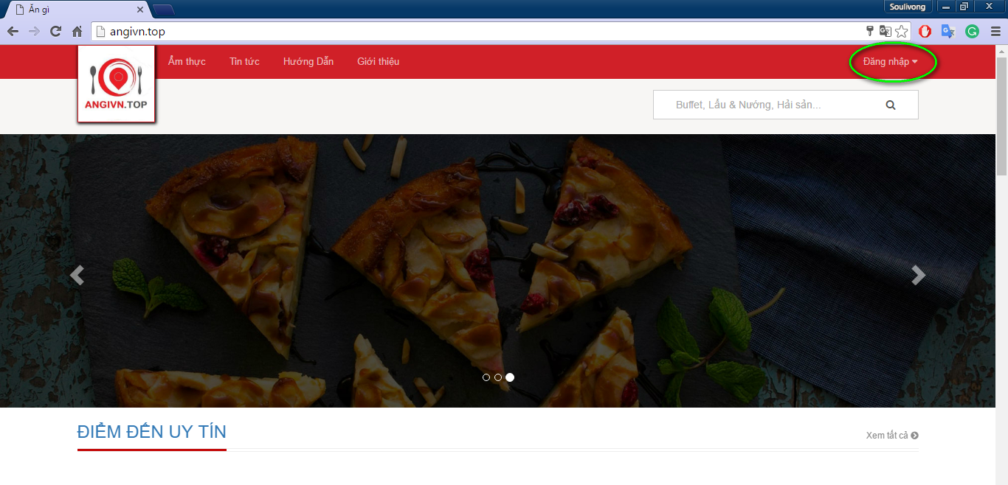

Figure 145: Login location

1. Click on “Đăng nhập button”

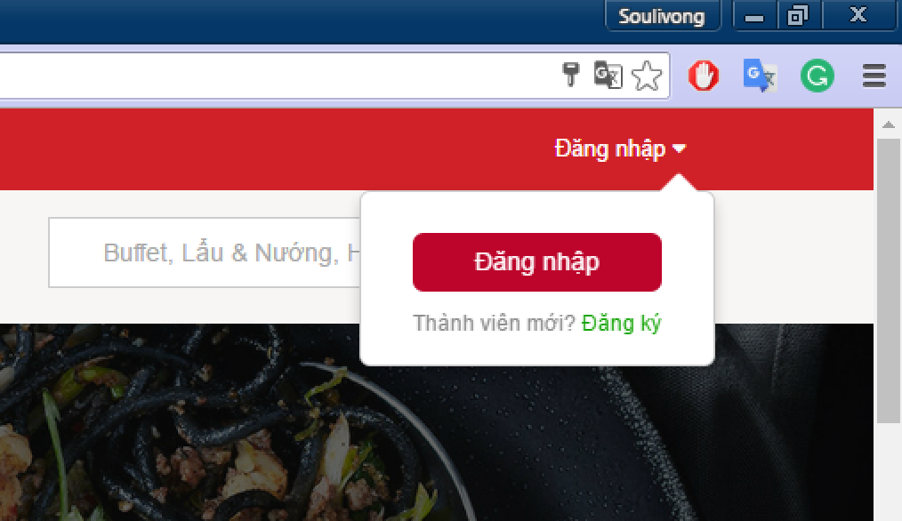

Figure 146: Login button

1. Enter user name or email and password into test boxes and click on “Đăng nhập button”

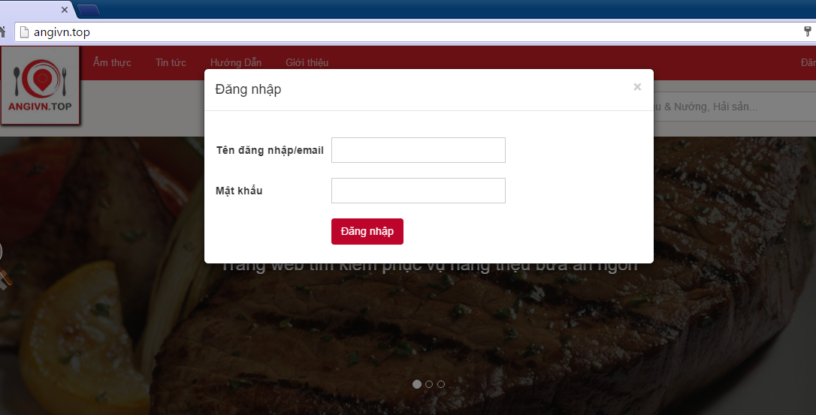

Figure 147: Login form

##### Logout from your account

Method 1**:** Hover mouse over “Xin chào” - your username/email text on the top right of the navigation bar, then click on “Đăng Xuất link”

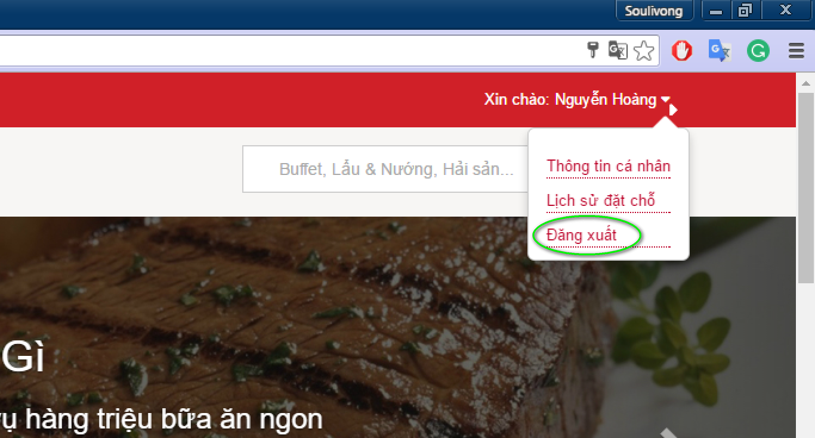

Figure 148: Logout 1

Method **2:**

* Hover mouse over “Xin chào your username/email” text on the top right of the navigation bar, then click on “Thông tin cá nhân” link

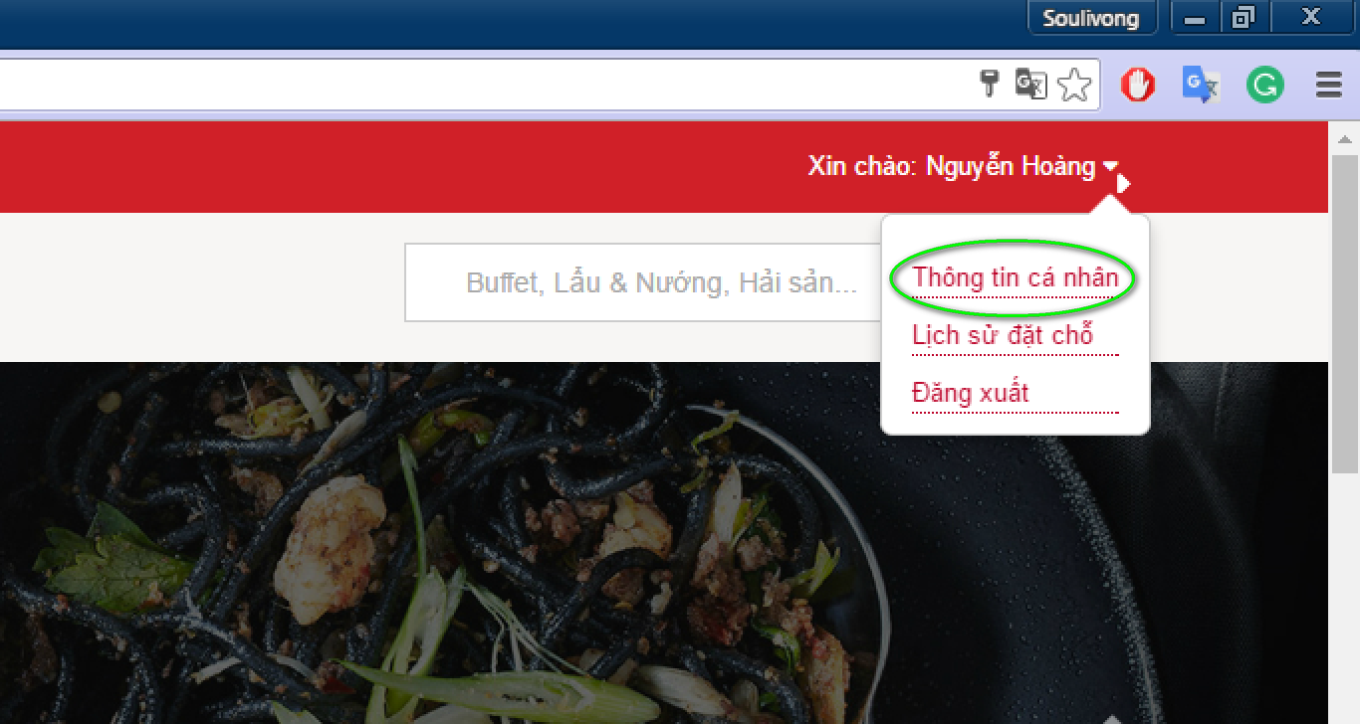

Figure 149: Profile link

* Click on “Thoát” tab

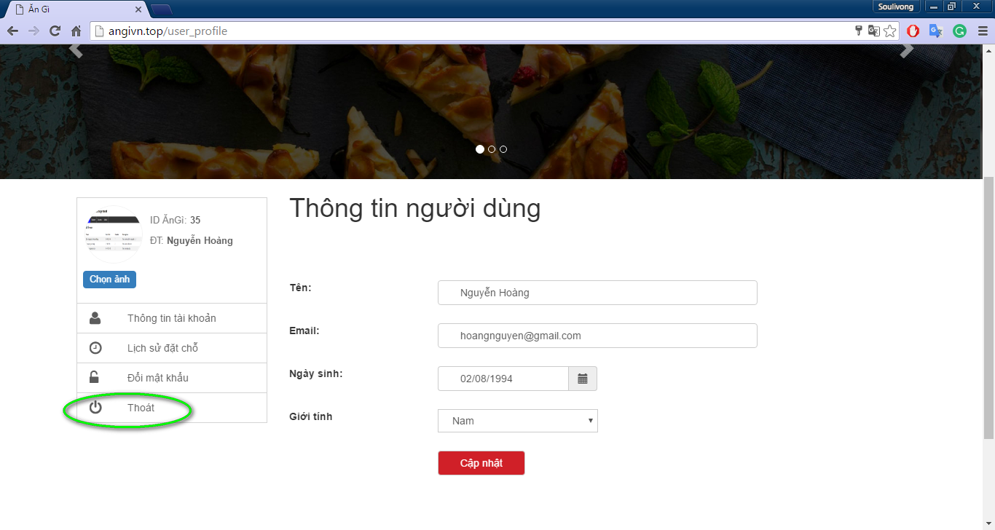

Figure 150: Logout 2

##### View your account/profile

* Logged in as customer by
* Hover mouse over “Xin chào your username/email” text on the top right of the navigation bar, then click on “Thông tin cá nhân” link



Figure 151: Profile link

##### After that, you can update account

* In user’s profile page, customer can edit information and click ‘Cập nhật’ to update account

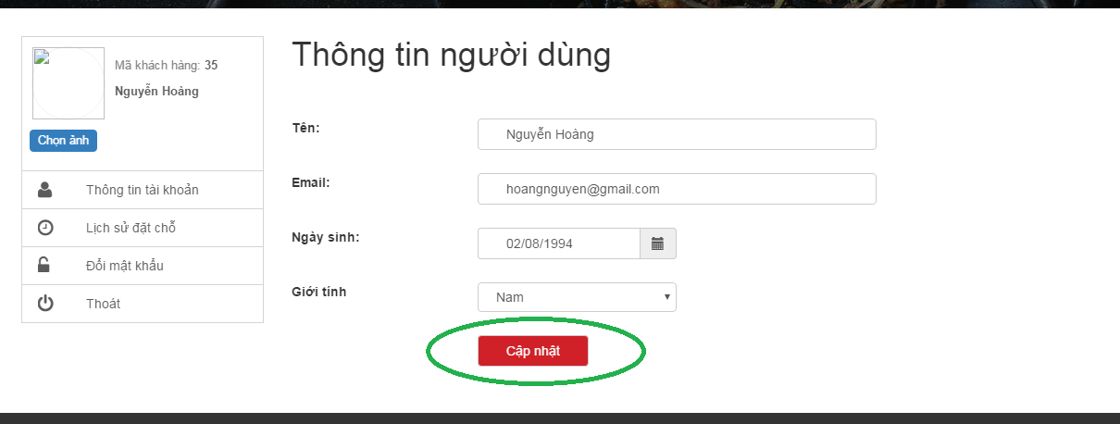

Figure 152: Update profile

##### You can update password by following

1. On profile click on ‘Đổi mật khẩu’.
2. Type old password, new pass word and re-new password that match new pass word
3. Click ‘Cập nhật’.

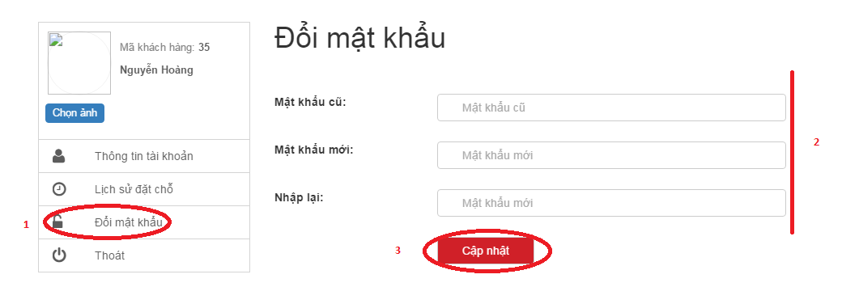

Figure 153: Change password

##### Step by step to book restaurant

* On restaurant detail page, type booking detail (1) on the booking form on the right panel and then click on ‘Đặt chỗ ngay’ .

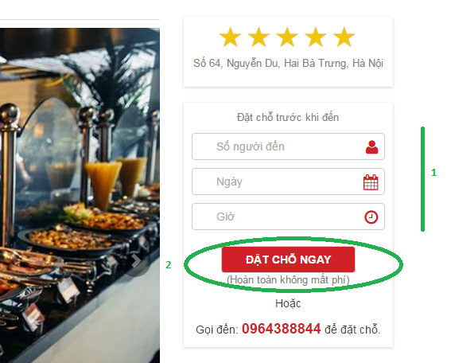

Figure 154: Booking

##### After that, you can view your booking history b

* Method 1: Hover mouse over name text on the top right of the navigation bar and click on ‘Lịch sử đặt chỗ’

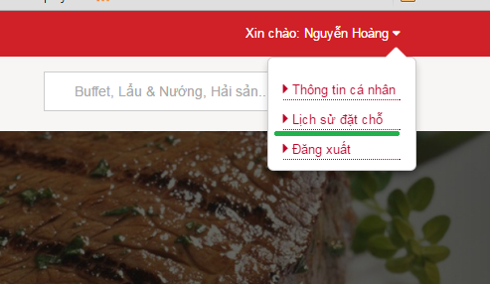

Figure 155: Manage booking

* Method 2: In profile page click on ‘Lịch sử đặt chỗ’ link

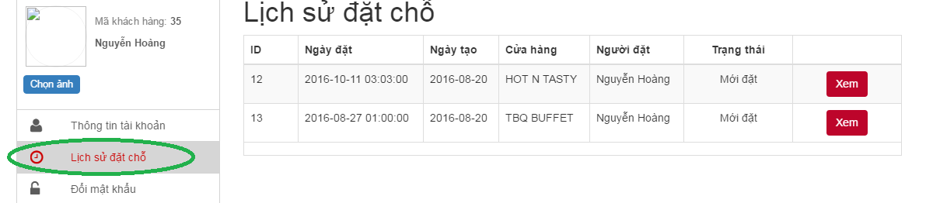

Figure 156: View booking

##### Step by step to upload your picture as avatar

* In user profile click on ‘Chọn ảnh’

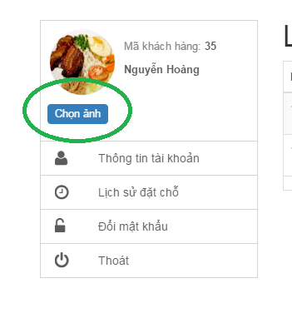

Figure 157: Chose image

* Click Upload to upload a picture then double click on a picture to choose as avatar

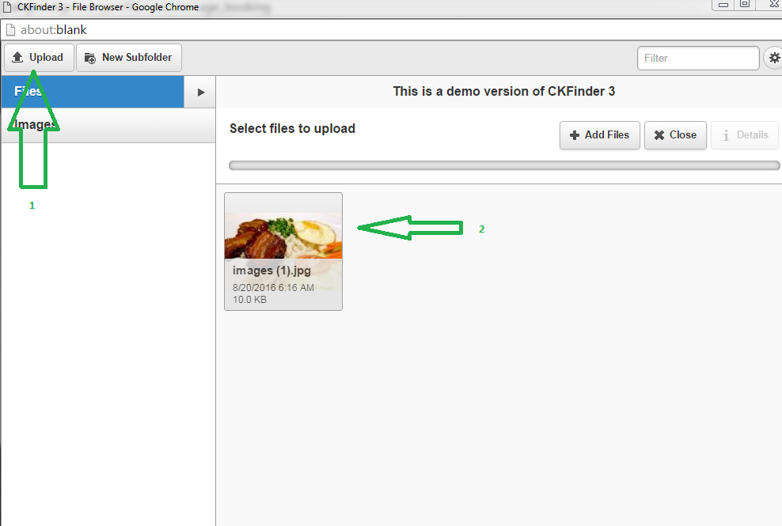

Figure 158: Upload image

* Click ‘Lưu’ to save change

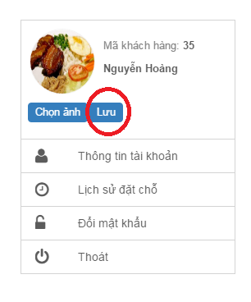

Figure 159: Save change

#### Guide line for restaurant management

##### How to add and update your restaurant

* After login to your restaurant owner account(similar to customer), click on ‘Quản lí nhà hàng’ in the menu

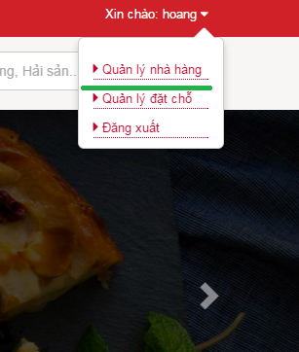

Figure 160: manage restaurant

* In the profile user can see restaurant information, if this is a new restaurant, all field will be blank. Then user can add or modify information. There are 4 tab to put information.

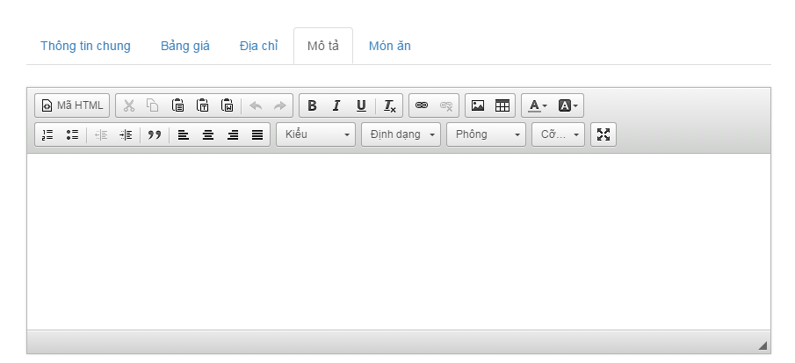

Figure 161: Restaurant description

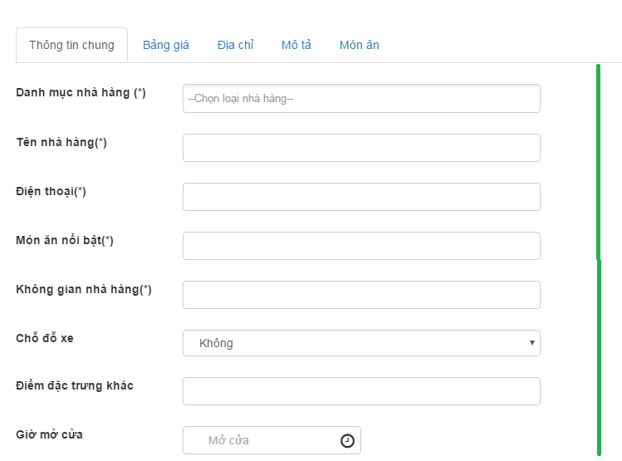

Figure 162: Restaurant info

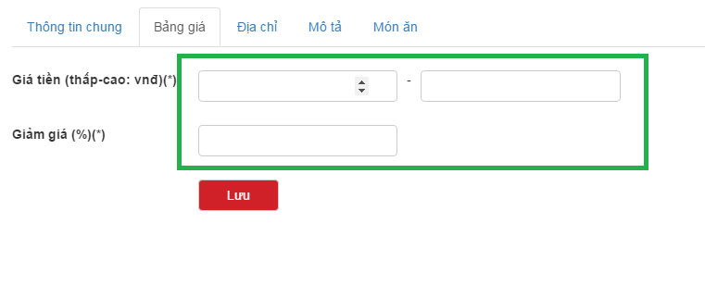

Figure 163: Menu

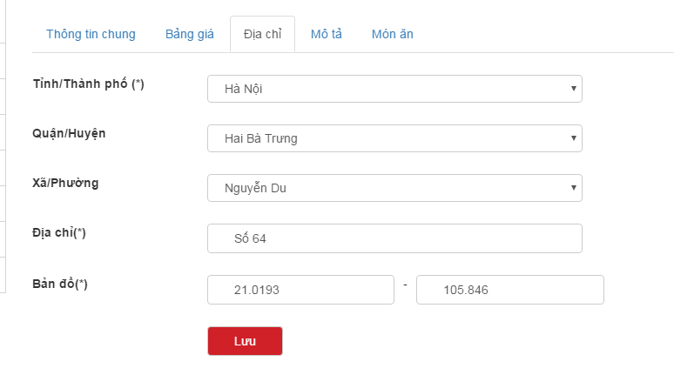

Figure 164: Address

* After type all information to form, user can click ‘lưu’ to save/update all restaurant information in bellows tabs.

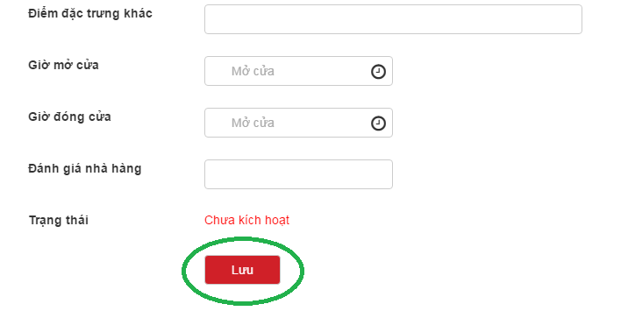

Figure 165: Save change

##### Step by step to add or delete restaurant banner

Note: Restaurant must be activated to add or delete banner, user has maximum 6 banner.

* After go to profile (similar to UC 003\_01). Click on ‘Banner nhà hàng’
* Click on ‘Image’ picture to add and choose an image (similar to up avatar )

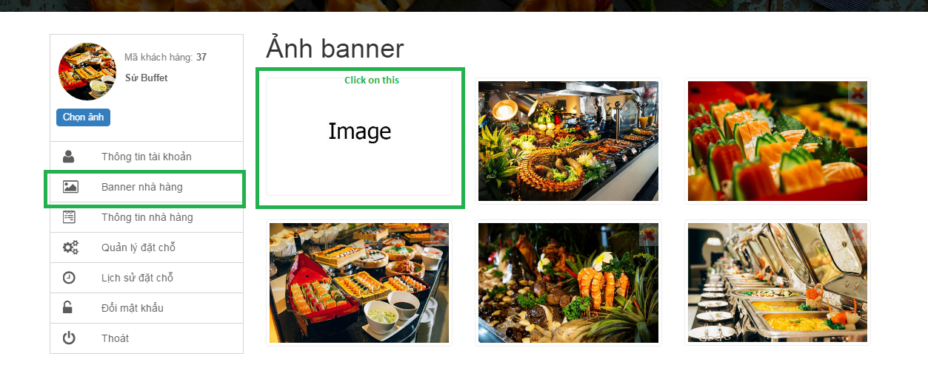

Figure 166: Add banner

* After double click on a picture, it will be add to restaurant banner
* Click on cross mark in the top of a banner to delete it

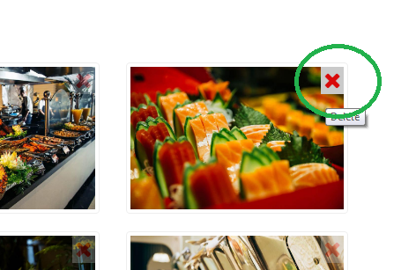

Figure 167: Delete banner

##### Set restaurant profile picture

* Similar to upload avatar in customer case. With owner, avatar is also restaurant profile picture.

##### How to add food to your restaurant

* In restaurant info page, click on tab ‘Món ăn’ then click ‘Thêm món ăn’

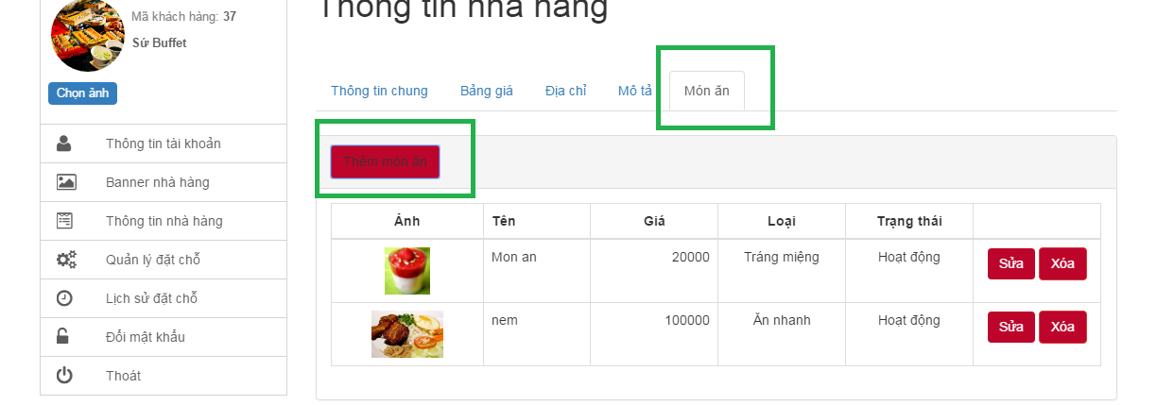

Figure 168: Add food

* An input form will be displayed, then insert food information to form, you can also upload image for food like upload avatar

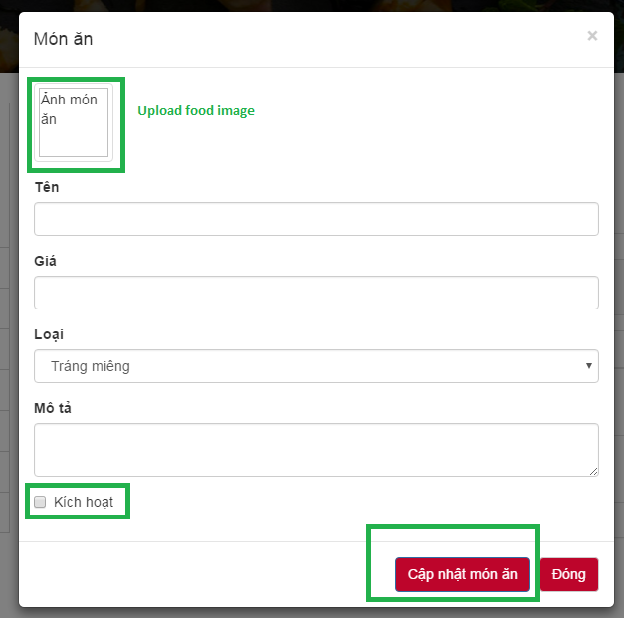

Figure 169: Type food info and save

* Check or uncheck ‘Kích hoạt’ to active/deactivate food
* After all click on ‘Cập nhật món ăn’ to save change

##### View – Update food

* On food panel, click on ‘sửa’ button corresponding to food then a new edit form will be displayed with old information.

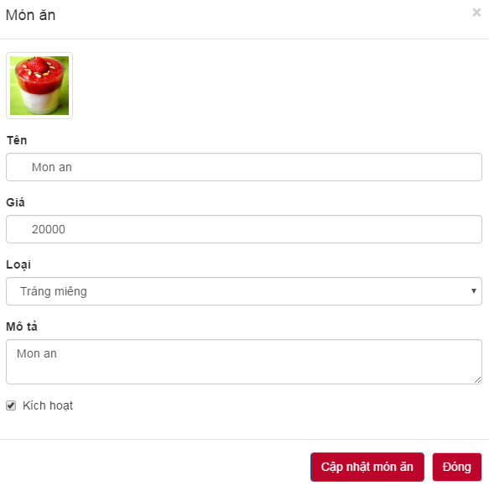

Figure 170: Update food

* Now you can modify info, change avatar and click ‘Cập nhật món ăn’ to save change

##### Delete food

* In food panel, click on delete button next to a food, then a confirm dialog will be display, click ok to remove food from restaurant

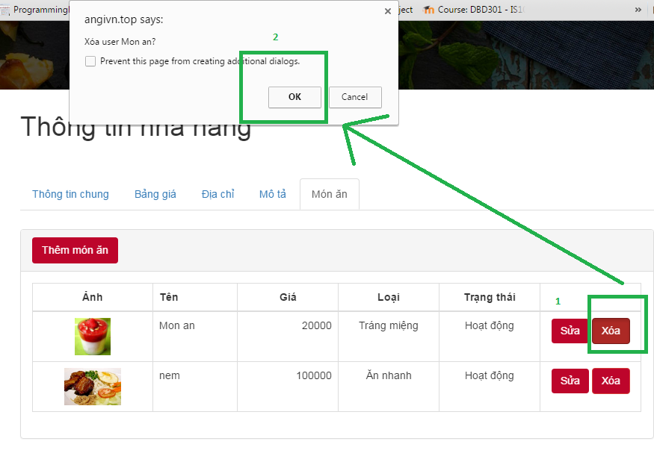

Figure 171: Delete food

##### Guide for manage booking

* On profile, click on ‘Quản lí đặt chỗ’ then click ‘xem’ to view a booking detail

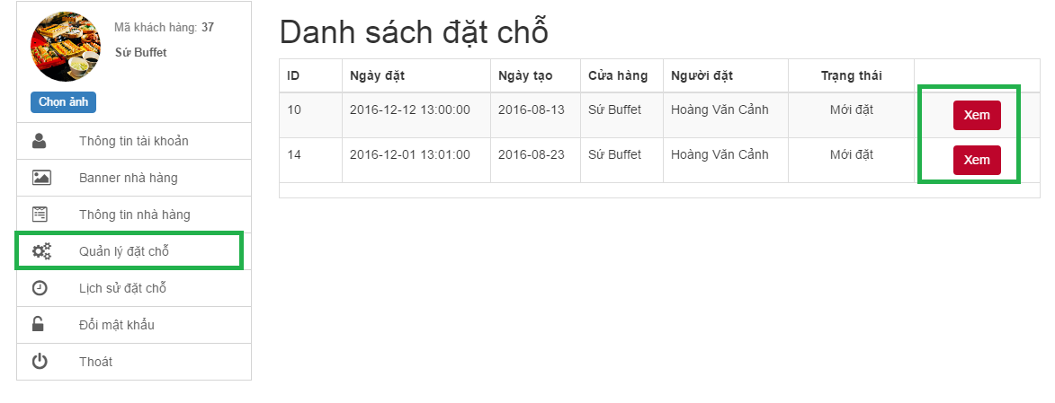

Figure 172: Manage booking

* Change booking status and click ‘Cập nhật trạng thái’ to save change

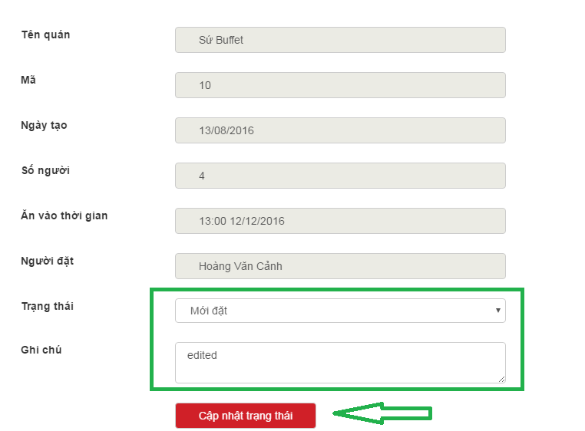

Figure 173: Update booking status

#### Guide line for Guest

##### How to access to our website?

* On the browser, type ‘http://angivn.top/’ and press enter then website home page will be displayed on your screen.

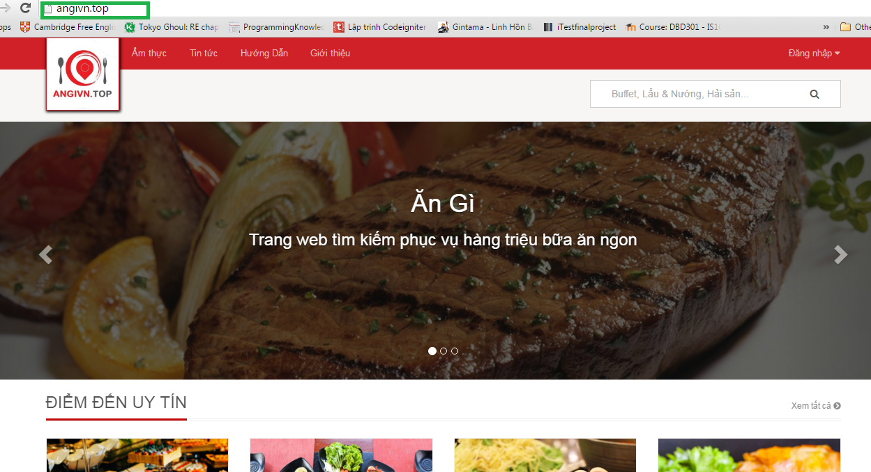

Figure 174: Access to system

* From here you can borrow many restaurants. We also filter some restaurants by top sale, top rate for you to find easier. To view more click ‘Xem tất cả’

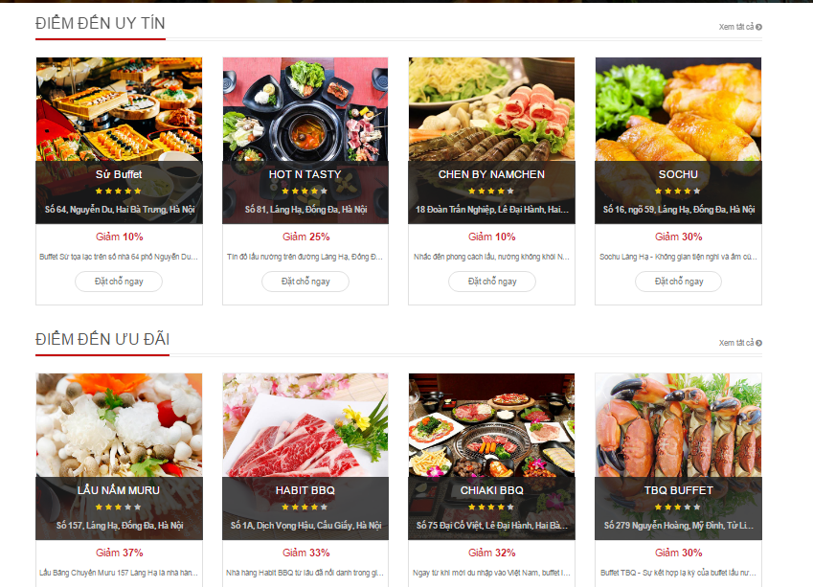

Figure 175: View home content

##### List all restaurant in a category by

* Hover mouse over “Ẩm thực” text on the top menu then chose a category

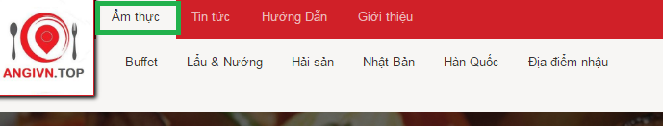

Figure 176: Chose category

* After that website will move to category page as bellow

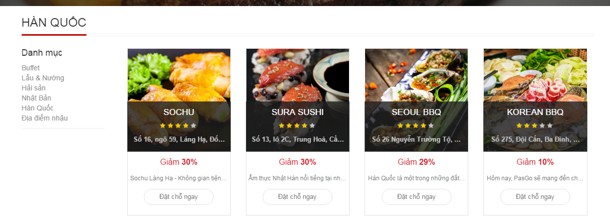

Figure 177: View result

* Then you can filter restaurant by left navigation panel.

##### Find restaurant by using search box and filter result

* Click on search box at the top right of website and type search key word in this

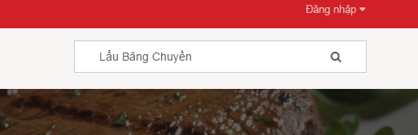

Figure 178: Search box

* Then click on magnifying glass icon to start searching, after that website will display search result page as bellow

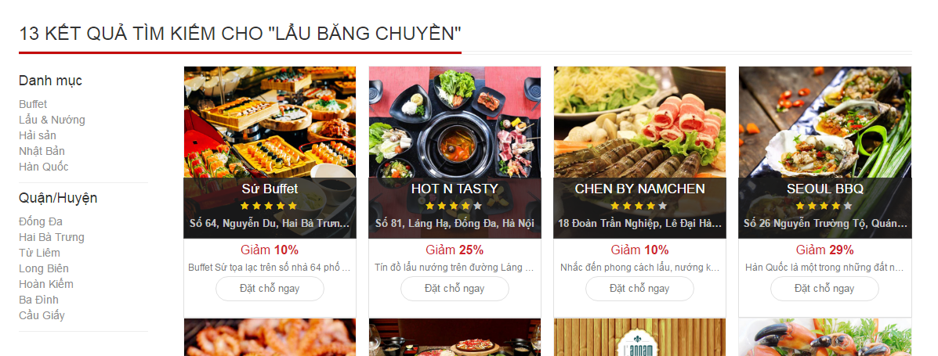

Figure 179: Search result

* After that look at left navigation, by click on this you can filter result base on location or category.

##### How to read restaurant detail page

* To view a restaurant detail, click on restaurant avatar that you see by using search or filter function, then website will move to restaurant page as bellow

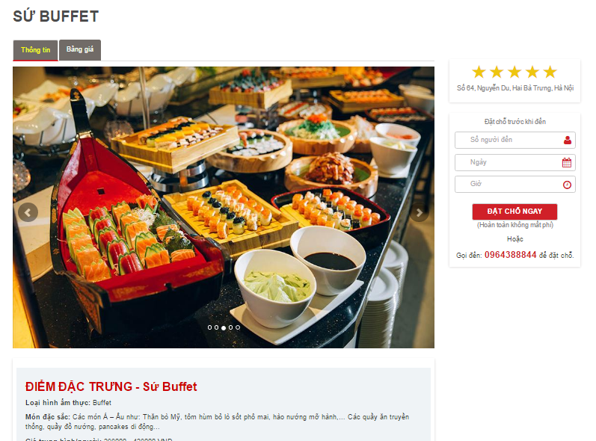

Figure 180: Restaurant detail page

* Click to ‘Bảng giá’ tab to view more about restaurant’s menu

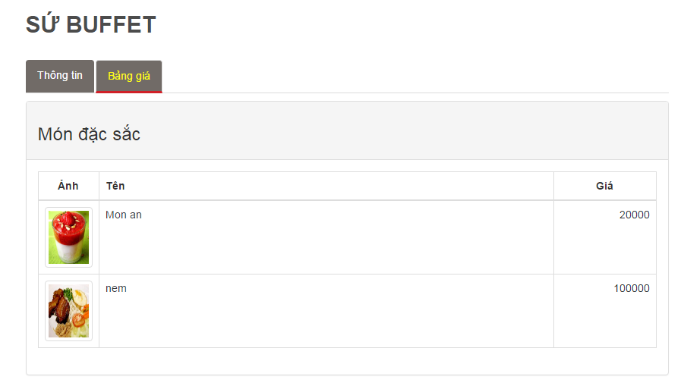

Figure 181: Menu tab

##### Step by step to view website’s new

Method 1: View news by category

* Hover mouse over “Tin tức” text on the top menu then chose a category

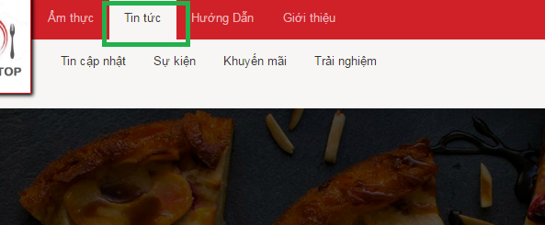

Figure 182: News category

* Click on a category bellow to go to view category page

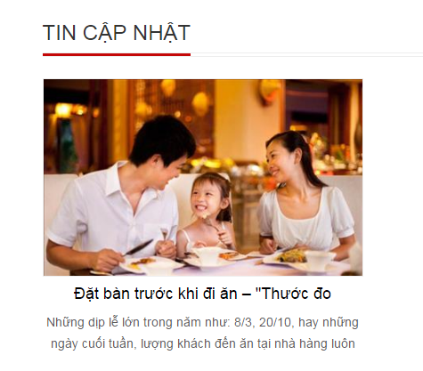

Figure 183: News by category

* Then click on a new to read detail

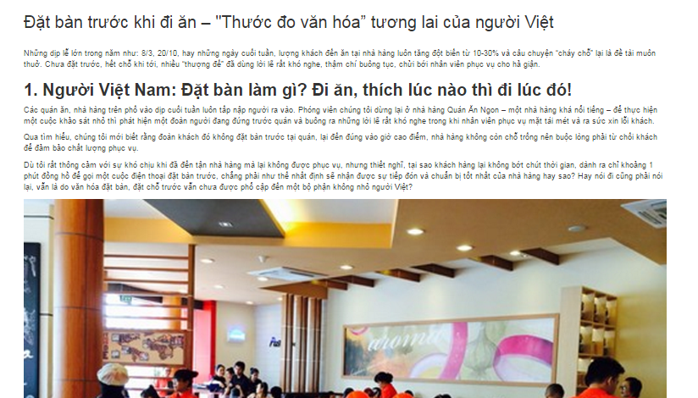

Figure 184: Read new

* Method 2: View newest news by go to the button of home page to view

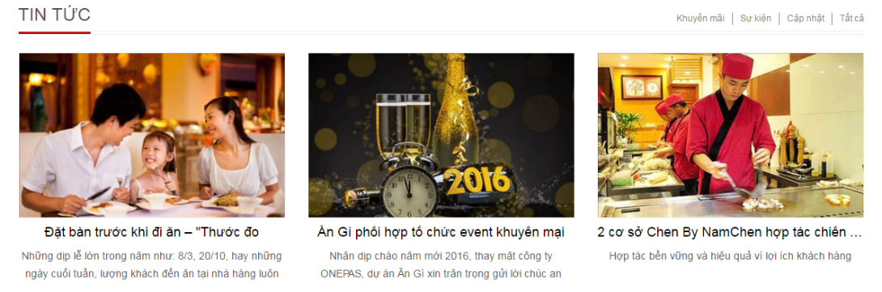

Figure 185: New at footer

##### How to Like, share, comment a restaurant

Note: We use Facebook API for this function so you have to log in to Facebook.

* In restaurant detail page go to button you will see social group here

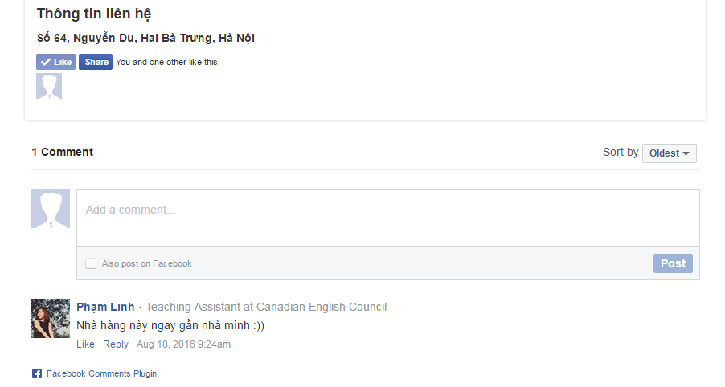

Figure 186: Facebook function

* From here you can like/unlike, share by click on corresponding button
* You can comment to restaurant by Facebook post form
* You can also like, reply another’s comment,… and another Facebook function here.

##### Step by step to register an account

* Hover mouse over “Đăng nhập” text on the top right of the navigation bar, then click on “Đăng ký” link

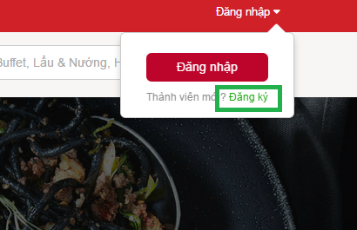

Figure 187: Register link

* Then website will go to register page like bellow

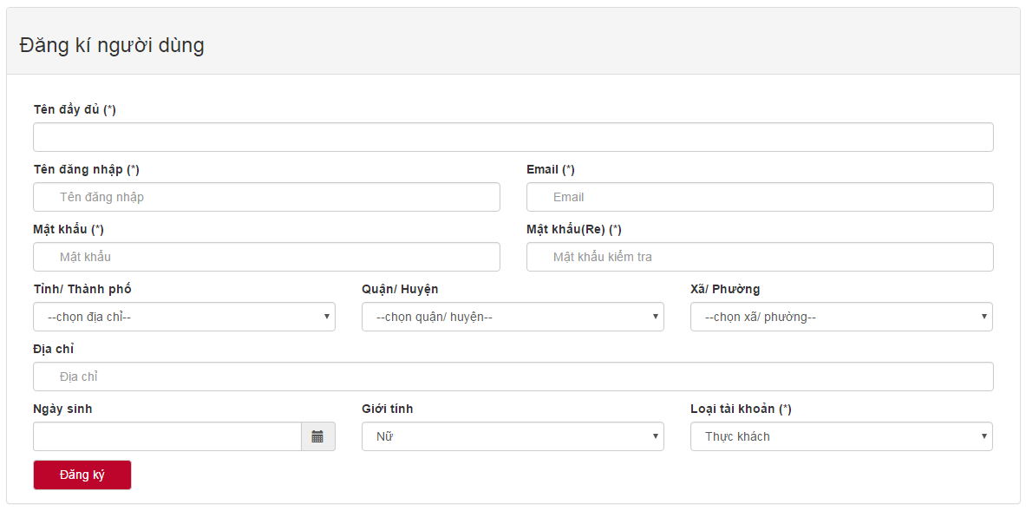

Figure 188: Register form

Note:

\_ (\*) field is required.

\_ Password length is at least 6 characters.

\_ Email must following format xxxx@xxx.xxx.

\_ Password must match re-Password

## PROJECT RESULT REPORT

### Product Judging

#### Advantages of AGC web application

AGC system is developed based on the understanding of internet and computing devices. Both of them are used everywhere and in every field in life which have made our day to day tasks become easier and simpler. Therefore, AGC system provides users functionalities to access information anytime and anywhere.

1. **Admin**

* Admin is a website site owner which he/she/they can gain profit generated by AGC system.
* Able to control users’ account and check the system status.

1. **Customers**
   * Check menu in restaurants.
   * Check restaurants’ addresses.
   * Check which restaurants has top rating.
   * Check which restaurants has the highest discount.
   * Make an online table booking.
   * View others restaurants’ information in detail.
   * View restaurants’ list based on interest, address, restaurant category, etc.
   * Have a quick search for any interested information.
   * Interact with social network.
2. **Restaurant owners**

* Help restaurant owners to have more channel to communicate their products or services to their potential customers.
* Manage table booking online.
* Check business status by viewing statistical data in the system.
* Restaurant owner account can be used as customer account which he/she can perform all functionalities those customer is able to.

1. **Guests**

* View all restaurants’ information.
* View all general information in AGC system.

#### Current limitations of AGC web application

* Functions for restaurant owners cover only basic functions.
* Users cannot directly rate restaurants and give reviews.
* Like and Comment functionalities still rely on social network.
* Images management still rely on third party web server.
* Customers cannot have a live chat with restaurant owners.
* No live notification service for users.
* Numbers of registered restaurants cover only Hanoi, Vietnam.
* Some graphical user interfaces do not provide understandable look and feel to users enough.
* Language used is only Vietnamese.

#### Expectation in the future

* Develop more functionalities for restaurant management.
* Manage images purely in AGC system without using third party server.
* Develop live chat functionality between Customers and restaurant owners.
* Develop live notification service for users.
* Expands area of registered restaurants while maintain original areas.
* Develop functionality for users to be able to swap between English and Vietnamese languages.

### Project Summary

|  |  |  |  |
| --- | --- | --- | --- |
| **Project title** | | AGC | |
| **Project advisor** | | Mr Nguyen Van Sang | |
| **committers: 5** | | | |
| 1 | Project manager | Soulivong Phimmathong | [soulivongse03451@fpt.edu.vn](mailto:soulivongse03451@fpt.edu.vn) |
| 2 | Requirement analysis leader | Nguyen Huu Thao | thaonhse03334@fpt.edu.vn |
| 3 | Software design leader | Vu Hoang Hieu | hieuvhse03030@fpt.edu.vn |
| 4 | Development leader | Hoang Van Canh | canhhvse03271@fpt.edu.vn |
| 5 | Quality assurance leader | Nguyen Hoang | hoangnse03193@fpt.edu.vn |
| **Main objective** | | develop a web application that connect customers to restaurant owners | |
| **Purpose** | | provides a convenient way for users to access restaurants’ information | |
| **Items** | | **Plan** | **Actual** |
| Release date | | 24 August 2016 | 24 August 2016 |
| Release version | | 1.0 | 1.0 |
| Days | |  | 144 |
| Weeks | |  | 20 weeks and 4 days |
| Months | | 4 | 4 months and 22 days |
| Test cases + checklists | |  | 191 |
| Documentation pages | |  | 257 |
| Lines of code | |  | Approximately 12470 |

Figure 189: AGC project summary

### Lessons Learnt

#### Project management skill

* **Work schedule:** we know how to create a plan for daily, weekly and even monthly to ensure the project will reach its goal. All steps of working processes are preliminary planned, and then assigned tasks to members which are given deadlines.
* **Time management:** Even though, we have created a clear schedule. But coding and documenting processes took longer time than they supposed to be. Therefore, in the last phase of development we had a very frequent meeting, working hard all day, and a little more at night in order to bring the work on schedule.
* **Human management:** from this project we have learnt that team work is the most important component in software development and in all others working field. We have more understanding of each member habit, his/her strengths and weaknesses. With this we can ensure that everyone will get the right work load that is suitable to his/her abilities, and he/she will engage to the tasks with satisfaction.
* **Integration management:** We know how to put many complex components in software system together and successfully deploy AGC system.

#### Soft skill

* **Communication Skill:** we have known what tools to be used and when to be used in order to communicate effectively.
* **Team work:** before join AGC project we do not know each other before, but suddenly we are grouped together. During 4 months working together, spent a lot of time together, helping each other to solve problems. Most of the time we have conflicts with each other, but those things could be passed because we understand each other and have the same goal which is to accomplish the project successfully.

#### Technical skill

* Documentation: a lot of technical documents were created, we have learnt how to write software documentations and used a lot of tools in software documenting.
* Programming languages: Php CodeIgniter framework, MySQL, HTML, CSS, bootstrap, JavaScript, Juery, etc.
* We know to publish website on the internet using host and domain
* Have more understanding of software architecture
* Have more understanding of software testing
* Know how to use Github and Tortoise Git.

# REFERENCES

- Foody.vn Hà Nội, viewed 23/5/2016 www.facebook.com/FoodyHaNoi/?fref=nf

- Foody.vn website, viewed 23/5/2016 [www.foody.vn/ha-noi](http://www.foody.vn/ha-noi)

- Lozi.vn website, viewed 23/5/2016 [lozi.vn/a/ha-noi](http://lozi.vn/a/ha-noi)

- Information Technology Project Management | 7e Kathy Schwalbe textbook.

- [www.projectmanagementdocs.com/project-documents/quality-checklist.html#axzz 49LxmQ8h0](http://www.projectmanagementdocs.com/project-documents/quality-checklist.html#axzz 49LxmQ8h0)

- [en.wikipedia.org/wiki/Rational\_Unified\_Process](https://en.wikipedia.org/wiki/Rational_Unified_Process)

- AGC\_WorkSchedule.mpp

- AGC\_Risk\_Register.xlsx

- AGC\_Risk\_Probablity\_and\_Impact\_Matric.xlsx

- www.codeigniter.com

- [www.tutorialspoint.com/sdlc/sdlc\_v\_model.htm](http://www.tutorialspoint.com/sdlc/sdlc_v_model.htm)l

- AGC\_Test\_Cases\_V1.0.xlsx

- AGC\_Defect\_Logs\_V1.0.xlsx

- [www.tutorialspoint.com/sdlc/sdlc\_v\_model.html](http://www.tutorialspoint.com/sdlc/sdlc_v_model.html)

- [www.sqaforums.com/attachments/437212-WebApplicationTesting.doc](http://www.sqaforums.com/attachments/437212-WebApplicationTesting.doc)

- AGC\_Test\_Cases\_V1.0.xlsx

- AGC\_Defect\_Logs\_V1.0.xlsx